Lesson 11:

What is the Most Ethical Way to Fund Public Schools?
Author: Matt Pierson

In this lesson, students will be analyzing documents to support their idea of the most ethical way to fund public schools.

Description of the lesson
In this lesson, students will be analyzing a variety of public-school funding formulas to answer the question, “What do you think is the most ethical way to fund public schools?” The students analyze documents, create a school-funding graphic organizer, and write an email to their state representative with their plan to fund schools in the most ethical way in their researched opinion.

Economics
Education is a service that is largely operated by governments instead of using a market system. As a society we have decided that K-12 education is something that should be provided to every student regardless of income or status. Public education is a complex and burdensome undertaking in a nation like the United States because funding decisions are primarily made at state and local levels. Since funding is mostly left up to the states, there is a system of trade-offs and cost/benefit analysis to try and get the highest quality education at the best price and to use the tax dollars in the most efficient way possible.

Ethics
As a country, many people believe we have an obligation to educate our citizens. In fact, every state constitution includes language mandating the creation of a public education system. It is an issue for ethical consideration to figure out how to fund that promised education. How do you allocate the tax dollars given to education? States are challenged to figure out a formula for educational funds that makes sure that all people, no matter their socio-economic status, can access quality education that is at least equitable to other students in their state. Ethics as it relates to school finance is, of course, about money. Plato held that justice in society was not just the interest of the strongest, or the most affluent, but that reason should prevail and that civic questions in society should be answered rationally, with a strong degree of disinterest. Jeremy Bentham argued for a utilitarian ethics that provided the greatest good for the greatest number in society. Therefore, it would seem that an ethical approach to school finance would involve some rational determination of what would produce the greatest good for the greatest number in a system of financing public schools. School funding is a normative analysis: How should funding be allocated?

Objectives:
After completing this lesson students will be able to:
- explain how public schools are funded in their state.
- identify three school funding formulas.
- analyze documents regarding school funding to decide which funding model will bring results that match their ethical and economic goals.

Standards
Voluntary National Content Standards in Economics
- Standard 2: Decision Making
  - Effective decision making requires comparing the additional costs of alternatives with the additional benefits. Many choices involve doing a little more or a little less of something: few choices are “all or nothing” decisions
- Standard 16: Role of Government and Market Failure
  - There is an economic role for government in a market economy whenever the benefits of a government policy outweigh its costs. Governments often provide for national defense, address environmental concerns, define and protect property rights, and attempt to make markets more competitive. Most government policies also have direct or indirect effects on peoples’ incomes.
- Standard 17: Government Failure
  - Costs of government policies sometimes exceed benefits. This may occur because of incentives facing voters, government officials, and government employees, because of actions by special interest groups that can impose costs on the general public, or because social goals other than economic efficiency are being pursued.

Concepts
Decision Making/Cost Benefits Analysis, Opportunity Cost, Role of Government

Time Required
90 minutes

Materials Needed
- Slide Presentation: What is the Most Ethical Way to Fund Public Schools?
- Copies of Activity 11.1: Word Puzzle 1, one per student for half of the class
- Copies of Activity 11.2: Word Puzzle 2, one per student for half of the class
- Pens or pencils, one per student
- Chalkboard/Whiteboard
- Copies of Activity 11.3: School Funding Video Worksheet, one per student.
- Device with internet access for each student.
- Copies of Activity 11.5: School Funding DBQ packet, one per student and one copy of each document to place in four different parts of the room. If you have a larger class, consider creating eight stations (two per document) around the room.
- Copies of Activity 11.7: School Funding Graphic Organizer, one per student
- Copies of Assessment 11: Write an Email, one per student

Preparation
Document 4 of the DBQ is a YouTube clip. There is a QR code provided, students can use phones or tablets to scan the QR code or there is a link if they have other devices. At least one student per group will need to have a device to view the clip. For extra resources on state funding of schools or if students have questions about funding for their state, please utilize https://usafacts.org/articles/how-are-public-schools-funded/ or https://www.census.gov/newsroom/press-releases/2023/public-school-spending.html.

Procedure
- Begin class by asking students, “Where does the money for this building, or these desks, or school buses come from?” Answers may vary but most students will say taxes some might even say property taxes. Display slide 1 of Slide Presentation: Ask: “What is the most ethical way to fund public schools?” Tell students that we are going to look at whether or not public schools are funded in the most ethical way.
- Tell students they are going to be doing a step-down puzzle and to get their pens or pencils out. Display slide 2. The idea of a step-down puzzle is that you have a word on the top of the puzzle and then each step down you remove a letter until you get to the single letter on the bottom. Since “I” is on the bottom of the puzzle, you know that “I” will be in each word.

- Distribute Activity 11.1: Word Puzzle 1 to half of the class. Distribute Activity 11.2: Word Puzzle 2 to the other half of the class
Teacher Note: Activity 11.2: World Puzzle 2 has clues to help the students while Activity 11.1: World Puzzle 1 has no clues. Do not let the students see there is a difference between Activity 11.1 and Activity 11.2.
- Give the students 3 minutes to complete the puzzle. Make a mental note of how long it takes the students who have Activity 11.2: Word Puzzle 2 to finish because they have the advantage. As students from Activity 11.2: Word Puzzle 2 are starting to finish, start to hurry the group up as it is important for them to feel the pressure of the situation. Students with Activity 11.1: Word Puzzle 1 will take longer overall and students should be confused as to why the others are getting done quicker.
Teacher Note: It is okay if students from Activity 11.1 do not finish the puzzle because they do not have hints like the students from Activity 11.2. If they do finish you could use this as a point to discuss that some students succeed despite the disadvantages they have based on differences in resources. Below is the answer to the step-down puzzle.
- After 3 minutes, tell students to stop working, display slide 3 which has the answers. Record on the board how many students finished the puzzle with 100% accuracy. Keep a tally of how many finished Activity 11.1: Word Puzzle 1 which had no advantage and how many completed Activity 11.2: Word Puzzle 2 which had an advantage.
- Once you record the results, have the students with Activity 11.2: Word Puzzle 2 show their puzzle to the students who had Activity 11.1: Word Puzzle 1. Ask the class why some students finished the puzzle faster than the students? Answer: Some students had hints for each line and this helped them figure out the puzzle faster.
Teacher note: students with Activity 11.1: World Puzzle 1 may be upset and frustrated that they had a harder puzzle or did not get help. That is ok and expected.
- Explain to the students that advantages and disadvantages exist in our world, especially in the area of education. Explain that these inequities in education give some students an advantage over others. In the puzzle simulation, for example, a few clues helped a small group of students complete a puzzle quicker. Ask students to consider this advantage over 12-14 years, the length of compulsory education in the United States. Pose the following discussion question to your students. If you compound this advantage over time, how far ahead or behind will some students be, through no fault of their own, besides the geographic area they grew up in? Ask students to discuss this with students around them and then ask for volunteers to guide this discussion in class.
Answers may vary but try to guide the discussion towards the compounding impact over time. You could also compare it to hiring a private coach for a sport or instrument and the advantage that would give over time over someone who did not have that advantage. The overall goal is to get them to understand the snowball effect of the learning gap.
- Explain to students that there are many causes of educational inequality. One of them is how we fund our public schools, the focus of this lesson. To introduce this idea you will have them watch this YouTube video from Kansas City PBS, “School Funding: The Devil’s in the Details” (4:19 min) that explains some of the ins and outs of school funding on slide 4. Please have them complete Activity 11.3 School Funding Video Worksheet as they watch. A preferred answer document is provided.
- Display the definitions of Equity and Equality on slide 5.
  - Equality: means providing the same to all
  - Equity: refers to fairness and justness and is distinguished from equality
  - Equity means recognizing that we do not all start from the same place and must acknowledge and make adjustments to imbalances.
- Display slide 6 and ask the students, should public education funding promote equality or equity? Answers may vary but could include wanting equity to provide similar opportunities to all students. Some students might choose equality so that schools all get the same amount of funding.
Use the picture showing the difference between equity and equality to help guide the discussion. Then take an informal poll with the class, have students who think public school funding should promote equity hold up 1 finger, those who think public school funding should promote equality hold 2 fingers up. Have a few students explain their position. Remind students that we will come back to this picture at the end of the activity to see if their opinion has changed.
- Hand out a copy of Activity 11.5: School Funding DBQ to each student and display slide 7. Have the students read the directions silently while you are handing the document packet out. Teacher note: See references for the source of each document.

- Make 4 stations around your classroom and put a document at each station. Tell students that they will be looking at 4 documents around the room and answering questions that go with it. Break your class into 4 groups and have them work together on each document as they rotate. Give them 6 minutes per station. Remind students they need to complete the questions on their own individual packet but can talk and discuss questions as a group. There are suggested answers to the DBQ on Activity 11.6 DBQ Suggested Answers
  - Document #1: Court Decision from CCJEF v. Rell (2018)
  - Document #2: This is an overview of Brown v. Board of Education Supreme Court decision. It discusses the issues that this decision still has today with funding inequality.
  - Document #3: This article talks about how equal funding does not guarantee that students will succeed. You also need to look at rigor and quality of the actual education.
  - Document #4: This video from VICE news discusses how high need students like English Language Learners cost more to serve.
- After the DBQ is done, explain that now that they have seen some of the information on school funding that they now need to look into the different funding formulas. Display Slide 8. Hand a copy of Activity 11.7: School Funding Graphic Organizer to each student. Have the students access this website about school funding formulas on a device. The QR code on the worksheet is a link to this website as well if they want to use a device that can access QR codes.
- While the students are looking at the Urban.Org website, have them create a 2-3 sentence description of each formula in the columns on Activity 11.5: School Funding Graphic Organizer. A starting point for answers and discussion questions are provided in Activity 11.8: School Funding Graphic Organizer Teacher Guide. Give students 10 minutes to complete the graphic organizer.
- Now have the students discuss school funding formulas. Use Activity 11.8: School Funding Graphic Organizer Teacher Guide to assist you. Use slide 9 as a visual reminder when reviewing the graphic.

Closure
- Display slide 10. Ask students if they remember this photo. Then have them write on a slip of paper their answer to the following prompt. “Now that you have learned about Public School Funding, what do you think? Should public school funding support equality or equity? What are the trade-offs?” Answers may vary but should talk about how equality would give everyone the same amount but equity would give more to the neediest areas. The trade-offs would be that some districts wouldn’t get as much money and may feel cheated depending on which one you choose.

Assessment
- Hand out Assessment 11: Write an Email. Read the directions with the class. Remind them that they need to use the documents and their graphic organizer to guide their answer.

Some sample assessment items:

- What is the primary source of public-school funding?
  - local property tax
  - sales tax
  - charitable donations
  - tuition paid by families

2. If you decided to fund schools equitably what outcome is MOST likely?
- Schools might admit more high need students to get more funding.
- Students would perform better immediately.
- Schools would have a hard time taking care of their maintenance.
- Schools would have to cut programs like music and art.

- Which school funding model is described as “the state taxes all districts the same amount and all revenue goes to the state and gets distributed equally among the districts to meet a minimum funding level”?
- Foundation Grants
- Guaranteed Tax Base
- Centralized School Finance
- Model State Tax Distribution

Essay/short answer assessment:

- What is the economic trade-off that governments must decide with school funding?
Answers may vary but could include, whenever you use tax dollars to fund anything there are other programs that will not get the money. If you fund schools then that is money that is not going to other parts of society.

References
Connecticut Coalition for Justice in Education Funding, Inc. v. Rell, 327 Conn. 650 (2018). Retrieved September 19, 2022 from https://jud.ct.gov/external/supapp/Cases/AROcr/CR327/327CR19.pdf
Fritts, J. (2021, July 7). How High Are Property Taxes in Your State? Tax Foundation. Retrieved September 19, 2022, from https://taxfoundation.org/high-state-property-taxes-2021/
How do school funding formulas work? (2017, November 29). Urban Institute. Retrieved September 19, 2022, from https://apps.urban.org/features/funding-formulas/
Jimenez, L., & Boser, U. (2018, November 13). A Quality Approach to School Funding. Center for American Progress. Retrieved September 19, 2022, from https://www.americanprogress.org/article/quality-approach-school-funding/
Knoff, H. (n.d.). The Impact of Inequitable School Funding: Solutions for Struggling Schools Without the Money to Fully Help Struggling Students | Equity & Access Pre K-12. The American Consortium for Equity in Education. Retrieved September 19, 2022, from https://www.ace-ed.org/inequitable-school-funding/
School Districts and Property Taxes in Illinois | The Civic Federation. (2017, October 6). The Civic Federation |. Retrieved September 19, 2022, from https://www.civicfed.org/civic-federation/blog/school-districts-and-property-taxes-illinois
Semuels, Alana. (2016, October 25) Good School, Rich School; Bad School, Poor School. The Atlantic. https://www.theatlantic.com/business/archive/2016/08/property-taxes-and-unequal-schools/497333/.

Activity 11.1: Word Puzzle 1
Instructions: Solve the puzzle below. When you are done, raise your hand and the teacher will check your answer. This is called a step-down puzzle. You need to remove a letter from the original word and rearrange the letters to form the next word, then you remove a letter from that word and rearrange the letters to form the next word. You continue doing this until you get to the “I” at the bottom.

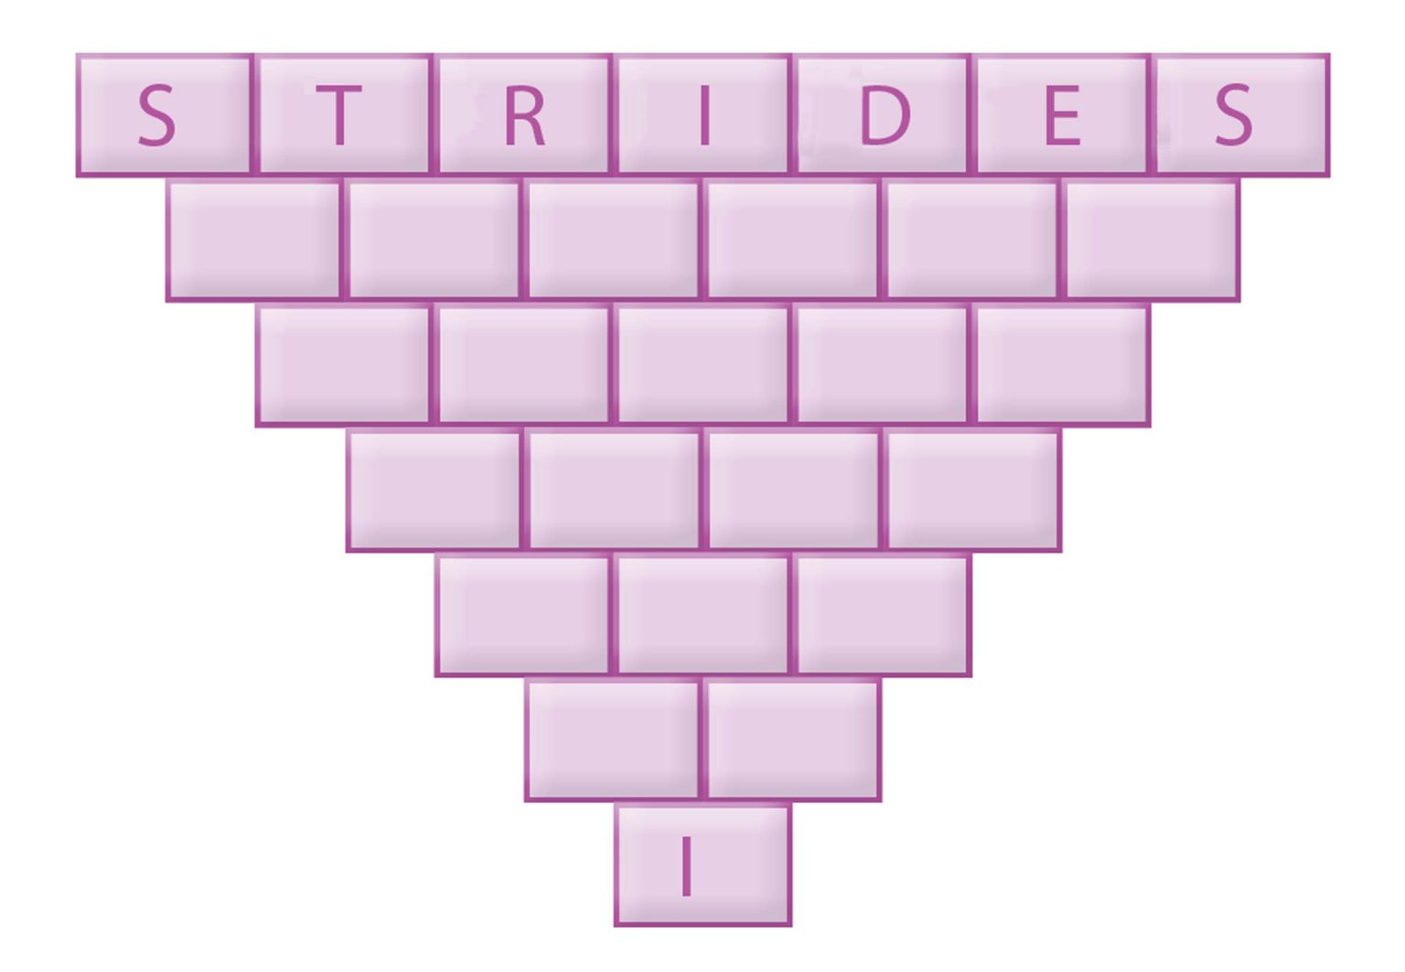

Activity 11.2: Word Puzzle 2
Instructions: Solve the puzzle below. When you are done, raise your hand and the teacher will check your answer. This is called a step-down puzzle. You need to remove a letter from the original word and rearrange the letters to form the next word, then you remove a letter from that word and rearrange the letters to form the next word. You continue doing this until you get to the “I” at the bottom.

Hints:
Line 2: Having the least moisture.
Line 3: Plans to lose weight.
Line 4: Something you can wear around your neck.
Line 5: To rest on a chair.
Line 6: Be verb or to exist.

Activity 11.3: School Funding Video Worksheet
Directions: Please answer these questions as you watch the video “School Funding: The Devil is in the Details” from YouTube.

- What does the Supreme Court Case Brown v. Board of Education dictate when it comes to schools? Does this impact funding?

- What does the Supreme Court Case San Antonio ISD v. Rodriguez dictate when it comes to schools? Does this impact funding?

- What is the GENERAL split for Federal, State and Local funding? Draw it as a pie chart below.

- Explain the difference between capital and operational expenses when it comes to school funding.

Activity 11.4: School Funding Video Worksheet Answers

Directions: Please answer these questions as you watch the video “School Funding: The Devil is in the Details” from YouTube.

- What does the Supreme Court Case Brown v. Board of Education dictate when it comes to schools? Does this impact funding?
Suggested Answer: Brown v Board of Education stated that separate but equal could not exist in schools. It required schools to integrate. It did not impact school funding.

- What does the Supreme Court Case San Antonio ISD v. Rodriguez dictate when it comes to schools? Does this impact funding?
Suggested Answer: San Antonio ISD v Rodriguez said that the Constitution did not guarantee equal funding for schools.

- What is the GENERAL split for Federal, State and Local funding? Draw it as a pie chart below.

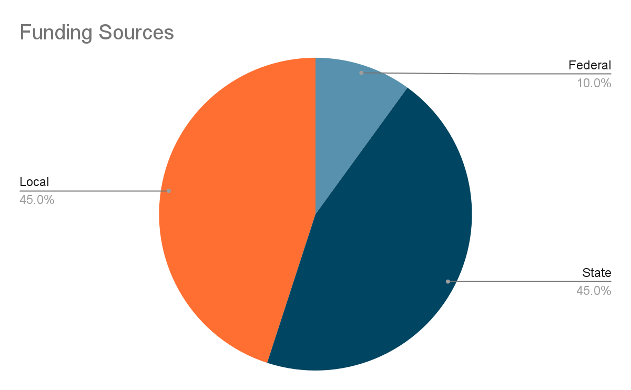

- Explain the difference between capital and operational expenses when it comes to school funding.
Suggested Answer: “Capital expenses” would be the school buildings and structures and their expenses whereas “operational expenses” would be teachers and other employee expenses.

Activity 11.5: School Funding DBQ
Instructions: Read the documents and answer the questions following each document.

Document #1: CCJEF v. Rell (2018) (CT Supreme Court Decision)

Jan 17, 2018
Background: Public school districts in Connecticut are funded by local property taxes. High-poverty areas have lower home values and collect less taxes, and so can’t raise as much money as places where homes are worth millions of dollars. The court was asked to decide if the state should be required to compensate local systems to end these discrepancies and whether inequality in school funding violates the state’s constitution.

In a 4-3 ruling, the Connecticut Supreme Court handed down its decision in Connecticut Coalition for Justice in Education Funding v. Rell and ruled in favor of the State of Connecticut and rejected the legal claims made by CCJEF. Writing for the Court, Chief Justice Chase Rogers noted there is “an imperfect public educational system in [Connecticut] that is straining to serve many students who, because their basic needs for, among other things, adequate parenting, financial resources, housing, nutrition and care for their physical and psychological health are not being met, cannot take advantage of the educational opportunities that the state is offering.”

However, the Chief Justice and the Court’s majority found that although Connecticut has “an imperfect public educational system,” [i]t is not the function of the courts…to create educational policy or to attempt by judicial fiat to eliminate all of the societal deficiencies that continue to frustrate the state’s educational efforts.” Instead, the Court stated, “the function of the courts is to determine whether the narrow and specific criteria for a minimally adequate educational system under [Connecticut’s] state constitution have been satisfied.”

In its decision, the Court found the State of Connecticut had satisfied its constitutional requirement to provide a minimally adequate public educational system, and reversed an earlier ruling that the State violated the Connecticut Constitution by not having educational policies and spending practices that are “rationally, substantially and verifiably connected to creating educational opportunities for children.” It did find that the State of Connecticut is spending more on education, in total, than the state constitution requires.

1: What is the main point of the court’s decision?

2: Do you agree or disagree with the court’s ruling? Explain your reasoning.

Document #2: An excerpt from, “THE IMPACT OF INEQUITABLE SCHOOL FUNDING: SOLUTIONS FOR STRUGGLING SCHOOLS WITHOUT THE MONEY TO FULLY HELP STRUGGLING STUDENTS”

Source: American Consortium for Equity in Education, Dr. Howie Knoff

The 65th anniversary of the landmark Brown v. Board of Education case was celebrated on May 17, 2019. As we all know, this unanimous Supreme Court decision determined that state laws that established racially segregated public schools were unconstitutional, even if the segregated schools were otherwise equal in quality. More specifically, the Court decided that “separate educational facilities are inherently unequal” and, thus, that they violated the Equal Protection Clause of the U.S. Constitution’s 14th Amendment.

Critically, the Supreme Court decision did not specify how states were to eliminate racial segregation in schools, and it ordered states to desegregate “with all deliberate speed.” Thus, while Brown was a landmark civil rights decision, many districts and schools have “waxed and waned” from segregation to integration to re-segregation during the following 65 years.
The “bottom line” is that the current state of educational equity is not good. While segregated educational facilities were deemed by the Supreme Court to be inherently unequal, the quality of instruction and the availability of resources and money in today’s schools—for many students from poverty and students of color—is unequal.

3: What is the main idea of this document?

4: Why should we care about determining and addressing the causes of educational inequality?

Document #3: An excerpt from, “A Quality Approach to School Funding”
Source: American Progress, 11/13/2018

“Dollars must be at the start of every conversation around equity. Funding is a central component to providing a high-quality education and often leads to improved outcomes. A 2016 study found that, between 1990 and 2011, states that reformed school finance policies in order to allocate more funding to high-poverty school districts narrowed the achievement gap by an average of one-fifth.

But allocating equal funding for every student does not guarantee that all students will have a rigorous educational experience. School finance reform must focus on the quality of every school, from the excellence of the instruction to the rigor of the classes.

This idea is at the heart of this report. The authors argue that the efforts to resolve inequities through the courts or with legislation need to move beyond funding. Furthermore, reforms must focus on both funding levels and equal access to resources shown to be fundamental to a quality education. True educational equity will require two central reforms. First, there needs to be additional resources—not the same resources—in order to meet the needs of at-risk students. Second, there should be accountability frameworks to ensure that the key ingredients to student success—access to early childhood programs, effective teachers, and rigorous curriculum—are available to students irrespective of their race, zip code, or economic status.”

5: What is the main idea of this document? How do the solutions provided reflect the concept of equity?

6: How does school funding relate to a quality education?

Document #4: Vice News Video about School Funding Crisis

https://www.youtube.com/watch?v=MBjrdHANZXo&ab_channel=VICENews

​​7: Based on the video, why do the schools in Dodge City need more funding than other schools?

8: In the video, what programs are the first to get cut when funding issues happen?

Activity 11.6: DBQ Suggested Answers

- Use this answer guide to assist students with their document analysis in Activity 11.4
  - Document 1
1: The court decided that the state had met its requirement for funding for the schools in CT and it was not the court’s job to address the many issues facing students in this way.
2: Answers will vary. Students should focus on if they believe the state should be funding the schools more if they face more challenges that are listed in the decision.
  - Document 2
3: The Supreme Court case Brown V Board of Education concluded that “separate educational facilities are inherently unequal”. The author of the document argues that students in today’s schools, particularly students of color and those living in poverty, are experiencing inequality due to differences in quality of instruction and the availability of resources and money in different districts.
4: Answers will vary. Students should talk about how solving problems at the root can stop the cycle. If you do not solve the root of the issue then you will continue to see the problems arising. Economically, it might cost more to solve the root issue but in the long run benefits should outweigh the cost.
  - Document 3
5: Overall, allocating money to high poverty districts has been shown to close the achievement gap by 1/5th. Making sure that high-poverty and high-need schools have equal access is not enough, they need extra funding to close these achievement gaps.
6: School funding can lead to a higher quality of education by having higher wages to attract the best teachers, by hiring more staff to meet the needs of students, hiring more paraprofessionals and specialists to work in smaller groups with students. Also having high quality facilities and access to quality technology.
  - Document 4
7: The large population of Second Language Learners requires specialized staff and programs that are an additional cost on top of basic education.
8: Many of the after-school programs are the first to be cut. They do apply for grants sometimes but those are not guaranteed and could run out.

Activity 11.7: School Funding Formula Graphic Organizer

https://apps.urban.org/features/funding-formulas/

Foundation Grants | Guaranteed Tax Base | Centralized School Finance
Does this formula promote equity or equality? Why? | Does this formula promote equity or equality? Why? | Does this formula promote equity or equality? Why?

Activity 11.8: School Funding Formula Graphic Organizer and Discussion Teacher Guide
Please use this as a guide to assist in discussing the three different school funding formulas.

Foundation Grants | Guaranteed Tax Base | Centralized School Finance
Most common formula. The state decides the minimum amount that should be spent on each student. The state then calculates how much each district can pay, and fills the rest up to the minimum. | The state guarantees a steady tax base by “matching” the tax effort of each district. This formula helps less property-rich districts raise tax funds with the help of the state. | In this model the state taxes all districts the same amount and all revenue goes to the state and gets distributed equally among the districts to meet a minimum funding level.

Equity or Equality?
- All systems listed here set a minimum level of funding and work to make sure that is met. So, they are promoting equality as they are looking to fund all students the same.

DICUSSION QUESTIONS

What is a Foundation Grant? How can districts raise more money than others in this system?
- Answers will vary but could include: Foundation Grants set a minimum that districts must spend on students and fill the gap between property taxes and the minimum. This makes sure each student is being funded to at least the minimum level. Wealthier districts can raise more taxes and go well beyond the minimum level in this system, thus providing more funding to their students than poorer districts.
How does Guaranteed Tax Base incentivize higher taxes to assist with school funding? Who benefits from this?
- Answers may vary but could include: The districts are guaranteed a consistent funding level for each percent of tax they raise. So poorer areas who have a much smaller tax base could still raise taxes and get more benefit. However, wealthier districts will still get more in this system than poorer districts due to property values unless the state decides to recapture.
In the Centralized School Finance model there is a choice that states must make with wealthier districts, what is that choice?
- Answers may vary but could include: Do you allow wealthier districts to raise more funds or do you recapture those funds?
What does it mean if a state chooses to “recapture” some revenue? What are the disadvantages of recapture?
- Answer: The state sets a cap on spending for the unaided districts and recaptures any revenue above that cap to redistribute to districts that do require aid. The disadvantage of recapture is that the state may need to lower the recapture threshold year after year which could decrease property values.
Should all states use the same funding formula? Explain.
- Answers may vary but could include: Students may cite that different states have different goals, obstacles, and student demographics, so a one-size-all approach may not be adequate

Assessment 11: Write an Email
Instructions: Now that you have learned about school funding and its link to educational inequality, you will take action. Write an email to a state legislator in response to the essential question: What is the most ethical way to fund schools? Your email should include:
- A short description of how schools in your state are currently funded
- An explanation of why you think the current funding equation is or is not equitable
- A proposition for how the current funding equation should be changed in an effort to make education more equitable in your state
- Must cite information from at least 2 of the DBQ documents.
- Make sure that you explain if your plan is going to promote equality or equity and explain the difference.
- You can find your state legislator at https://pluralpolicy.com/find-your-legislator/

Write your email below.

To:

Subject:

Body:

Assessment 11: Sample Test Questions
Some sample assessment items:
- What is the primary source of public-school funding?
  - local property tax
  - sales tax
  - charitable donations
  - tuition paid by families
- If you decided to fund schools equitably what outcome is MOST likely?
- Schools might admit more high need students to get more funding.
- Students would perform better immediately.
- Schools would have a hard time taking care of their maintenance.
- Schools would have to cut programs like music and art.

- Which school funding model is defined as “the state taxes all districts the same amount and all revenue goes to the state and gets distributed equally among the districts to meet a minimum funding level”?
- Foundation Grants
- Guaranteed Tax Base
- Centralized School Finance
- Model State Tax Distribution

Essay/short answer assessment:

- What is the economic trade-off that governments must decide with school funding?

Ward, James Gordon (2004) "Ethics and the Legitimation of the Pursuit of Equity in School Finance," Saint Louis University Public Law Review: Vol. 23 : No. 2 , Article 4. Available at: https://scholarship.law.slu.edu/plr/vol23/iss2/4
Voluntary National Content Standards in Economics: https://www.councilforeconed.org/wp-content/uploads/2012/03/voluntary-national-content-standards-2010.pdf
Kansas City PBS “School Funding: The Devil’s in the Details” https://www.youtube.com/watch?v=D9W2Vlg2GVA&ab_channel=KansasCityPBS
Urban Institute “How do School Funding Formulas Work?” ttps://apps.urban.org/features/funding-formulas/

