Effects of the War of 1812:

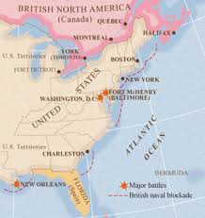
End of the Federalist Party:
Many of the members of the Federalist Party made most of their money through trade both with Britain and other foreign nations. However, the British placed their navy by the American coast to prevent any trade from
occurring between America and other nations during the war, effectively reducing all American trade to zero. Because of this, the Federalist Party generally opposed the war, and their political opponents used their opposition to the war to label them as traitors and turn public opinion against them. With the end of the war claimed as an American victory, the Federalist party lost the trust of the people and collapsed.

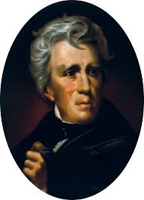

Andrew Jackson:
At the battle of New Orleans, Andrew Jackson led a ragtag group of 5,700 soldiers against an invading British force with 8,000 well trained soldiers. Rather than retreat, Jackson dug his troops into well defended trenches and waiting for the British forces to attack. Despite all odds, Andrew Jackson was able to lead his troops to victory, inflicting over 2,400 casualties on the British while losing less than 100 of his men. Andrew Jackson was labeled as a national hero, and he used his newfound fame to run for and win the presidency.

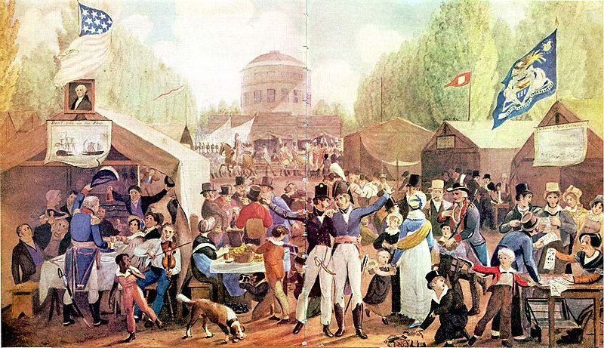
The Era of Good Feelings:
The War of 1812 was the first war that America fought as a newly founded country, and the idea of Americans coming together to fight off a common enemy had not been tested until this point in history. Even though the war ended with a result that was basically a draw, Americans claimed the conflict as a victory in which they fought off an invasion from a great european power. This perceived victory led to an increased sense of Nationalism and Patriotism among a majority of Americans and the time after to war became known as the “Era of Good Feelings”.

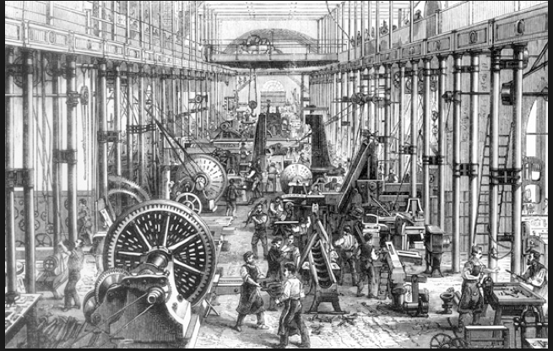
Growth of the Army, Navy, and Manufacturing:
Because the British blockade prevented Americans from trading with foreign nations, the American manufacturing industry was forced to grow at a faster rate than before. This eventually made America one of the largest manufacturers in the world and paved the way for what became known as the Market Revolution. Furthermore, during and after the war, America began to focus on growing its military in order to be able to stand up to any other foreign threats similar to those faced in the War of 1812.

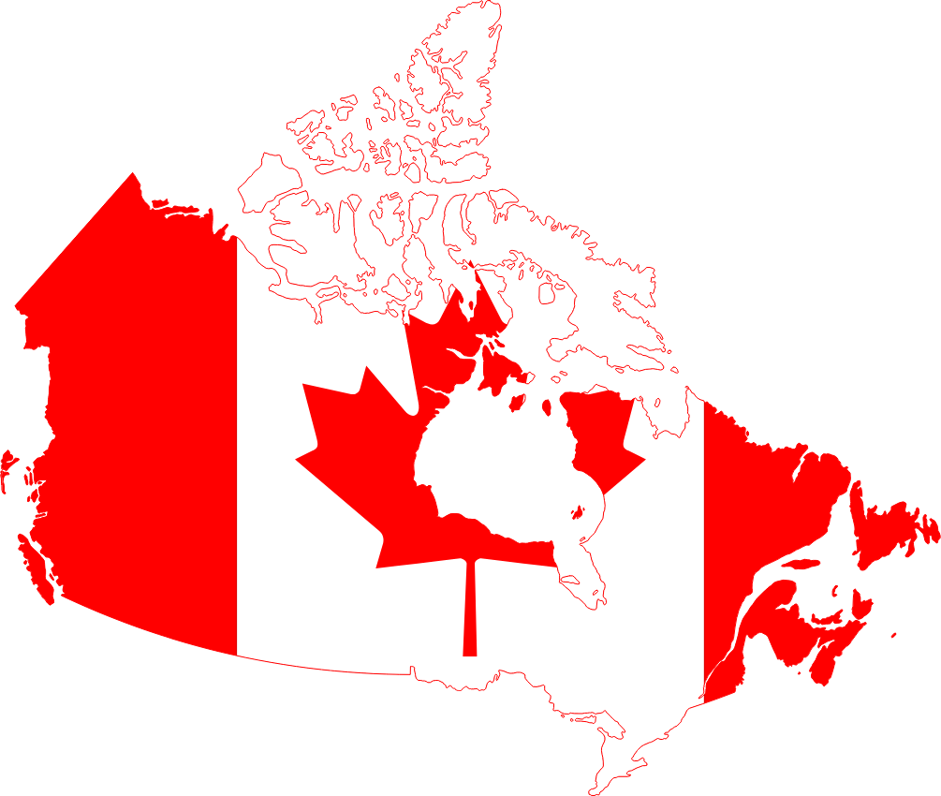
Canadian Sovereignty:
One of the principal causes of the war of 1812 was the desire of American “Warhawks” to conquer the British territory of Canada and add it to the United States. Most of the fighting during the war actually took place in Canada. Many Americans thought that an invasion of Canada would be a simple affair, but much to their surprise Canadian soldiers allied with British regiments fought hard to defend their home. The American invasion of Canada ended in a miserable failure, and with it so did the desire of many Americans to ever try conquering the land again. In other words, the War of 1812 solidified Canada as a region independent and separate from the United States.

Native American Losses:
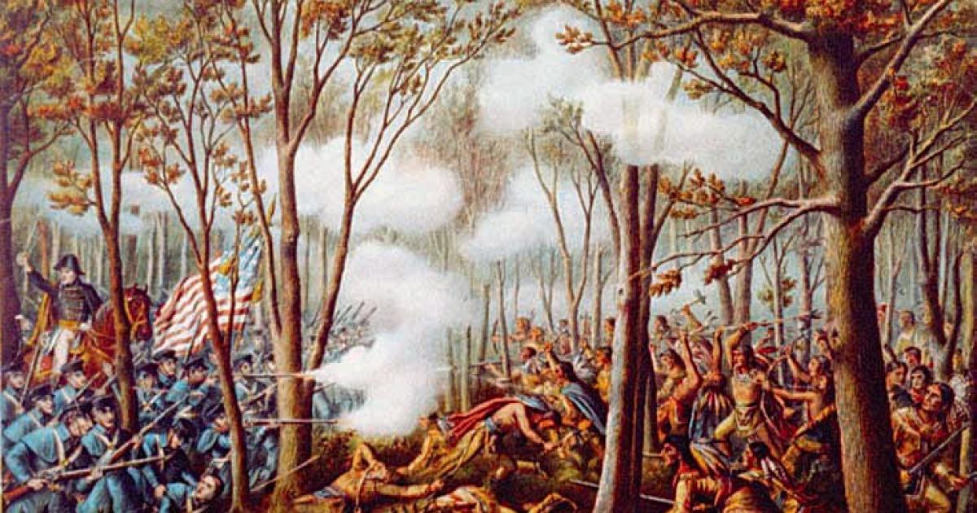
During the War of 1812 a majority of Native American tribes sided with the British against the Americans, seeing the United States as the biggest threat to Native land and society. Many of these tribes were led in a successful Confederation by the Native American leader Tecumseh. Despite successes, many of these tribes still suffered great casualties fighting against the Americans. With the end of the war basically a draw, America used Native resistance as a justification to encroach even further upon their land.

Star Spangled Banner: 66
Washington DC: 235
New Orleans: 140
Impressment: 8
Blockade: 40
Canada: 59
Native Americans: 67
France: 500
Sailors: 623
Fort McHenry: 220
Battle of New Orleans: 142
Treaty of Ghent: 268
Federalist Party: 85
Andrew Jackson: 1
Nationalism: 47
Patriotism: 89
Era of Good Feelings: 20
Army & Navy: 206
Manufacturing: 109
Tecumseh: 422
Warhawks: 341
New York: 229
Philadelphia: 55
George Washington: 91
Thomas Jefferson: 120
Imperialism: 171
Slavery: 135
Land: 27
Great Britain: 90
United States: 134
Democratic Republican Party: 159
India: 812
Mexico: 278
Canadians: 700
Mexicans: 462
The French: 163
Baltimore: 612
Treaty of Paris: 193
Fort Knox: 274
2,400: 3
8,500: 58
1,200: 30
Market Revolution: 99

Pink Lock:
Causes of the War of 1812
Find the answers to the questions on this sheet, then add up the numbers next to every answer to get the lock combination.

Question #1: One of the causes of the war of 1812 was a desire of some American Congressmen to try and gain this territory from Great Britain.
Answer | Number
Canada | 59

Question #2: One of the causes of the war of 1812 was this British practice of kidnapping American sailors and forcing them to join the British Navy, called this.
Answer | Number
Impressment | 8

Question #3: One of the causes of the war of 1812 was the perception that the British were inciting this group of people to make war with the United States.
Answer | Number
Native Americans | 67

Question #4: One of the causes of the war of 1812 was this British policy of stopping American trade with France [who was at war with Great Britain]
Answer | Number
Blockade | 40

Lock Combination
174

Silver Lock:
Stories During the War of 1812
Find the answers to the questions on this sheet, then add up the numbers next to every answer to get the lock combination.

Question #1: During the War of 1812, the British army burned this American city to the ground.
Answer | Number
Washington DC | 235

Question #2: The defense of the city of Baltimore during the War of 1812 inspired the creation of this song
Answer | Number
Star Spangled Banner | 66

Question #3: This was the name of the defensive fortification that defended Baltimore during the War of 1812
Answer | Number
Fort McHenry | 220

Question #4: The defense of this city was the largest American victory during the war of 1812 [even though it happened after a peace treaty had been signed]
Answer | Number
New Orleans | 140

Question #5: This officially ended the War of 1812.
Answer | Number
Treaty of Ghent | 268

Lock Combination
929

Blue Lock:
Effects of The War of 1812 #1
Find the answers to the questions on this sheet, then add up the numbers next to every answer to get the lock combination.

Question #1: The British stopping of American trade caused the growth of this.
Answer | Number
Manufacturing | 109

Question #2: The desire of America to better defend itself during the War of 1812 and any future threats caused the growth of this.
Answer | Number
Army & Navy | 206

Question #3: The end of the war of 1812 ensured that this region would be a separate nation from the United States.
Answer | Number
Canada | 59

Question #4: This group of people sided with the British during the war of 1812, and ended up receiving massive losses to their because of this.
Answer | Number
Native Americans | 67

Question #5: This was the name of the Native American leader who united many tribes to fight together during the War of 1812.
Answer | Number
Tecumseh | 422

Lock Combination
863

Black Lock:
Effects of The War of 1812 #2
Find the answers to the questions on this sheet, then add up the numbers next to every answer to get the lock combination.

Question #1: Because this group was against the War of 1812, they were labeled as traitors and their group was eventually destroyed because of this.
Answer | Number
Federalist Party | 85

Question #2: Because of the war of 1812, this man became a national hero after winning a massive victory.
Answer | Number
Andrew Jackson | 1

Question #3: The largest American victory of the war of 1812 had about this many British casualties.
Answer | Number
2,400 | 3

Question #4: After the war of 1812, there was an increase in national pride among Americas, so much so that the time period the war was called this.
Answer | Number
Era of Good Feelings | 20

Question #5:The war of 1812 led to a massive increase in American manufacturing, also known as this event.
Answer | Number
Market Revolution | 99

Lock Combination
208

Orange Lock: [Answers In Images And This Sheet]
Effects of The War of 1812 #4
1. Piece together the images that relate to the effects of the War of 1812
2. Find the three images that relate to the three effects listed below
3. Find the hidden number in each image and complete the math problem to get the combination

Effect | Hidden Number
Growth of the Army, Navy, and Manufacturing: | 190
Canadian Sovereignty: | 80
Native American Losses: | 11
Combination | 281

Purple Lock [Answer In Images And This Sheet]
Effects of The War of 1812 #3
1. Piece together the images that relate to the effects of the War of 1812
2. Find the three images that relate to the three effects listed below
3. Find the hidden number in each image and add them together to get the combination

Effect | Hidden Number
End of the Federalist Party: | 40
Andrew Jackson: | 100
The Era of Good Feelings: | 14
Combination | 154

Part One of Two to Find The Key

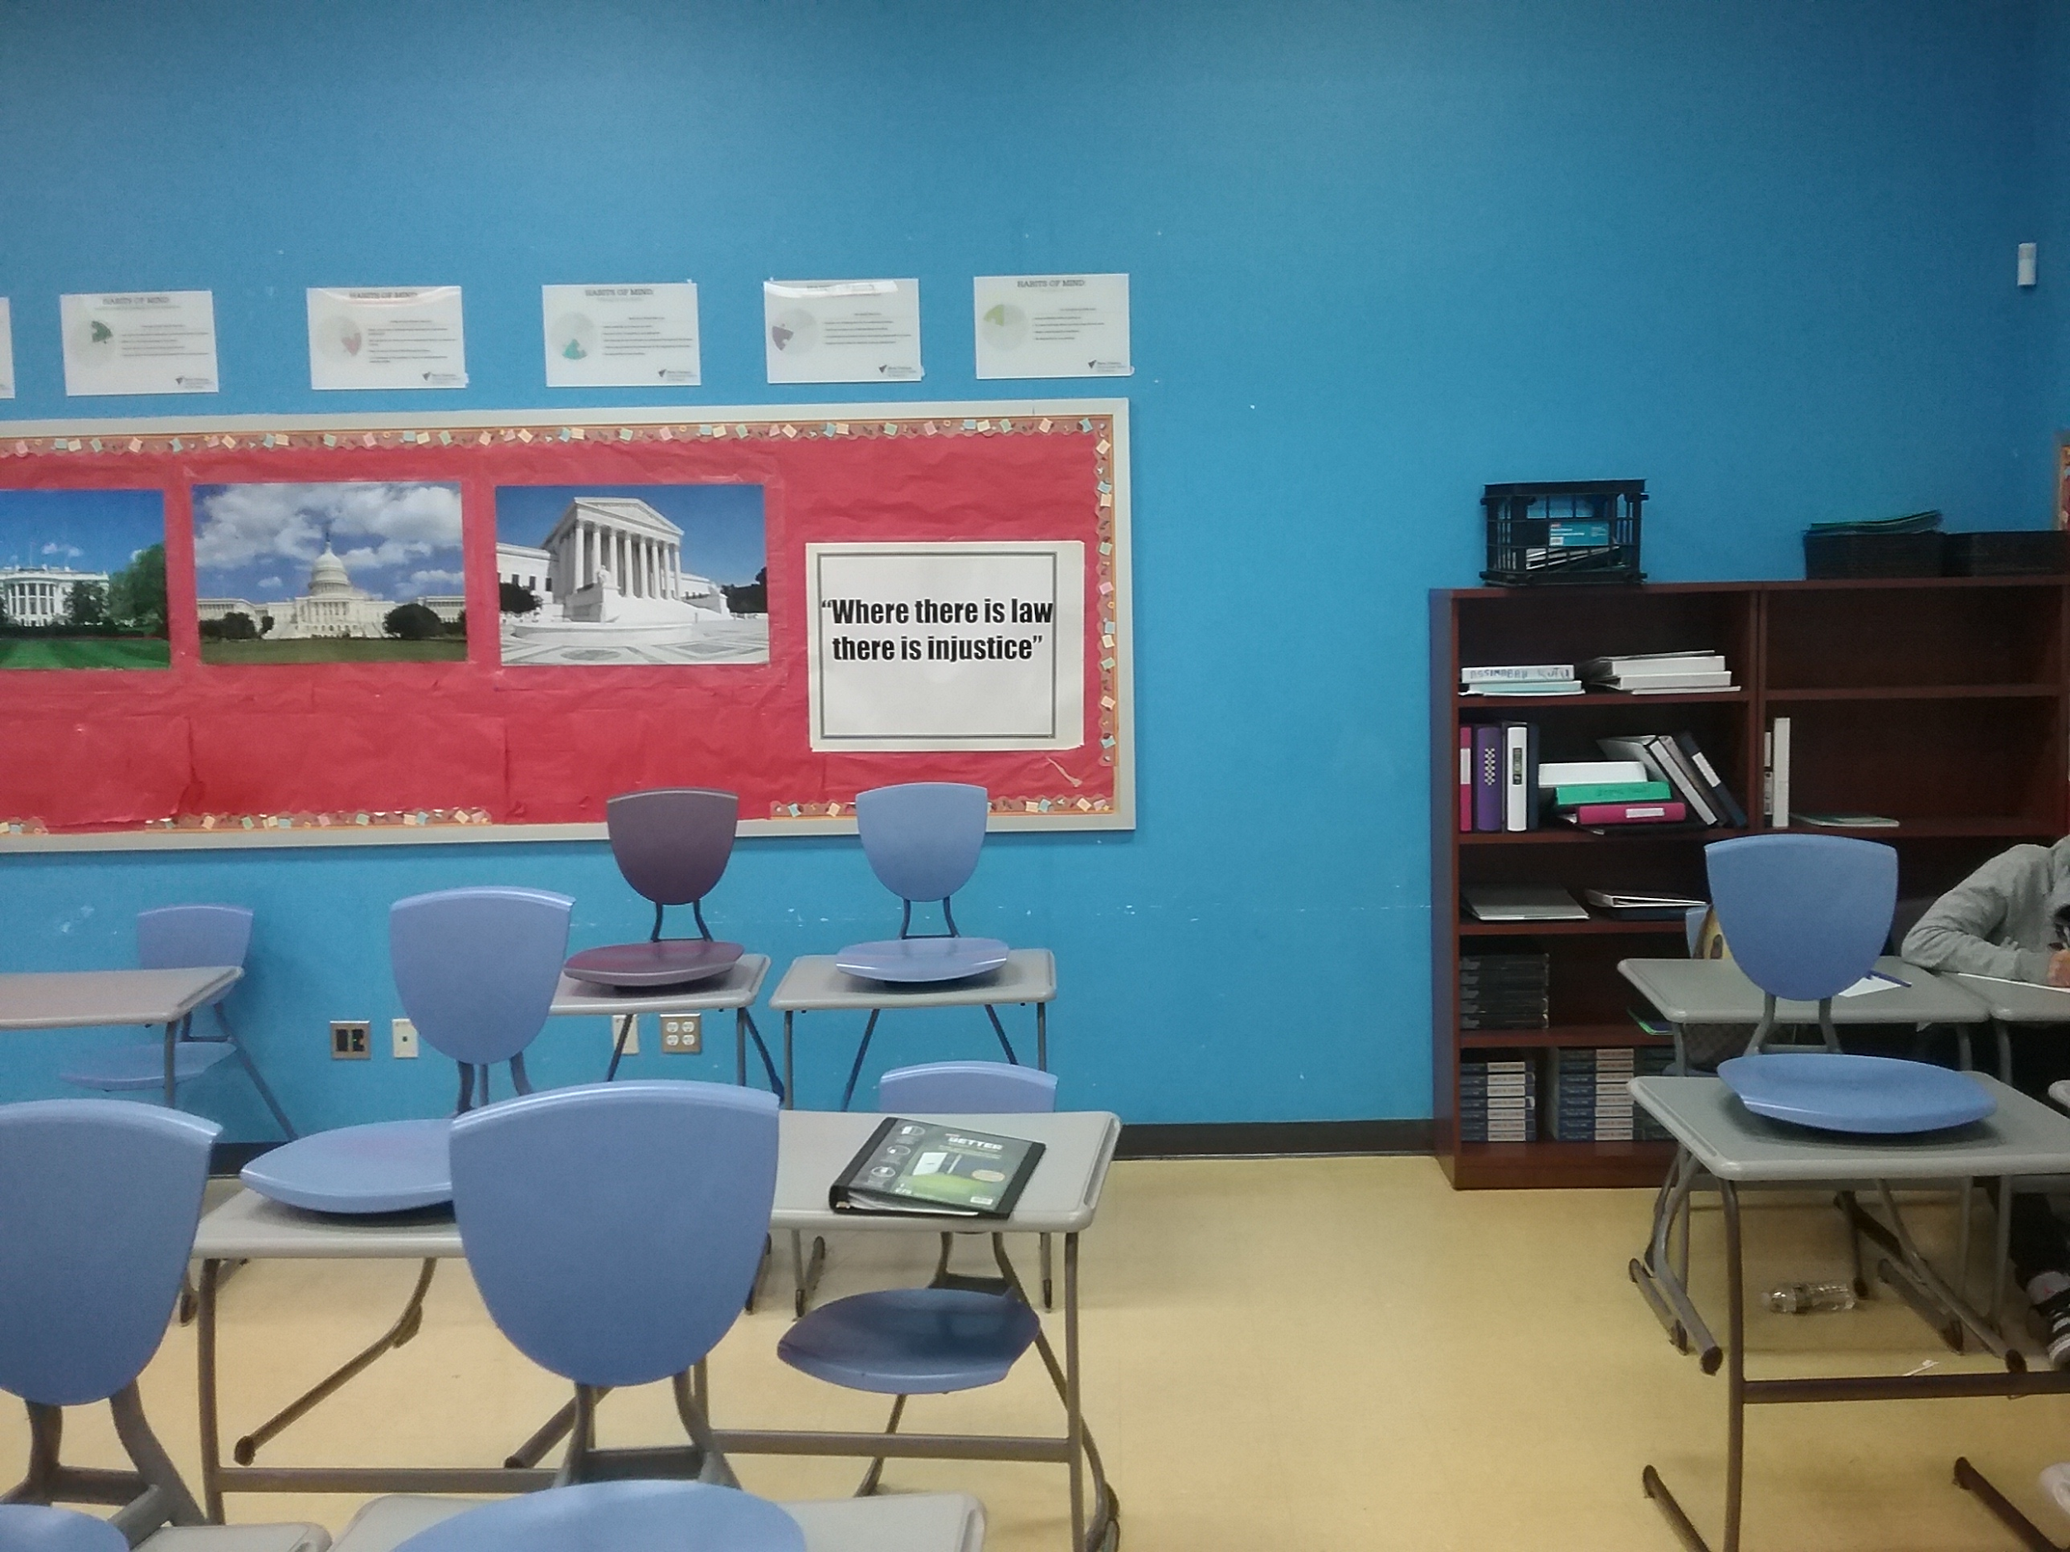

Part One of Two to Find The Key

Part One of Two to Find The Key

Part One of Two to Find The Key

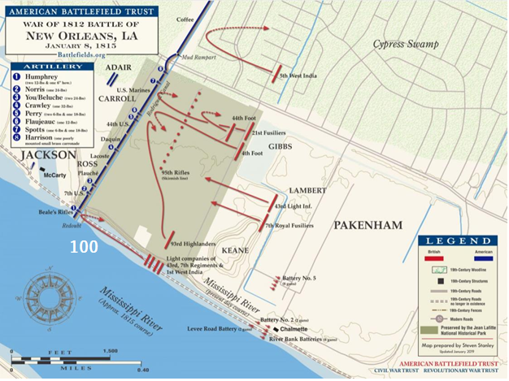

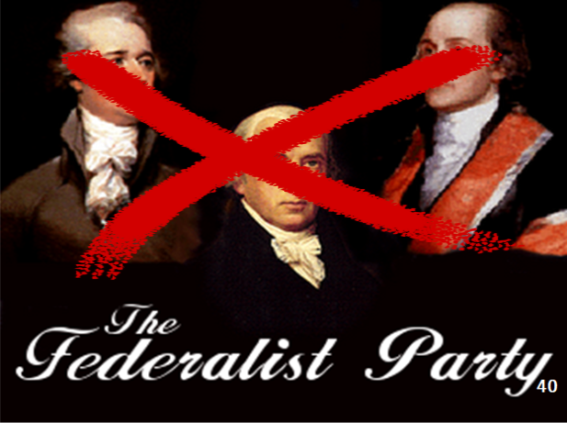
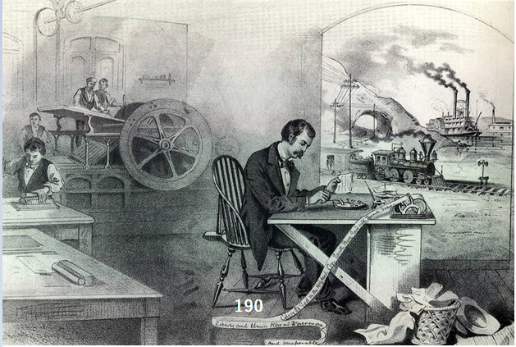
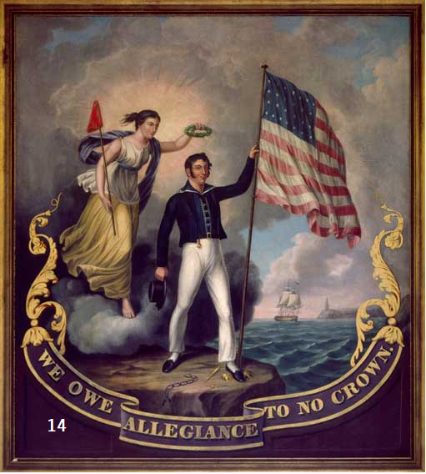

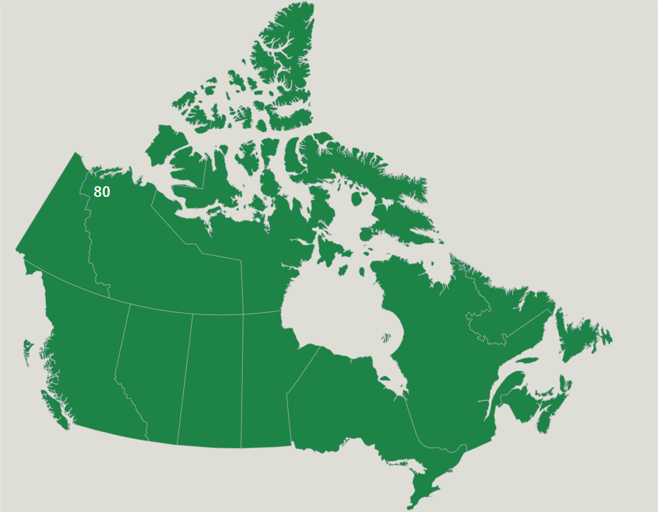

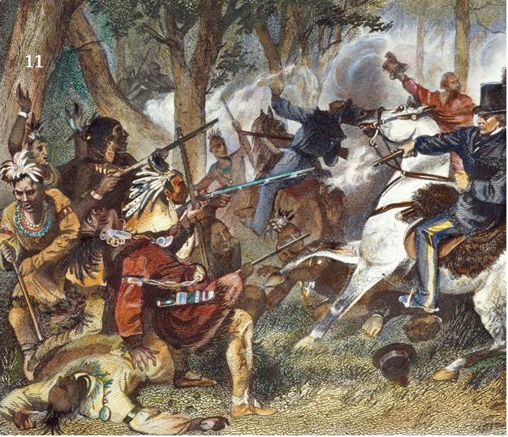

Have every member of your group answer these questions on separate pieces of loose paper, hand them in, then you win!

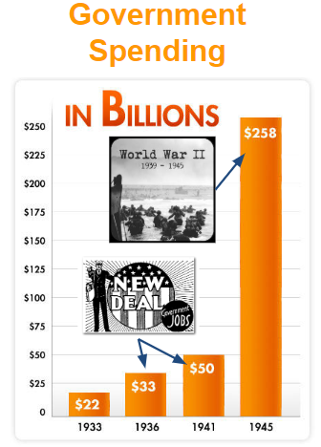
1. In your opinion, what was the most important New Deal Program? Why?

2. In your opinion, what was the least important New Deal Program? Why?

3. Look at the graph to the right. Many historians argue that the New Deal started to help end the Great Depression by using government money to provide jobs and opportunity, but it was really WWII that ended the Depression. How did WWII provide even more jobs?

Pink Lock:
Causes of the War of 1812
Find the answers to the questions on this sheet, then add up the numbers next to every answer to get the lock combination.

Question #1: One of the causes of the war of 1812 was a desire of some American Congressmen to try and gain this territory from Great Britain.
Answer | Number

Question #2: One of the causes of the war of 1812 was this British practice of kidnapping American sailors and forcing them to join the British Navy, called this.
Answer | Number

Question #3: One of the causes of the war of 1812 was the perception that the British were inciting this group of people to make war with the United States.
Answer | Number

Question #4: One of the causes of the war of 1812 was this British policy of stopping American trade with France [who was at war with Great Britain]
Answer | Number

Lock Combination

Silver Lock:
Stories During the War of 1812
Find the answers to the questions on this sheet, then add up the numbers next to every answer to get the lock combination.

Question #1: During the War of 1812, the British army burned this American city to the ground.
Answer | Number

Question #2: The defense of the city of Baltimore during the War of 1812 inspired the creation of this song
Answer | Number

Question #3: This was the name of the defensive fortification that defended Baltimore during the War of 1812
Answer | Number

Question #4: The defense of this city was the largest American victory during the war of 1812 [even though it happened after a peace treaty had been signed]
Answer | Number

Question #5: This officially ended the War of 1812.
Answer | Number

Lock Combination

Blue Lock:
Effects of The War of 1812 #1
Find the answers to the questions on this sheet, then add up the numbers next to every answer to get the lock combination.

Question #1: The British stopping of American trade caused the growth of this.
Answer | Number

Question #2: The desire of America to better defend itself during the War of 1812 and any future threats caused the growth of this.
Answer | Number

Question #3: The end of the war of 1812 ensured that this region would be a separate nation from the United States.
Answer | Number

Question #4: This group of people sided with the British during the war of 1812, and ended up receiving massive losses to their because of this.
Answer | Number

Question #5: This was the name of the Native American leader who united many tribes to fight together during the War of 1812.
Answer | Number

Lock Combination

Black Lock:
Effects of The War of 1812 #2
Find the answers to the questions on this sheet, then add up the numbers next to every answer to get the lock combination.

Question #1: Because this group was against the War of 1812, they were labeled as traitors and their group was eventually destroyed because of this.
Answer | Number

Question #2: Because of the war of 1812, this man became a national hero after winning a massive victory.
Answer | Number

Question #3: The largest American victory of the war of 1812 had about this many British casualties.
Answer | Number

Question #4: After the war of 1812, there was an increase in national pride among Americas, so much so that the time period the war was called this.
Answer | Number

Question #5:The war of 1812 led to a massive increase in American manufacturing, also known as this event.
Answer | Number

Lock Combination

Orange Lock: [Answers In Images And This Sheet]
Effects of The War of 1812 #4
1. Piece together the images that relate to the effects of the War of 1812
2. Find the three images that relate to the three effects listed below
3. Find the hidden number in each image and complete the math problem to get the combination

Effect | Hidden Number
Growth of the Army, Navy, and Manufacturing:
Canadian Sovereignty:
Native American Losses:
Combination

Purple Lock [Answer In Images And This Sheet]
Effects of The War of 1812 #3
1. Piece together the images that relate to the effects of the War of 1812
2. Find the three images that relate to the three effects listed below
3. Find the hidden number in each image and add them together to get the combination

Effect | Hidden Number
End of the Federalist Party:
Andrew Jackson:
The Era of Good Feelings:
Combination

Orange Lock Red Tag:
Causes of the War of 1812
Find the answers to the questions on this sheet, then add up the numbers next to every answer to get the lock combination.

Question #1: One of the causes of the war of 1812 was a desire of some American Congressmen to try and gain this territory from Great Britain.
Answer | Number

Question #2: One of the causes of the war of 1812 was this British practice of kidnapping American sailors and forcing them to join the British Navy, called this.
Answer | Number

Question #3: One of the causes of the war of 1812 was the perception that the British were inciting this group of people to make war with the United States.
Answer | Number

Question #4: One of the causes of the war of 1812 was this British policy of stopping American trade with France [who was at war with Great Britain]
Answer | Number

Lock Combination

Orange Lock Yellow Tag:
Stories During the War of 1812
Find the answers to the questions on this sheet, then add up the numbers next to every answer to get the lock combination.

Question #1: During the War of 1812, the British army burned this American city to the ground.
Answer | Number

Question #2: The defense of the city of Baltimore during the War of 1812 inspired the creation of this song
Answer | Number

Question #3: This was the name of the defensive fortification that defended Baltimore during the War of 1812
Answer | Number

Question #4: The defense of this city was the largest American victory during the war of 1812 [even though it happened after a peace treaty had been signed]
Answer | Number

Question #5: This officially ended the War of 1812.
Answer | Number

Lock Combination

Orange Lock Blue Tag:
Effects of The War of 1812 #1
Find the answers to the questions on this sheet, then add up the numbers next to every answer to get the lock combination.

Question #1: The British stopping of American trade caused the growth of this.
Answer | Number

Question #2: The desire of America to better defend itself during the War of 1812 and any future threats caused the growth of this.
Answer | Number

Question #3: The end of the war of 1812 ensured that this region would be a separate nation from the United States.
Answer | Number

Question #4: This group of people sided with the British during the war of 1812, and ended up receiving massive losses to their because of this.
Answer | Number

Question #5: This was the name of the Native American leader who united many tribes to fight together during the War of 1812.
Answer | Number

Lock Combination

Orange Lock Green Tag:
Effects of The War of 1812 #2
Find the answers to the questions on this sheet, then add up the numbers next to every answer to get the lock combination.

Question #1: Because this group was against the War of 1812, they were labeled as traitors and their group was eventually destroyed because of this.
Answer | Number

Question #2: Because of the war of 1812, this man became a national hero after winning a massive victory.
Answer | Number

Question #3: The largest American victory of the war of 1812 had about this many British casualties.
Answer | Number

Question #4: After the war of 1812, there was an increase in national pride among Americas, so much so that the time period the war was called this.
Answer | Number

Question #5:The war of 1812 led to a massive increase in American manufacturing, also known as this event.
Answer | Number

Lock Combination

Orange Lock NO TAG: [Answers In Images And This Sheet]
Effects of The War of 1812 #4
1. Piece together the images that relate to the effects of the War of 1812
2. Find the three images that relate to the three effects listed below
3. Find the hidden number in each image and complete the math problem to get the combination

Effect | Hidden Number
Growth of the Army, Navy, and Manufacturing:
Canadian Sovereignty:
Native American Losses:
Combination

Purple Lock [Answer In Images And This Sheet]
Effects of The War of 1812 #3
1. Piece together the images that relate to the effects of the War of 1812
2. Find the three images that relate to the three effects listed below
3. Find the hidden number in each image and add them together to get the combination

Effect | Hidden Number
End of the Federalist Party:
Andrew Jackson:
The Era of Good Feelings:
Combination

? Answer The Following Riddle ?
? Tell The Correct Answer To Mr. Menfi ?

What is at the beginning of eternity and the end of time and space?

? Answer The Following Riddle ?
? Tell The Correct Answer To Mr. Menfi ?

What is something that the richest people need, the poorest people have, and that if you eat will kill you?

? Answer The Following Riddle ?
? Tell The Correct Answer To Mr. Menfi ?

If you have me, you will want to share me. If you share me, you will no longer have me. What am I?

? Answer The Following Riddle ?
? Tell The Correct Answer To Mr. Menfi ?

What is broken the second you say its name?

ORANGE: 281
PURPLE: 154
BLUE OR Blue Tag: 863
SILVER OR Yellow Tag: 929
PINK OR Red Tag: 174
BLACK OR Green Tag: 208

KEY A: Bin With Folders
Key B: Black File Cabinet
KEY C: Teacher Desk
KEY D: Previous Week’s Work Bins

