Assessment Questions - Microeconomics 201
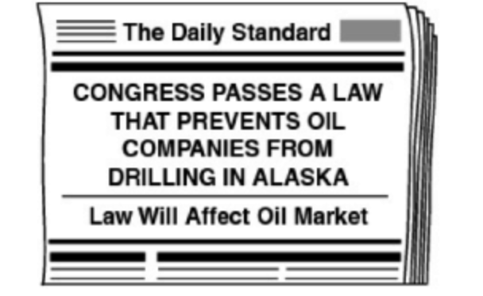
1. What is the most likely effect this news headline will have on the oil market?
a) price will decrease
b) price will increase
c) demand will increase
d) demand will decrease

2. What sort of relationship is there between demand and price of a good?
a) inflated
b) inverse
c) direct
d) disproportionate

3. Changes in the demand of a good result from which of the following?
a) changes in market size
b) changes in technology
c) change in the price of the good
d) price changes of resources

4. If the demand for a product stays the same, and the supply decreases, then what would be the result?
a) The new equilibrium price would be higher.
b) The new equilibrium price would be lower.
c) The equilibrium price would be the same.
d) There would be no equilibrium price.

5. Which of the following is NOT a supply shifter (determinant)?
a) technology
b) government tools (taxes/subsides)
c) market size/population
d) number of sellers/competition

