Effects of the War of 1812:

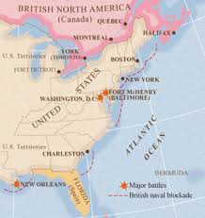
End of the Federalist Party:
Many of the members of the Federalist Party made most of their money through trade both with Britain and other foreign nations. However, the British placed their navy by the American coast to prevent any trade from
occurring between America and other nations during the war, effectively reducing all American trade to zero. Because of this, the Federalist Party generally opposed the war, and their political opponents used their opposition to the war to label them as traitors and turn public opinion against them. With the end of the war claimed as an American victory, the Federalist party lost the trust of the people and collapsed.

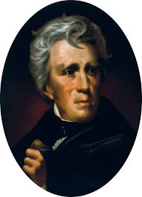

Andrew Jackson:
At the battle of New Orleans, Andrew Jackson led a ragtag group of 5,700 soldiers against an invading British force with 8,000 well trained soldiers. Rather than retreat, Jackson dug his troops into well defended trenches and waited for the British forces to attack. Despite all odds, Andrew Jackson was able to lead his troops to victory, inflicting over 2,400 casualties on the British while losing less than 100 of his men. Andrew Jackson was labeled as a national hero, and he used his newfound fame to run for and win the presidency.

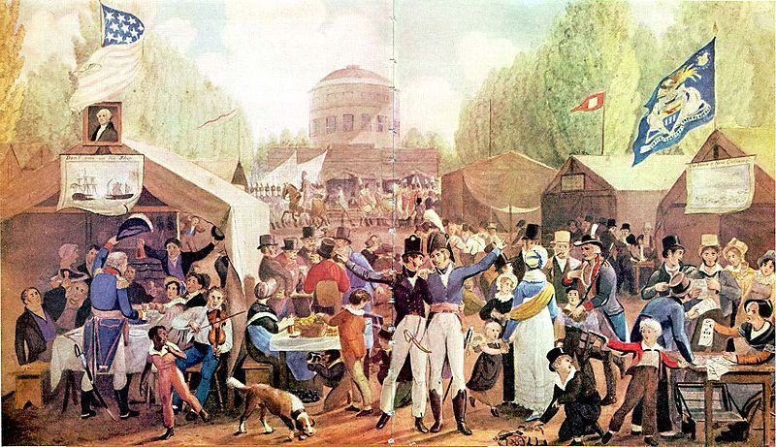
The Era of Good Feelings: Secret Code: 58892
The War of 1812 was the first war that America fought as a newly founded country, and the idea of Americans coming together to fight off a common enemy had not been tested until this point in history. Even though the war ended with a result that was basically a draw, Americans claimed the conflict as a victory in which they fought off an invasion from a great European power. This perceived victory led to an increased sense of Nationalism and Patriotism among a majority of Americans and the time after the war became known as the “Era of Good Feelings.” Secret Code: 58892

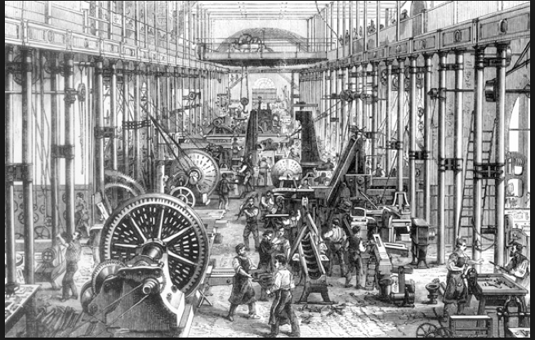
Growth of the Army, Navy, and Manufacturing:
Because the British blockade prevented Americans from trading with foreign nations, the American manufacturing industry was forced to grow at a faster rate than before. This eventually made America one of the largest manufacturers in the world and paved the way for what became known as the Market Revolution. Furthermore, during and after the war, America began to focus on growing its military in order to be able to stand up to any other foreign threats similar to those faced in the War of 1812.

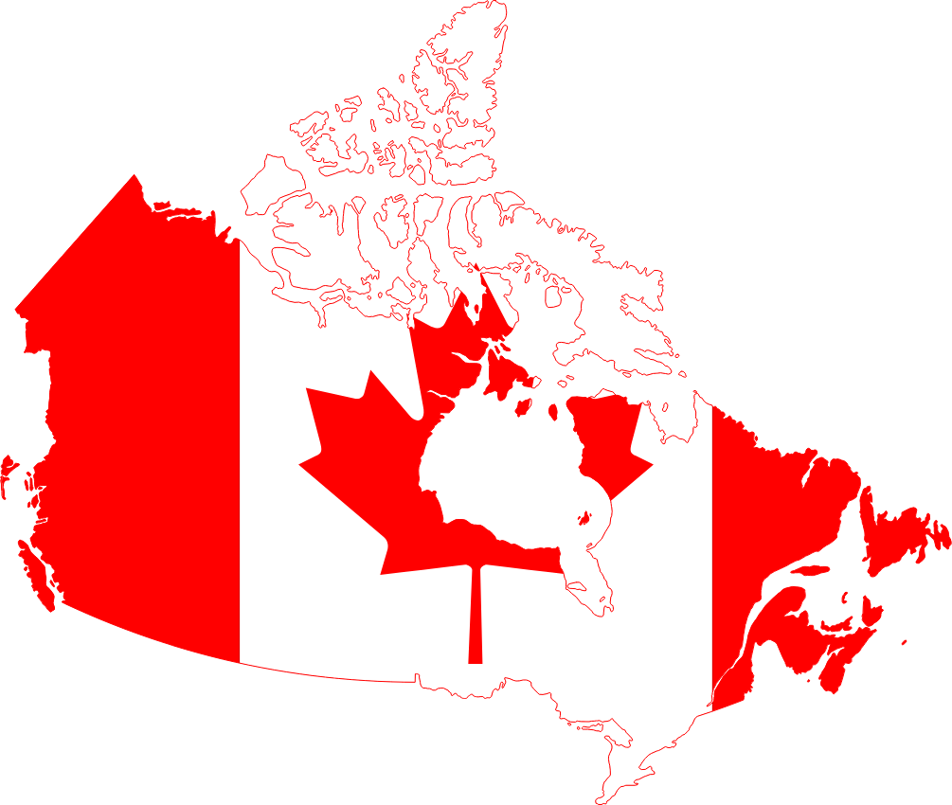
Canadian Sovereignty:
One of the principal causes of the war of 1812 was the desire of American “Warhawks” to conquer the British territory of Canada and add it to the United States. Most of the fighting during the war actually took place in Canada. Many Americans thought that an invasion of Canada would be a simple affair, but much to their surprise Canadian soldiers allied with British regiments fought hard to defend their home. The American invasion of Canada ended in a miserable failure, and with it so did the desire of many Americans to ever try conquering the land again. In other words, the War of 1812 solidified Canada as a region independent and separate from the United States.

Native American Losses:
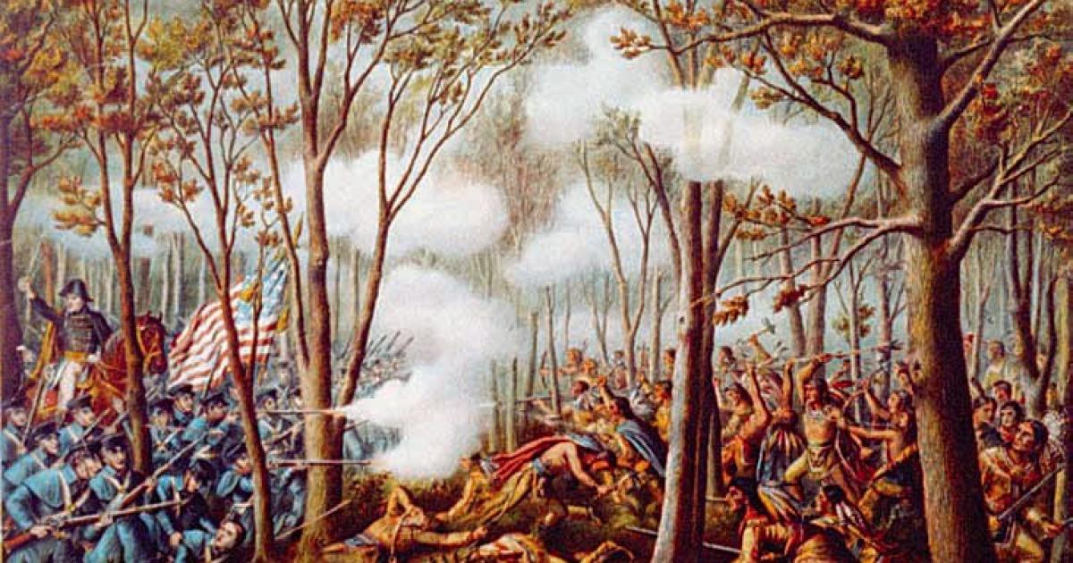
During the War of 1812, a majority of Native American tribes sided with the British against the Americans, seeing the United States as the biggest threat to Native land and society. Many of these tribes were led in a successful Confederation by the Native American leader Tecumseh. Despite successes, many of these tribes still suffered great casualties fighting against the Americans. With the end of the war basically a draw, America used Native resistance as a justification to encroach even further upon their land.

