Lemonade in Winter
A Book About Two Kids Counting Money
Written by Emily Jenkins

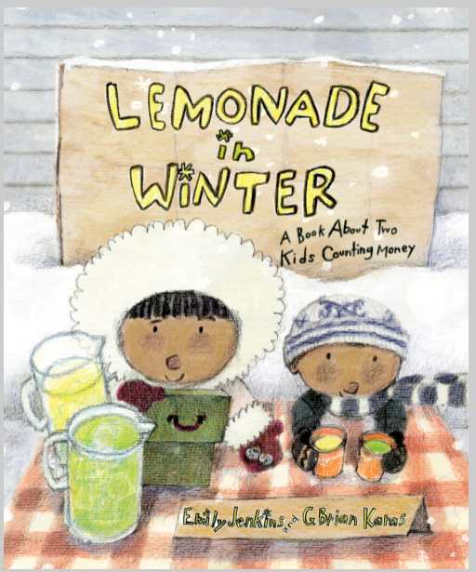

Book Synopsis: Determined Pauline and little brother John-John decide to sell lemonade on a blustery winter day. The two siblings count money, buy the needed resources at the corner grocery store, make their product, and set up a lemonade stand. As their mother predicted, they have few customers and during the slow spells they create advertisements, make decorations, create a jingle, and lower prices. At the end of the day they calculate their earnings and discover that they have lost money. They return to the store and purchase popsicles to help them overcome their disappointment and celebrate a fun-filled day.

Lesson
Pauline Makes a Decision

Introduction: It is a very cold day when Pauline comes up with the “cool” idea to set up a lemonade stand and make some money. She and her brother do a lot of work and have a grand time, but in the end, they do not make a profit. Maybe if she had given her idea some thought she would have decided to spend her time and money differently. If she had considered her costs and benefits of opening a lemonade stand, the day may have had another outcome.

Time: 20-25 minutes

Grade Level: K-3

Materials:
- Visual- Lemonade in Winter Economic Concepts
- Visual- Decision-Making Tree
- Activity Sheet- Decision-Making Tree
- Writing Tools

Students will

- Review the definitions for the economic concepts: benefit, cost, consumer, producer, goods, services, choice, and opportunity cost.
- Use a decision-making model to reach a decision by weighing the costs and benefits of their options.
- Develop skills using the decision-making model in order to improve students’ ability to make reasoned decisions.

Virginia Standards of Learning – History and Social Science

K-3.1h | The student will demonstrate skills for historical thinking, geographical analysis,  economic decision making, and responsible citizenship by using a decision-making model to  make informed decisions.
K.9 | The student will  a) recognize that people make choices because they cannot have everything they want; and  b) explain that people work to earn money to buy the things they want.
1.7 | The student will explain the difference between goods and services and describe how people are consumers and producers of goods and services.
1.8 | The student will explain that people make choices because they cannot have everything they want.
2.8 | The student will describe natural resources (water, soil, wood, and coal), human resources (people at work), and capital resources (machines, tools, and buildings).
2.10 | The student will explain that scarcity (limited resources) requires people to make choices about producing and consuming goods and services.
3.10 | The student will identify examples of making an economic choice and will explain the idea of opportunity cost (what is given up when making a choice).

Procedure:
- Prepare and collect materials prior to class.
- Introduce the lesson asking the students if they know what a lemonade stand is. Explain that the story they are about to hear is about a different kind of lemonade stand because the cold drinks are being offered for sale during a blustery winter day.
- Read the book Lemonade in Winter to the class. This takes around six minutes. YouTube link: https://www.youtube.com/watch?v=5ODTiLvF-Zc
- Review the listed economic concepts on Visual 1 relating it to connections in the story.
- Explain that all decisions have costs and benefits and that Pauline and John-John experienced some positive and some negative things when they became producers and worked hard to sell lemonade to consumers. Did they make the right choice? If they had created a cost-benefit decision grid before spending their money on the ingredients to make lemonade, would they still have set up a lemonade stand?
- Display Visual 2. Solicit suggestions from the students concerning the costs and benefits of making and selling lemonade and record them on the Cost-Benefit Decision Grid visual. Accept all reasonable suggestions.
Possible Student Suggestions:

Benefits of selling lemonade | Costs of selling lemonade
☺ It would be healty to get outside in the chrisp fresh air  ☺ You could make money selling lemonade  ☺ You might see friends and meet new people  ☺ Decorating the lemonade stand and creating a jingle would be creative activities | ☹You might get very cold while standing outside  ☹Ingredients cost money and you might not sell any lemonade  ☹There may be no customers  ☹You might miss a favorite TV program while outside

- Ask the students to use the information they have suggested on the Cost-Benefit Decision Grid to help them decide if they would try to sell lemonade in the winter. Take a class vote and record the most popular choice in the Decision box.
- Distribute the activity sheet and writing tools. Instruct students to complete a Cost-Benefit Decision Grid based on another situation from the story. (Students may work in pairs or small groups.) Decision Examples: Should they charge 50¢ for a cup of lemonade? Should they spend the earned money for popsicles?
- Allow students to share their completed Cost-Benefit Decision Grids including their final decision with the class.
- Conclude the lesson by reminding the students that all choices have costs and benefits. Often, we will make better decisions if we stop and think about our costs and benefits before we choose what to do.

Extension Activities:
- A page titled “Pauline Explains Money to John-John” can be found at the back of Lemonade in Winter. Using a document camera, share this information with the students. Then distribute preassembled zip-lock bags containing various combinations of coins. (real or duplicated on paper) Instruct each student to count the money in their bag and record their total on an index card. They are then to exchange their bag with a classmate, count the coins in the new bag, and compare the totals.

- Ask the students to list the natural, human, and capital resources needed to make lemonade. Or use the attached picture on page 8 to ask these questions to reinforce the following economic concepts:
Who is the producer? The boy holding the pitcher is the producer.
Who is the consumer? The children drinking lemonade are the consumers.
Where is the market? The lemonade stand is a market because a market is any place comsumers and producers interact.
What is traded? The children gave money to get lemonade.
Is lemonade a good or a service? Lemonade is a good.
What resources are used to produce lemonade?
Natural resources - lemons, water, and ice
Human resources – the person making the lemonade.
Capital resources - the stand, the pitcher, the glasses, and the spoon.

- For discussion: What might have been different if Pauline and John-John had decided to sell hot chocolate instead of lemonade and limeade?

Visual 1
Lemonade in Winter
Economic Concepts

Benefit- A benefit is what satisfies your wants.
A benefit is the positive effect of a decision. ☺

Cost- A cost is what you give up when you decide to do something. A cost is the negative effect of a decision.

Consumer- A person who uses or buys goods and services is a consumer.

Producer - A person who makes goods or provides services is a producer.

Goods - Things people make or use to satisfy wants are goods.

Services - Activities that satisfy people’s wants are services.

Choice (or Economic Choice) - You cannot have all the goods and services you want, so you must choose some things and give up others. A choice is the decision you make among alternatives or possibilities.

Opportunity Cost - The next best choice that is given up when you make a decision is your opportunity cost.

Visual 2
Pauline Makes a Decision
Cost-Benefit Decision Grid

Problem: Should Pauline and John-John make and sell
lemonade on a cold winter day?

☺  Benefits of selling lemonade  A benefit is what satifies your wants | ☹   Costs of selling lemonade  A cost is what you give up when you decide to do something
☺  ☺  ☺  ☺ | ☹  ☹  ☹  ☹

Decision:

Activity Sheet-

Cost-Benefit Decision Grid

Problem:

☺  Benefits ______________________  A benefit is what satifies your wants | ☹   Costs ________________________  A cost is what you give up when you decide to do something
☺  ☺  ☺  ☺ | ☹  ☹  ☹  ☹

Decision:

