Sloth & Squirrel in a Pickle
Author Cathy Ballou Mealey, Illustrator Kelly Collier
Kids Can Press/2021
Specialization
INTRODUCTION: When we specialize, we focus on one thing and get really good at it. People tend to specialize in those things they like doing, find interesting, or have an aptitude for. It is to be noted that specialization also takes place during the production of goods and services. Work on a production line is divided and workers perform different jobs. This makes it possible to get more work done and allows people to specialize in the part of the job they do best.

STORY SYNOPSIS: A pair of unlikely friends, decide they would like a new tandem bike and begin their pursuit to earn money to purchase one. Mr. Peacock, the manager of a pickle-packing company, hires them and it does not go well. Squirrel’s plan to specialize, with him packing the jars and Sloth attaching the labels, backfires. When Mr. Peacock discovers six hundred and seventy-seven pickle jars with upside down labels, he fires them. Stating he cannot pay them for their work, he gives them the unsellable pickles. The entrepreneurial friends turn their mistake into a unique business, make a profit, and surpass their goal.

TIME ALLOCATION: 20-25 minutes [Allocate extra time for extension and enrichment activities.]

MATERIALS:
- Book- Sloth & Squirrel in a Pickle by Cathy Ballou Mealey
- Document camera
- Visual – Specialization: Putting the Pieces Together
- Sets of Puzzle Strips – Run off on cardstock and cut into pieces (for ease of organization use a different color for each set)
- Envelopes or paperclips for puzzle strip sets management
- Assessment-Create Your Own Puzzle
- Markers, crayons, or colored pencils
- Scissors
- Optional: Extension Activity & writing tools

OBJECTIVES:
- The student will listen to a story and determine the advantages of setting goals, being creative, and making money.
- The student will define and understand the meaning of specialization.
- The student will participate in a hands-on activity that reinforces the featured concepts of specialists/entrepreneurs, workers, capital resources, and products.

ECONOMIC CONCEPTS:
- Natural Resources – gifts from nature, such as land, water and trees.
- Entrepreneur – a person who organizes, operates, and assumes the risk for a business hoping to make a profit.
- Human Resources- human effort directed toward producing goods and services (labor).
- Capital Resources – goods produced and used to make other goods and service (tools).
- Specialization – focusing on the production of selected goods and services.
- Specialist - an expert who is devoted to one occupation or branch of learning.
- Product - something manufactured or refined for sale.

NATIONAL CONTENT STANDARDS IN ECONOMICS
STANDARD 1: SCARCITY
Productive resources are limited. Therefore, people cannot have all the goods and services they want; as a result, they must choose some things and give up others.
STANDARD 2: DECISION MAKING
Effective decision making requires comparing the additional costs of alternatives with the additional benefits. Many choices involve doing a little more or a little less of something: few choices are “all or nothing” decisions.
STANDARD 4: INCENTIVES
Voluntary exchange occurs only when all participating parties expect to gain. This is true for trade among individuals or organizations within a nation, and among individuals or organizations in different nations.
STANDARD 6: SPECIALIZATION
When individuals, regions, and nations specialize in what they can p

VIRGINA STANDARD OF LEARNING- HISTORY AND SOCIAL SCIENCE
K.8 The student will match simple descriptions of work that people do with the names of those jobs.
2.8 The student will describe natural resources (water, soil, wood, and coal), human resources (people at work), and capital resources (machines, tools, and buildings).
3.9 The student will recognize that because people and regions cannot produce everything they want, they specialize in what they do best and trade for the rest.

PROCEDURE:
- Collect and prepare the materials prior the class. Make the appropriate amount of puzzle strip sets.

- Introduce the lesson by telling the students that they will be listening to a story that is about two friends setting out to accomplish a goal. Explain that one friend is a doer and the other friend a thinker and you will be asking them to identify which one is which at the end of the story.

- Read the book to the students. Ask them who was the “doer” [speedy Squirrel] and who was the “thinker” [slow Sloth]. Discuss why it’s possible for friends to be different than each other. Note: A YouTube read-aloud of the book may be found here: https://www.youtube.com/watch?v=lpwVwa8GaxI

- Display the visual, Putting the Pieces Together Puzzle Strip to the students. Read them the information. Review the following economic concepts if necessary. Natural Resources: gifts from nature, such as land, water and trees, Entrepreneur: a person who organizes, operates, and assumes the risk for a business hoping to make a profit. Human Resources: human effort directed toward producing goods and services (labor).
Capital Resources: goods produced and used to make other goods and service (tools).
Specialization: focusing on the production of selected goods and services. Specialist: an expert who is devoted to one occupation or branch of learning. Product: something manufactured or refined for sale.

- Explain to the students that they will be assembling their own puzzle strips. Students may work in pairs or small groups.

- Distribute the prepared puzzle strip sets. Inform students to wait until the sets have been distributed and you say “GO!”

- Say “GO!” and allow the puzzle strips to be completed, between 3-5 minutes. The correct assembly of the puzzle strips is self-checking.

- Ask the students who finished first if they were able to specialize to complete the task quickly. Was anyone a puzzle specialist?

- Instruct the students to mix the puzzle pieces up and return them to the envelope or secure them with a paperclip.

ASSESSMENT: This assessment, Create Your Own Puzzle, checks for student understanding of the featured concepts as it challenges them to create their own puzzle strip. Once completed, these may be redistributed to other classmates who can check to see if they agree with the puzzle strip’s content. This process reinforces the concepts and checks for student understanding.

ENRICHMENT & EXTENSION:
- Art – Create a class collage using photos, drawings, words, and clippings from old magazines that depicts different kinds of jobs.
- Creative Problem Solving- Challenge the students to create a class ABC Book that contains a job for every letter in the alphabet.
- Extension Activity Sheet – The Job Poems activity sheet may be run off for individual students, used in a learning center, or displayed and conducted as a teacher directed lesson. Answers: 1. Farmer, 2. Plant Manager, 3. Salesperson, 4. Artist, 5. Assembly Line Workers, 6. Author
- Poetry- Write an acrostic poem focusing on one of the economic concepts featured in the book. The poem should include words or phrases that describe the concept. Concepts include: advertise, choice, consumer, earn, entrepreneur, goods, job, money, producer, product, profit, saving, services, spending, wants.

EXAMPLE: SPECIALIZATION
A Situation in which
People
producE
Certain
servIces
And goods
Letting productivity
Increase.
SpecialiZation
Allows
Trade and
Interdependence to
Occur
Nicely.

Visual
Specialization
Putting the Pieces Together Puzzle Strip

Below is an example of a puzzle strip that shows the workers and resources needed to create a finished product.

The four parts of the puzzle show:
- The specialist or entrepreneur who takes the risk for making the product
- The workers, human resources, who create it
- The tools, capital resources, the workers use
- The finished product

1. 2. 3. 4. 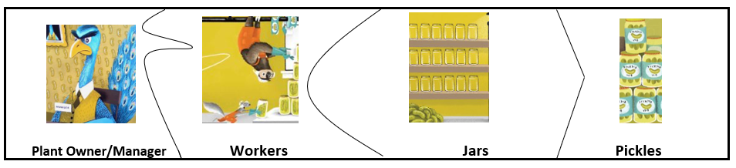

Extension Activity
Job Poems
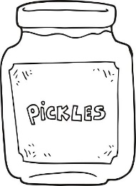
Directions: Sloth and Squirrel wanted to get a job to buy a new bicycle. A job is the work that a person does regularly in order to earn money. Use the jobs listed in the word box to complete the rhymes.

- It’s our job is to grow vegetables, including cucumbers.
We plant, water, weed and harvest. We are hard-working ______.

- Leadership and problem-solving are needed in my career.
I am in charge of the factory. I am a ______________.

- Come to the shop to buy a bike for transportation or fun.
My job is to help you find what you want. I am a __________.

- I create advertisements that people cannot resist.
I’m good with illustrations and lettering. I am a ____________.

- We work in a factory, making products for others.
Working fast is important. We are ________________.

- Writing stories and poems is what I adore.
Words are fun and wonderful! I’m a children’s book __________.

Word Box
Artist Assembly line workers Author
Salesperson Farmers Plant Manager

Activity
Puzzle Strips
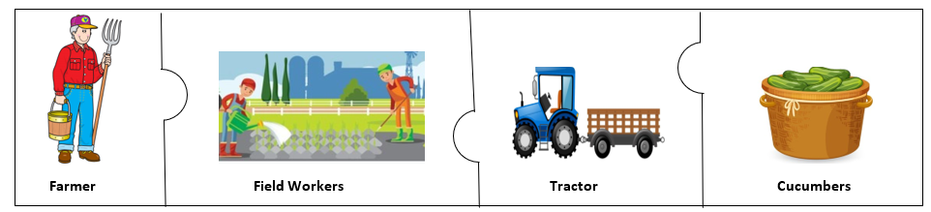

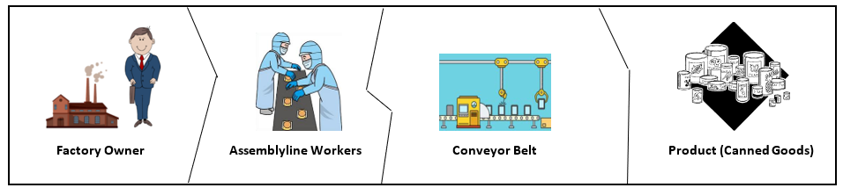

Assessment
Create Your Own Puzzle

Using examples from the book, Someone Builds the Dream, draw and label a puzzle that shows:
- The specialist or entrepreneur who takes the risk for making the product
- The workers, human resources, who create it
- The tools, capital resources, the workers use
- The finished product

Examples include:
- Ice Cream Truck Owner, Ice Cream Truck Operator, Freezers, Popsicles
- Bicycle Repair Shop Owner, Repairman, Screwdrivers & Pliers, Fixed Bicycle
- Pickle Pop Entrepreneurs, Pickle Pop Sellers, Jars, Pickle Pops

Sloth & Squirrel in a Pickle
Discussion Questions:
- Why did Sloth and Squirrel want to earn money? [Squirrel wanted to buy a new bike. This would be a special bike make for two riders that went fast.]

- What did the two friends discover when they went to the Spokes Bike Shop? [They discovered the type of bike they wanted would cost them a lot of money, which they did not have.]

- Squirrel had a great idea about how to get money for the bike. What was this idea? [He suggested that the two friends get jobs as pickle packers.]

- Before they were hired what were they required to do? [They had to be interviewed by Mr. Peacock, the pickle plant manager.]

- Once they were hired, Mr. Peacock gave them gloves, overalls, hairnets and safety goggles to wear. Why do you think these items were required? [Possible answers: These items will keep the pickles clean. The workers had to wear a certain uniform. The gloves and goggles were for the safety of the workers. The hairnets keep hair from getting in the pickle jars.]

- How do we know that Sloth and Squirrel had little training for their new job? [They made messes and broke jars.]

- Squirrel told Mr. Peacock that the reason they had only packed six jars of pickles is because they needed practice. Do you think this is true? [Answers will vary. However, students may suggest that it is good to be trained for a task. This is an example of investing in human capital.]

- Squirrel came up with a plan. He said that the two workers could specialize; do one task really well. What did they decide to do? [Squirrel packed the pickles and added the lids, Sloth attached the labels.]

- Why couldn’t Mr. Peacock sell the six hundred seventy-seven and one-half jars that Sloth and Squirrel were able to pack? [The labels were all upside down.]
- Sloth and Squirrel lost their job, but they did end up with a lot of free pickles. What did they do with these pickles? [They got creative and invented pickle pops.]

- Sloth and Squirrel took a risk, set up a pickle pop stand, and became successful entrepreneurs. What do you think an entrepreneur is? [An entrepreneur is someone who starts their own business.]

- Sloth and Squirrel made the pickle pops. They were the producers. Who were the consumers of the pickle pops? [Other animals bought the pickle pops which they liked because they came in many flavors and did not melt.]

- The two friends made money selling pickle pops. This is called a profit. What did they do with their profit? [They bought the bike they wanted. However, it did not go fast enough so they bought a motorcycle.]

- The moral of a story is the lesson that the characters learn. What would be a good moral for Sloth & Squirrel in a Pickle? [Possible responses: It is best to be trained for a task. A successful entrepreneur uses good problem- solving skills. You have to work for what you get. Good friends support you in many ways.]

