A Turkey for Thanksgiving
Opportunity Cost
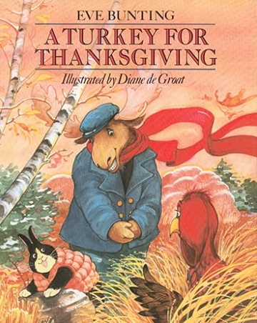

INTRODUCTION: In this lesson students will learn about making a choice and what you must give up in the process.

TIME REQUIRED: 25-30 minutes.

OBJECTIVE:
- The student will be introduced to the concept of opportunity cost: “In a choice, the benefit expected form the highest valued alternative forgone; or what you give up when you make a choice.”

MATERIALS:
- Book: A Turkey for Thanksgiving by Eve Bunting [Houghton Mifflin, 1991]
- Prepared color sheets (duplicated front-to-back)
- Crayons or colored pencils
- Scissors

ECONOMIC CONCEPTS:
Because we cannot have everything we want (scarcity), we must make choices. Each time we make a choice, we give something up. There is always a next best alternative when making any choice. The value of this next best alternative (or second favorite choice) is the opportunity cost.

PROCEDURE:
- Prepare the materials prior to class. Run off the Thanksgiving animal color sheets, front to back, in different combination.
- Introduce the lesson by reading A Turkey for Thanksgiving by Eve Bunting. A reading aloud can be found here: https://www.youtube.com/watch?v=tEmHlir9uaU
- Discuss the various decisions Mr. Moose had to make to find a turkey to be a guest at his wife’s Thanksgiving dinner. [He had to leave the house, walk through the woods, encounter other animals, and convince the turkey to return with him.]
- Distribute the activity sheet and coloring tools. Tell the students that these are images of types of animals that were invited to the Mooses’ Thanksgiving dinner.
- Instruct the students to color both sides to the best of their ability. When the students are finished, give them a pair of scissors and inform them they must cut out ONE of their colored of their colored animals for display. Explain that the other side will be destroyed, so the chance to display that side will be their opportunity cost. (Be prepared for complaints from students. Some will have a difficult time deciding which animal to keep.)
- If possible, display student work on a bulletin board titled “A Turkey for Thanksgiving Guest List”. Students may want to decorate the bulletin board with cut out pumpkins, ears of corn, autumn leaves, etc.

