Turkey Trouble Activity Sheets
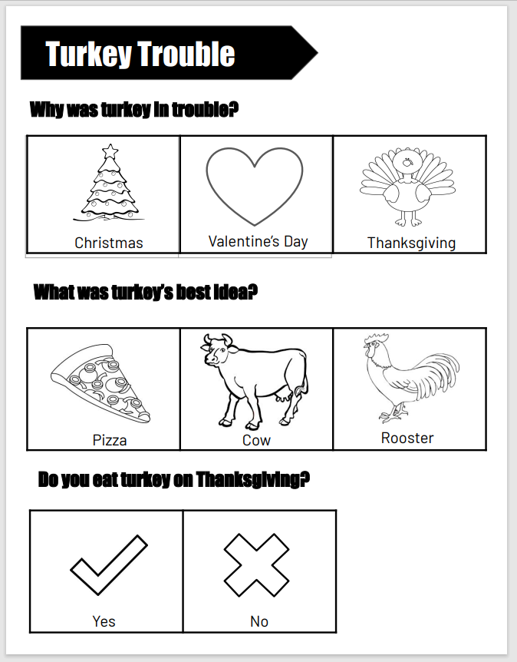

Activity Sheet can be used as:
- Assessment
- Color sheet
- Class discussion questions
- Bar graph data
