Book Series Featuring Economics and Personal Finance

[First Book in the Series]
Title/Author | Synopsis | Economic/Personal Finance Concepts | Notes
Cleo Edison Oliver: Playground Millionaire  by Sundee Frazier  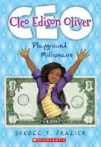 | Fifth-grader Cleo Edison Oliver is full of money-making ideas. Things get complicated when she has to keep her business running, be a good listener when her best friend needs her, and deal with the bully teasing her about being adopted at the same time. | Entrepreneurship, Money, Specialization, Scarcity, Saving, Opportunity Cost | Publisher: Scholastic  Copyright Date: 2016  Reading Level: 4.1  Interest Level: 3-6
Save It!  by Cinders McLeod  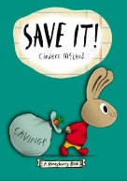 | With advice from her father, Honey saves her allowance to buy a playhouse in which she can get privacy from her five loud, bouncy siblings. | Earning, Saving, Decision-Making | Publisher: Penguin  Copyright Date: 2019  Reading Level: 1.5  Interest Level: PK-2
Front Desk  by Kelly Yang | Recent immigrants from China and desperate for work and money, ten-year-old Mia Tang's parents take a job managing a rundown motel in Southern California, while her mother (who was an engineer in China) does the cleaning, Mia works the front. | Entrepreneurship, Jobs, Income, Money, Pay-Day Lending, | Publisher: Scholastic  Copyright Date: 2019  Reading Level: 4.5  Interest Level: 4-7
J. D. and the Great Barber Battle  by J Dillard  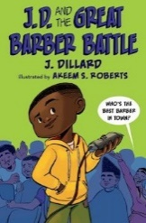 | J.D. turns a tragic home haircut into a thriving barber business in this hilarious new illustrated chapter book series that will appeal to early and reluctant readers alike. | Entrepreneurship, Jobs, Money, Specialization, Scarcity, Opportunity Cost | Publisher: Penguin  Copyright Date: 2021  Reading Level: 4.8  Interest Level: 2-6
The Lemonade War  By Jacqueline Davies | Evan and his younger sister, Jesse, react very differently to the news that they will be in the same class for fourth grade and as the end of summer approaches, they battle it out through lemonade stands, each trying to be the first to earn 100 dollars. | Entrepreneurship, Jobs, Money, Specialization, Scarcity, Opportunity Cost | Publisher: Houghton Mifflin  Copyright Date: 2007  Reading Level: 4.1  Interest Level: 3-6
Wednesday Wilson Gets Down to Business  by Bree Galbraith  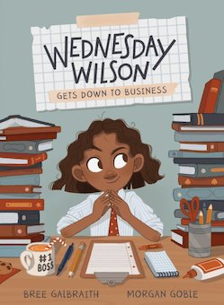 | Wednesday Wilson knows that she's an entrepreneur. She hasn't started any businesses yet, but she's pretty sure today is the day. Adventures ensue. | Entrepreneurship, Jobs, Income, Money, Ethics, Property Rights | Publisher: Kids Can Press  Copyright Date: 2021  Reading Level: 3.5  Interest Level: 3-6

