I’ve Got the Christmas Spirit
Connie Schofield-Morrison
[Bloomsbury, 2018]
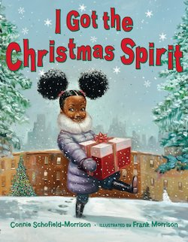
Story Synopsis: As young girl and her mother enjoy the sights and sounds of the holiday season, she spreads the spirit of giving. When she reaches Santa, she tells him her Christmas wish--for peace and love everywhere, all the days of the year.

LESSON
Philanthropy: Goods & Services
INTRODUCTION: The young girl in this story is joyous. She is also a saver, spender, and giver. The book’s wonderful illustrations reveal her encounter with a family in need and the eventual resolution of a group of people coming together to make things better.

GRADE LEVEL: K-2

TIME REQUIRED: 25-30 minutes.

OBJECTIVES:
- The student will determine what is a good and what is a service.
- The student will be introduced to the term philanthropy.

MATERIALS:
- Book I’ve Got the Christmas Spirit by Connie Schofield-Morrison
- Visual – Lend a Helping Hand
- Activity Sheet -Christmas Spirit Goods and Services
- Paper and writing tools
- Document camera or another display devise.

ECONOMIC CONCEPTS:
- Choice - You cannot have all the goods and services you want, so you must choose some things and give up others. A choice is the decision you make among alternatives or possibilities.
- Goods- Things that can be bought and sold such chestnuts and toys.
- Money - Anything that serves as a medium of exchange, a standard of value, and a store of value.
- Opportunity Cost - The next best choice that is given up when you make a decision is your opportunity cost.
- Philanthropy - desire and active effort to help other people
- Services– Activities performed by people such as cutting hair and baking cakes.
- Spend - To use money now to buy goods and services.
- Want- A desire that can be satisfied by consuming or using a good or service.

PROCEDURE:
- Prepare the materials prior to class.
- Introduce the lesson by showing the cover I’ve Got the Christmas Spirit by Connie Schofield-Morrison of to the students.
- Explain that the main character in this book loves the holiday season and enjoys helping others. Read the book. This will take between 4-5 minutes. A read aloud can be found here: https://www.youtube.com/watch?v=xkvM7-1CHbQ
- Ask the students the following questions:
- How did the girl help the family in need? [She, along with others, brought gifts and hope. It appears that there is a taxi in the illustration. Maybe it is taking the family to a warm, safe place.]
- Do you think helping others is a good thing to do? [Possible answers: We should take care of the others who are in need. Some times others have bad luck and need help.]
- Ask students to consider that charity can come in many different forms and isn’t always about giving money or objects (goods). Sometimes helping others by giving of your time, (performing a service) can also be meaningful. Remind them that we don’t help others because we expect something in return.
- Display Visual-Lend a Helping Hand. Read the content to the students.
- Solicit suggestions from the students about ways they can help at home, in school, and around the community. Record their suggestions for each category. Discuss which of their ideas they like the most.
- Explain that helping other is called philanthropy. Philanthropy is a personal interest in helping others.
- Distribute Activity Sheet Christmas Spirit Goods and Services and writing tools.
- Read the directions to the students. Students may work individually on in small groups.
- Check for understanding. Decorating a Tree: SERVICE, Holiday Decorations: GOOD, Gift Wrapping Paper: GOOD: Wrapping Presents: SERVICE, Volunteering at a Soup Kitchen: SERVICE, Holiday Turkey: GOOD.

Visual-
Lend a Helping Hand
Let’s think of ways to help others at home, in school or throughout the community?
List three things we can do to help in each box. Will we be providing a GOOD or a SERVICE?

GOODS: tangible things that can be bought and sold.
SERVICES: activities performed by people.

At Home

At School

In the Community
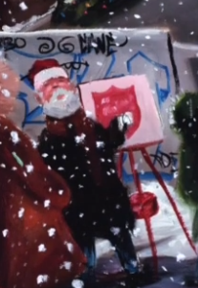

Big word of the day: PHILANTHROPY
Philanthropy is a personal interest in helping others.

Activity Sheet-
Christmas Spirit Goods and Services
It’s the season for giving to others. You can help by providing gifts (goods) or doing good deeds (services). Do you think these are pictures of goods or services?

A GOOD is a tangible thing that can be bought and sold such as hot chestnuts and toys.
A SERVICE is an action performed by a person, such as singing songs and driving taxi cabs.

Decorating a Tree  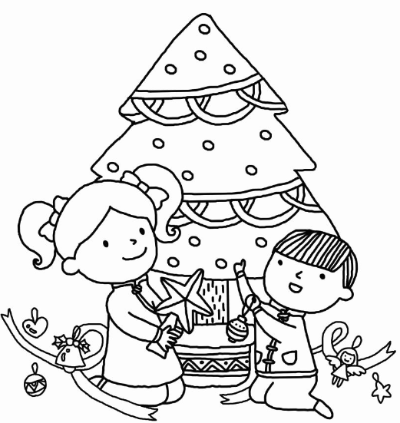  GOOD SERVICE | Holiday Decorations  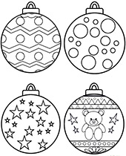  GOOD SERVICE
Gift Wrapping Paper  GOOD SERVICE | Wrapping Presents  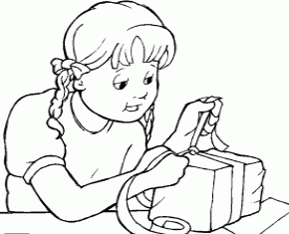  GOOD SERVICE
Volunteering at a Soup Kitchen  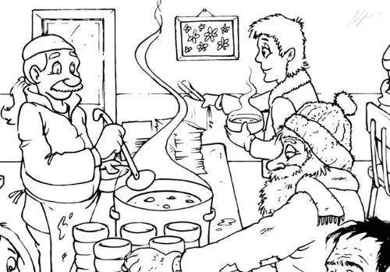  GOOD SERVICE | Holiday Turkey  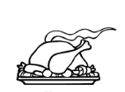  GOOD SERVICE

