Princess Persephone and the Money Wizards: Inflation Comes to Ganymede
by Sheila Bair
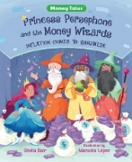
Lesson
A Classroom Action: Learning about Inflation
STORY SYNOPSIS: Princess Persephone wants to take a wonderful vacation with her friends. This vacation will cost lots of money. Therefore, she orders the Money Wizards to print more cash for the people of Ganymede. As her advisors predicted, things do not go well. Soon Ganymede is dealing with shortages of goods and services and rapid inflation. Can King Harris fix this monetary crisis?

LESSON INTRODUCTION: Students will experience inflation first-hand by participating in a classroom auction. Just like the circumstances on Ganymede, the goods and services will remain the same, but the amount of money chasing those goods and services will increase from the first action to the second one. Students learn that inflation is caused by too much spending chasing too few goods.
TIME REQUIRED: 30-35 minutes.
MATERIALS:
- Book- Princess Persephone and the Money Wizards: Inflation Comes to Ganymede by Sheila Bair
- Visual – A Classroom Auction: Learning About Inflation
- Activity Sheet- Auction Record [4-6 copies]
- Ganymede Money – run off and cut (about 10-12 bills for each student)
- Two sets of Classroom Coupons run off and cut. One set for each auction.

OBJECTIVES:
- The student will learn how money supply and inflation are connected.
- The student will participate in a classroom action, learning about the concept of inflation.
- The student will define auction, money, inflation, demand, supply, goods and services.

STANDARDS:
Voluntary National Content Standards in Economics (2nd Edition)
Standard 11: Money and Inflation. Money makes it easier to trade, borrow, save, invest, and compare the value of goods and services. The amount of money in the economy affects the overall price level. Inflation is an increase in the overall price level that reduces the value of money.
ECONOMIC CONCEPTS:
- Auction-A sale, usually public, where things are sold to the highest bidder.
- Demand - People’s desire to buy goods and services.
- Goods – Material things that provide for wants. Examples include sleds, skis, bread, and books.
- Inflation- An overall increase in the price of goods and services.
- Money – Any generally accepted medium of exchange.
- Services – Actions that provide wants. Examples include vacation trips, music concerts, or banking services.
- Supply- The amount of goods and services that are available to buy.

PROCEDURE:
- Prepare materials prior to class. Ganymede Money can be run off on colored paper if available. Note: You may want to run off the Ganymede Money and Class Coupons the day before teaching this lesson. Ask for volunteers to cut these out and pay them a few Ganymede bills for their effort. This tends to validate that Ganymede Money may have value. Divide the Ganymede Money into two stacks. Making approximately one-third available for the first round of the auction and two-thirds is available for the second round of the auction.
- Introduce the lesson by showing the students the cover of Princess Persephone and the Money Wizards: Inflation Comes to Ganymede. Tell them “Today we will be doing an activity based on story where a princess gets really excited about going on a vacation with her friends and does not make good decisions.” If time allows, read the book to the students. This takes about ten minutes.
- Ask the students what Princess Persephone learned from her quest to make it possible for her and her friends to afford to take a first-class vacation. Possible answers: “She learned that buying power of money depends on how much there is in circulation.” “She learned that goods and services do not need to do expensive to be fun.” “She learned that it’s important to listen to people who know what they are talking about.”
- Display the visual, A Classroom Auction: Learning About Inflation. Review the three questions and tell the students to think about them during the auctions. These questions will be answered at the end of the lesson.
- Review the auction rules with the students. Explain that you will be the auctioneer and will need several students to act as record keepers and money collectors. Ask for volunteers. Tell the students that these students will be able to participate in the auction. If several students volunteer, hand them a copy of the Auction Record and along with two Ganymede bills. Explain that they are being paid for services rendered.
- Distribute one-third of Ganymede Bucks to the students. This can be done in an informal manner, with some students getting a few more bills than the others. Make sure each student receives between 3-5 bills. [This may cause some complaining, but can lead to a future discussion about wealth inequity.]
- Introduce the students to their classmates who agreed to be record keepers. Explain the all of the record keepers will record the price each item sold for. There will be duplicate records to insure for accuracy.
- Reveal the four coupons that will be auctioned off. Explain that you will be the auctioneer. Conduct the auction by inviting the students to bid on each item. Sell the coupon to the highest bidder.
- Instruct the winning bidder to pay for the item by giving the agreed upon amount to one of the record keepers.
- After the first round, ask the students if they would have purchased one of the coupons if they had more money. Most students say they would.
- Explain to the students that you will conduct a second auction.
- Distribute the remainer of the Ganymede Bucks, again randomly. Tell the students that they may use money that they did not spend during the first auction for the second auction. This will be double the amount, about six to ten bills for each student.
- Auction off the second set of coupons. Again, asking the record keepers to record each item’s sale price. [They may ask for more compensation. Good for them! Give them few extra bills.]
- Remind students that this is the final round, and their Ganymede Money will not buy goods and services outside the classroom. Prices will most likely be much higher in this round.
- Display one of the Auction Accounting Records. Ask the students to study the information and ask them the following questions:
  - What was the difference between the prices in the two auctions? [Prices were higher in second auction.]
  - Was there any difference in the goods auctioned in each round? (No, the goods in both auctions were identical in the type of item and the amount of the items.]
  - What could be the reason the prices were higher in second round? [More money was available in the second round. It was possible to spend more.]
- Ask the students why they think that having too little as well as to much money can cause problems. Possible answers: “If you don’t have enough money, you can’t buy what you want. But if you have too much money you are likely to spend it.”
- Ask the students if they think spending money is good for the economy. Possible answers: “The economy can grow if people spend money on goods and services.” “If more goods and services are demanded, there could be more jobs.”
- After debriefing the auction, ask the students to answer the questions posed at the beginning of the auction. What is Money? [Money is anything accepted in exchange for goods and services. During the auction, Ganymede Money will be used.] How are money and spending connected? [Money is used to purchase goods and services. Money facilitates spending.] What is inflation? [Inflation happens when spending increases at a faster rate than the supply of goods and services.]
- NOTE: Instruct the students to turn in their unspent Ganymede Money for reuse.

Visual-
A Classroom Auction: Learning About Inflation

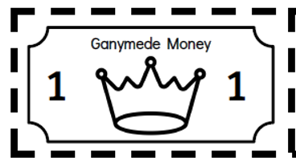

Things to think about:
- What is money?

- How are money and spending connected?

- What is inflation?

CLASSROOM AUCTION RULES

- There will be two auctions.

- Four items will be auctioned in each round.

- Ganymede Money is considered currency during this auction and can be exchanged for auctioned items.

- The highest bidder will win each item.

Classroom Coupons
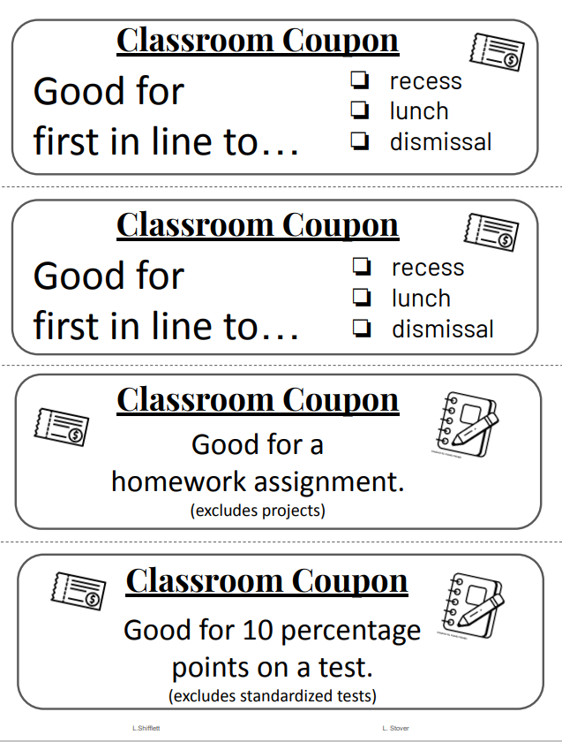
Auction Accounting Record
Date: _______________________
Name of Recorder: ______________________

ITEM | Amount Round 1 | Amount Round 2
1.
2.
3.
4.
TOTALS

Auction Accounting Record
Date: _______________________
Name of Recorder: ______________________

ITEM | Amount Round 1 | Amount Round 2
1.
2.
3.
4.
TOTALS

Ganymede Money

