Title/Author | Publisher/Copyright | Notes
Gracie's Night:  A Hanukkah Story  by Lynn Taylor Gordon  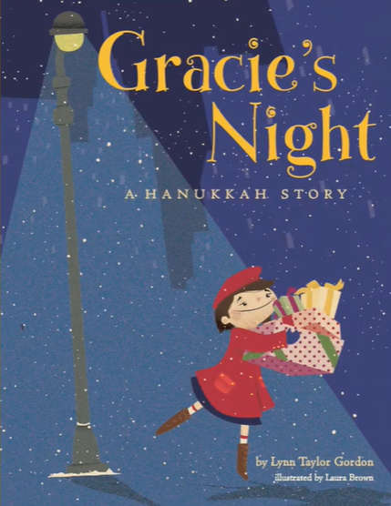 | Cookie and Nudge Books - 2013 | Interest Level: 1-3  Econ Concepts: Earning, Giving, Jobs, Poverty  Read Aloud:  https://www.youtube.com/watch?v=_hPVUhvz4u0  [7 minutes]
I Got the Christmas Spirit  by Connie Schofield-Morrison  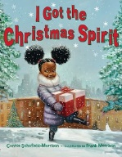 | Bloomsbury-2018 | Reading Level: 2.0  Interest Level: K-3  Econ Concepts: Markets, Giving, Goods, Services  Read Aloud:  https://www.youtube.com/watch?v=xkvM7-1CHbQ  [4 minutes]
Lemonade in Winter  by Emily Jenkins  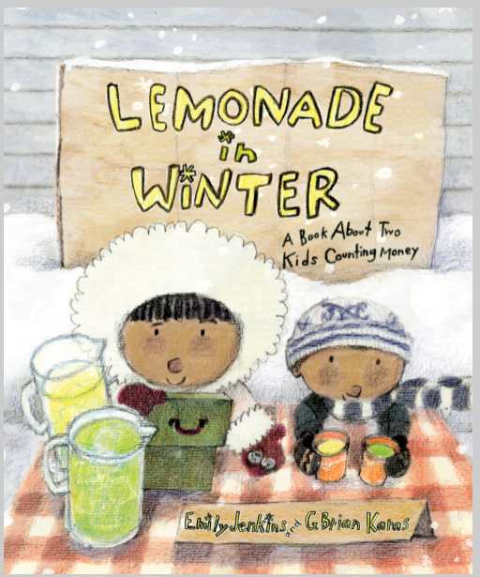 | Random House-2012 | Reading Level: 2.5  Interest Level: P-2  Econ Concepts: Entrepreneurship, Profit, Cost, Benefit,  Producer, Consumer  Read Aloud:  https://www.youtube.com/watch?v=4jnmzlurv_Y  [8 minutes]
My Family Celebrates Kwanzaa  by Lisa Bullard  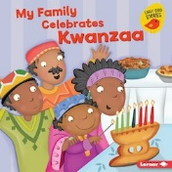 | Lerner Publications- 2019 | Reading Level: 1.9  Interest Level: P-2  Econ Concepts: The Principle of Ujamaa is “Cooperative Economics”  Read Aloud:  https://www.youtube.com/watch?v=eUNkZkv-oWg  [8 minutes]
Silver Packages: An Appalachian Christmas Story  by Cynthia Rylant  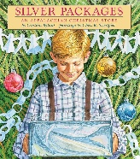 | Orchard Books- 1917 | Reading Level: 4.1  Interest Level: K-3  Econ Concepts: Poverty, Investing in Human Capital  Read Aloud:  https://www.youtube.com/watch?v=MrYHAiF0iwI  [8 minutes]
What is Given from the Heart  by Patricia McKissack 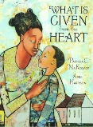 | Random House- 2019 | Reading Level: 3.3  Interest Level: PK-2  Econ Concepts: Goods and Services  Read Aloud:  https://www.youtube.com/watch?v=zQxY9cHcV7o  [7 minutes]

