What is Given from the Heart
by Patricia C. McKissack

Book Synopsis: Times are hard for nine-year-old James Otis. He and his mother are living in a dilapidated house after losing their farm due to the death of his father. Things get worse when there is a flood and the dog runs away. Despite their own poverty, James Otis and his mother problem solve how to help the Temples, a family who has lost everything in a fire. Using a treasured tablecloth for the material to sew a new apron, and writing a book featuring seven-year-old Sarah Temple as the main character, the mother and son duo give gifts from their hearts.

LESSON
Goods & Services
Introduction: James Otis has to decide what to donate to the “loving box” the community is putting together for the Temple family who lost everything they own in a house fire. He and his mother have little to give so coming up with something is going to be a challenge.

Time: 20-25 minutes

Grade Level: 2-4

Materials:
- Book- What is Given from the Heart by Patricia C. McKissack
- Visual – Economic Concepts
- Activity Cards “Loving Boxes” Goods & Services Cards (runoff on card stock or printed on 3X5 cards)
- Activity Sheet- Goods and Services
- Writing tools
Students Will:
- Understand that productive resources are limited. Therefore, people cannot have all the goods and services they want; as a result, they must choose some things and give up others
- Define and compare goods and services as they participate in a card sorting activity

Virginia Standards of Learning – History and Social Science
Economics
1.7 The student will explain the difference between goods and services and describe how people are consumers and producers of goods and services.
1.8 The student will explain that people make choices because they cannot have everything they want.
Civics
1.10 The student will apply the traits of a good citizen by
a) focusing on fair play, exhibiting good sportsmanship, helping others, and treating others with respect.
Procedure:
- Prepare and collect materials prior to class. Run off the Activity Cards on cardstock and place in card decks. Create enough decks as needed for each student pair or small groups.
- Introduce the lesson telling the students that the story in today’s lesson is based on a book about a boy and his mother who are struggling with limited resources. Explain that the boy will decide to make a choice to help someone else.
- Read the book What is Given from the Heart to the students. YouTube link: https://www.youtube.com/watch?v=eE7C4etCqh0
- Display Visual 1 and review the listed concepts by relating each term to its connection to the story.
- Explain to the students that they will now be participating in a fun sorting activity based on the concepts of goods & services.
- Place the students in pairs or small groups.
- Draw a card from one of the decks, show it to the students and ask them if it is an example of a good or a service. Students should be able to state that a good is an object and a service is an action.
- Distribute the card decks. Tell the students to place them face down on a flat surface.
- Explain that one student is to turn over a card and tell if it is a good or a service and have their choice verified by the other students. That card is to be left face up in place. They are then to turn over another card. If the types of the cards match (both goods or both services), the student is to remove the two cards and put them in front of them. If they don’t match, turn the cards over and return them to the card display. The next student may then take their turn.
- Continue to play until all the cards have been sorted. The student with the most cards wins bragging rights.
- Conclude the lesson with the assessment activity sheet.
- Distribute Goods and Services activity sheet and writing tools. Read the directions to the students. Check for understanding. Part I Answers: 1. Service, 2. Good, 3. Good, 4. Good, 5. Service, 6. Service, 7. Good, 8. Service, 9. Service, 10. Good. Part II Answers will vary.

Visual
What is Given from the Heart
Economic Concepts

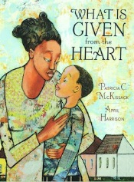

Choice- You cannot have all the goods and services you want, so you must choose some things and give up others.

Decision Making – Reaching a conclusion after considering alternatives and their results.

Goods- Things that can be bought and sold such as toys, books, and food.

Philanthropy- promoting the welfare of others; giving to good causes.
Poverty – the condition in which a person lacks the financial resources and essentials for a minimum standard of living.
Scarcity- the condition that exists because people’s wants are greater than the resources to satisfy those wants.
Services – Activities performed by people such as childcare, and delivering items.

Assessment Sheet
What is Given from the Heart
Goods and Services

A GOOD is an object that can be touched, like a book or a pencil.
A SERVICE is an action performed by a person such as baking bread or cutting hair.

PART I
Directions: Read each statement. In the blank, write if it is a good or a service.
- James Otis sweeps the porch. ____________
- A broom is used to sweep the porch. ____________
- Mama gave James Otis gloves for Christmas. ____________
- James Otis has a puzzle with missing pieces. ____________
- James Otis writes a book for Sarah. ____________
- Mama sews an apron for Mrs. Temple. ____________
- Mama uses a tablecloth to make the apron. __________
- Reverend Davis teaches about giving. ____________
- The church members collect items for the loving boxes. ____________
- Food, toys, tools, and books are in the loving boxes. ____________

PART II
If you were asked to help Sarah and her family after their house fire, what goods and services would you donate? List at least three of each.
Goods | Services

Activity Cards
Goods & Services “Loving Boxes” Cards
FOOD  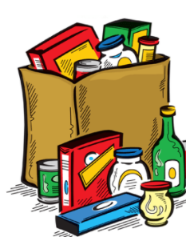 | CLOTHING  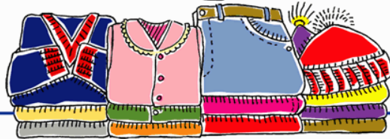
KITCHEN TOOLS  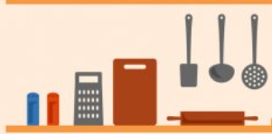 | TOYS  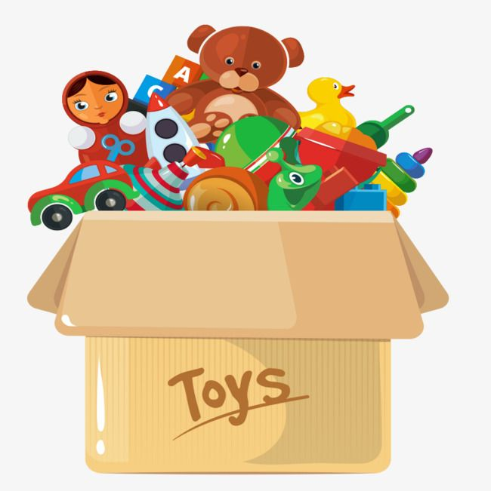
BOOKS | CLEANING SUPPLIES  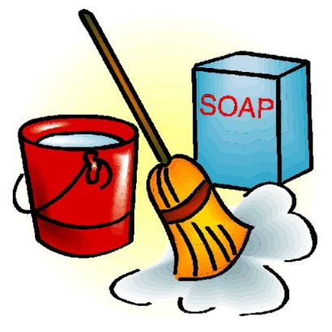
WRITING A BOOK  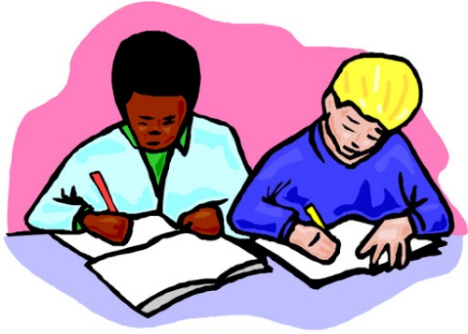 | SEWING AN APRON
REBUILDING A HOUSE | ASSEMBLING DONATION BOXES  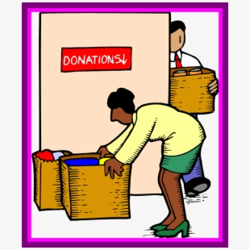
WASHING DISHES  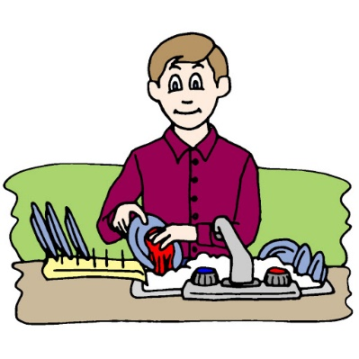 | BAKING COOKIES  