Lesson Plan 1
Time 30 mins | National Standards in Economics  STANDARD 1: SCARCITY, STANDARD 2: DECISION MAKING, STANDARD 6: SPECIALIZATION
Objectives  Students will be able to:  - Listen to a story and determine the human capital traits of the main characters.  - Define human capital and demonstrate understanding of the concept by identifying their own human capital traits. | Materials  - Book - Sloth & Squirrel in a Pickle by Cathy Ballou Mealey  - Human Capital Graphic Organizer
Activities

Read Aloud
Share with students that today they will listen to a book featuring 3 characters. All of them have special skills, attitudes, education, training, talents, and abilities. Challenge them to listen for those skills in the book. Read the book to the students. Ask them to identify the characters which are Squirrel, Sloth, and Mr. Peacock.

Human Capital Graphic Organizer
Display the handout. In economics, the term used to describe those skills, talents, education, experience, and abilities is called human capital. Challenge students to look at each character and complete the chart in teams or as a whole group. Challenge students to pretend they are Mr. Peacock. Ask them to identify human capital traits they would like in an “ideal” new hire to work at the pickle factory. Record the answers on the graphic organizer.

Assessment

Thumbs Up or Thumbs Down
Assess student learning by reading the following statements. If the student agrees with the statement, they will show a thumbs up sign with their thumb. If they disagree, they should show a thumbs down sign with their thumb.
- Sloth was a very fast worker. (thumbs down)
- A person’s skills, talents, education, and abilities are called their human capital. (thumbs up)
- Squirrel was a very fast worker. (thumbs up)
- Specialization leads to more productivity. (thumbs up)
- Being tall, practicing, being a good shot, and a team player, would be examples of human capital for a basketball player. (thumbs up)
- Being tall, practicing, being a good shot, and a team player would be examples of human capital for a pilot. (thumbs down)
- There are ways to increase your human capital. (thumbs up)
- Watching a You Tube video, reading a manual, or practicing is an example of investing in your human capital. (thumbs up)

Human Capital Graphic Organizer

Human capital refers to the quality of labor resources, which can be improved through investments in education, training, and health. Complete the graphic organizer below by writing the skills, talents, education, and suggestion for an investment in human capital of each character from the book.

Character | Skills | Education | Talents | Suggestion for an investment in human capital
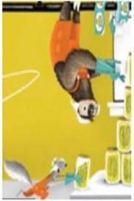
The ideal hire at the pickle factory

Answer Key for Human Capital Graphic Organizer

Human capital refers to the quality of labor resources, which can be improved through investments in education, training, and health. Complete the graphic organizer below by writing the skills, talents, education, and suggestion for an investment in human capital of each character from the book.

Character | Skills | Education | Talents | Suggestion for an investment in human capital
 | Manages a business | Has a diploma of pickleology | Expects quality  Very serious about business | Invest in technology and training for employees
 | Team player | No experience but willing to work | reliable  has good ideas | Practice  Find a different working posture
 | Works really, really fast  Goal setter | Can bury a jillion acorns in an hour | Confident  Great shape | Practice, training
The ideal hire at the pickle factory | Fast  Quality worker | Has received training and practice on how to assemble pickle jars | Fast  Close eye to detail  Good worker | Continuous training

Lesson Plan 2
Time 30 mins | National Standards in Economics  STANDARD 1: SCARCITY, STANDARD 2: DECISION MAKING, STANDARD 6: SPECIALIZATION
Objectives  Students will be able to:  - Participate in a production activity to experience how investments in human capital increase productivity. | Materials  - Pickle Jar Assembling Activity  - Resources for Pickle Jar Assembling Activity: copies of the activity worksheets, scissors (2 pair for each team), green crayon (one for each team), glue stick (one for each team)  - Human Capital Sorting
Activities

Pickle Jar Assembling Activity Teacher Preparation
Create stations. At each station provide labels, colors, scissors, glue sticks, and pickle jars. Print copies of the Pickle Jar Assembling Activity. Divide students into groups of 4 students with assigned roles: Scissor Specialist, Artistic Specialist, Glue Specialist, and Assembly Specialist.

Pickle Jar Assembling Activity
Begin the activity by stating the following directions, “Sloth and Squirrel decided they should specialize to be more productive. To specialize means that a worker focuses on a specific task. This makes each worker more efficient at a task, and thus more productive. Teams will specialize in creating as many pickle jars as they can in four minutes See the perfect pickle jar. Two students will serve as supply specialists. Supply specialists will need certain tools to do their job efficiently. Ask students what an example of a tool would be that would help them cut along a dotted line to create labels. Scissors will make it easier and faster to cut the labels. Another specialist will cut along the dotted line to create pickle jars. That specialist will also need a set of scissors. One artistic specialist will color the pickle green making sure to stay exactly in the lines and coloring the pickle completely. The next student will serve as the assembly specialist gluing and adhering the label in the correct position within the dotted line. This specialist will need a careful eye for detail. All should be advised to do their very best work because Mr. Peabody expects quality for the consumer. If any are messy, he will not accept it. The team wouldn’t earn income for their work…just like Squirrel and Sloth.”

Start the timer. At the end of four minutes, the teacher will visit each station to see how many pickle jars are ready for the market. Just like Mr. Peabody, the teacher can only accept quality pickle jars. Ask students the following questions, “How did you feel you performed? What would you do differently if you had another opportunity to be more productive? How would you change the process to be more productive the second round?”

Conduct Round 2. Identify the quality of the pickle jars for market. The number of quality pickle jars should increase. Discuss the reasons why. Some answers might include practice or training.

Assessment

Human Capital Sorting
Distribute an assessment worksheet to each student. Ask students to sort the human capital cards that would best fit each specialist and write their answer under each box.

Pickle Jar Assembling Activity

The Perfect Pickle

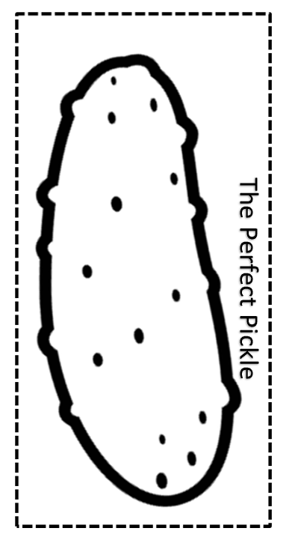

Human Capital Sort

Sort the human capital traits below that best fits each specialist. Write in the box the correct descriptions or cut and paste them in the correct category.

Basketball Player | Doctor | Baker
good at measuring | tall | physically fit
team player | finishes medical school | knows how to read recipes
attends basketball camp | artistic/creative | practices shooting
knows how to read an x-ray | practices with new recipes | attends trainings about new medicine
enjoys taking care of people | enjoys being in the kitchen | knows how to use medical equipment

Answer Key for Human Capital Sort

Sort the human capital traits below that best fits each specialist. Write in the box the correct descriptions or cut and paste them in the correct category.

Basketball Player | Doctor | Baker
tall | finishes medical school | good at measuring
physically fit | enjoys taking care of people | knows how to read recipes
team player | knows how to use medical equipment | artistic/creative
attends basketball camp | knows how to read an x-ray | practices with new recipes
practices shooting | attends trainings about new medicines | enjoys being in the kitchen

