Lesson Plan 1
Time 30 mins | National Standards in Economics  STANDARD 2: DECISION MAKING, STANDARD 7: MARKETS AND PRICES
Objectives  Students will be able to:  - Listen to a story to see how producers make goods and use their income to buy other goods and services.  - Participate in a production activity to experience how producers are also consumers when buying the goods needed to make what they will sell. | Materials  - Book- Sloth & Squirrel in a Pickle by Cathy Ballou Mealey  - Make An Ad Activity Slides  - Required supplies for Make An Ad activity: $1 play money, for students to have $5 each, half of a blank sheet of paper per student, at least 10-15 sets of blue and green crayons (1 blue and 1 green in each set), at least 20 pickle images, at least 20 Buy Our Pickles sign, 1 Patrick Peacock check per student, 1 glue stick per student  - Producers Are Consumers Too Matching Activity  - Small items students can buy with their earned money from the “Make an Ad” activity: pieces of candy, coupons for classroom privileges, small toys, etc. (optional)
Activities

Read Aloud
Tell your students they will learn about characters who want to earn income to buy a bike. Read aloud the story, Sloth and Squirrel in a Pickle, to your students or watch https://www.youtube.com/watch?v=fat_e8ISsNY

Make An Ad Activity Teacher Preparation
Set up a mini store in your classroom with the following:
- Cut out the play money (enough for 5 $1 bill per student), at least 20 pickle images, and at least 20 “Buy Our Pickles” images. It is recommended you cut these to avoid students having to cut anything for this activity
- Create 10-15 sets of one blue crayon and one green crayon
- Cut blank sheets of copy paper in half to have enough for each student and put in a stack
- Have enough glue sticks for each student
- Have each student’s name written on the checks from Mr. Peacock cut out and ready to give as “income” when each student gives you the final product of the ad.

Make an Ad Activity
Open Make an Ad Activity slides and display them to your students. Review the meaning of the terms “producer” and “consumer” to students. You will read aloud Mr. Pickle’s words as he explains in Slides 2-5 that he is a producer who must buy goods and services to make his goods. You will continue to read aloud Mr. Peacock’s instructions from slides 6 to 12. Begin the activity by distributing $5 in play money to each student before they shop for supplies. Tell students they will first buy the supplies they need from you to make the ads. They must buy a half sheet of paper, but they can buy any of the remaining supplies they want to complete the task. Remind them they must produce an ad that contains both things: a picture of a pickle and the words “Buy our pickles!” written in green and blue print. Leave slide 12 on the board for students to view the prices of each item. Open the mini store for business and allow students a minute to be consumers and make their purchases. Read slide 13. Give students 10 minutes to make their product. They must make wise choices with their time and other resources. At 5 minutes on the timer and before you pay $10 to the first student who is finished with the ad, display Slide 14. Once a student finished making the ad, they will bring it to you in exchange for the $10 in a check from Mr. Peacock.
Assessment

Review the meaning of producer and consumer. Give each student a copy of Producers Are Consumers Too Matching Activity.
Play Money for Make an Ad Activity
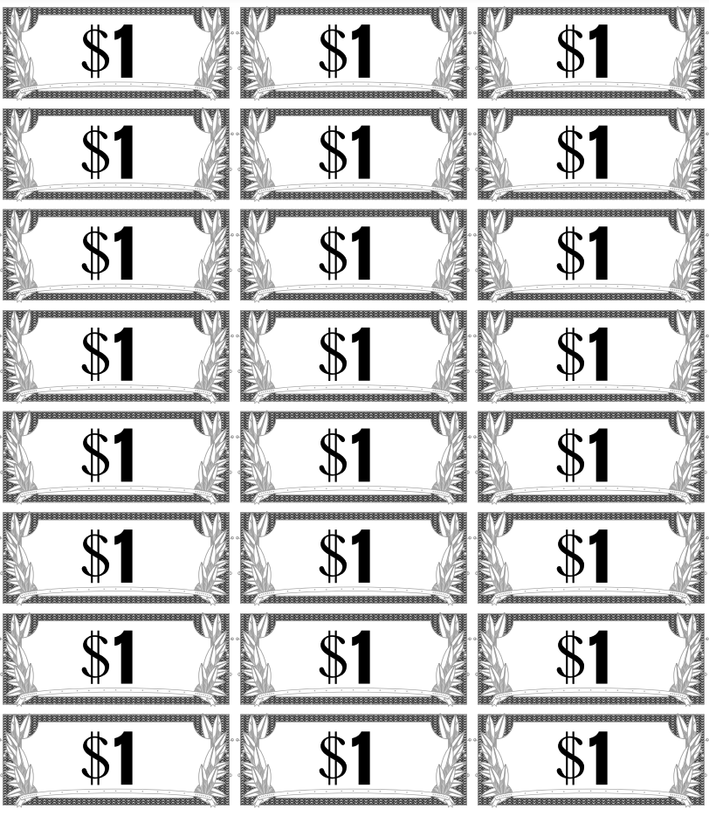

Pickles for Make an Ad Activity
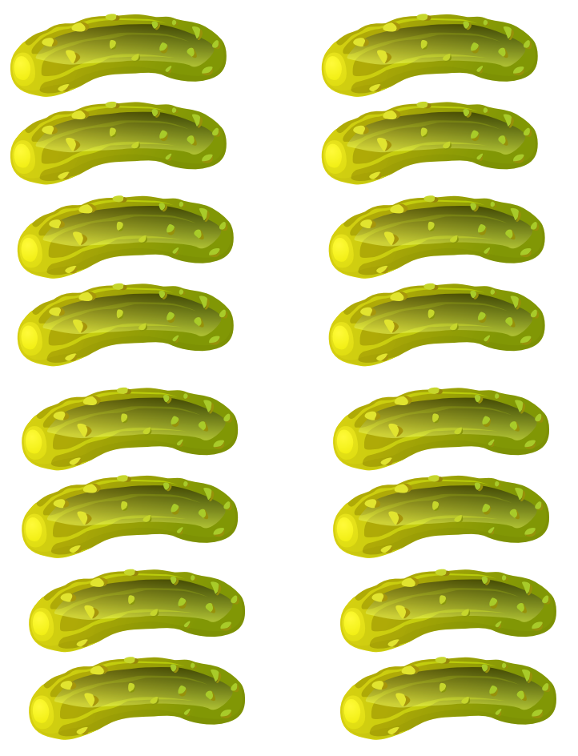
Buy Our Pickles for Make an Ad Activity
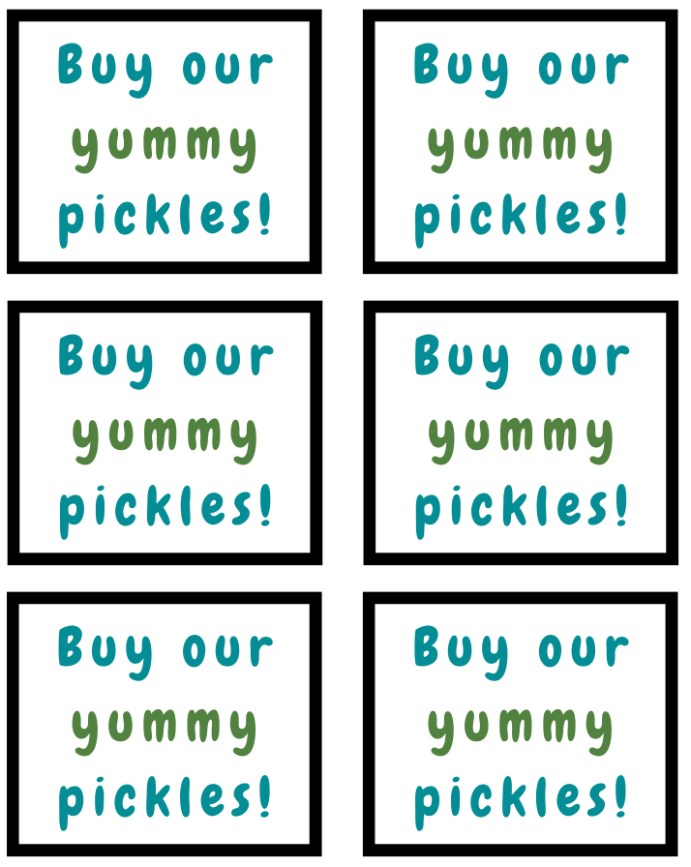
Patrick Peacock’s Checks for Make an Ad Activity
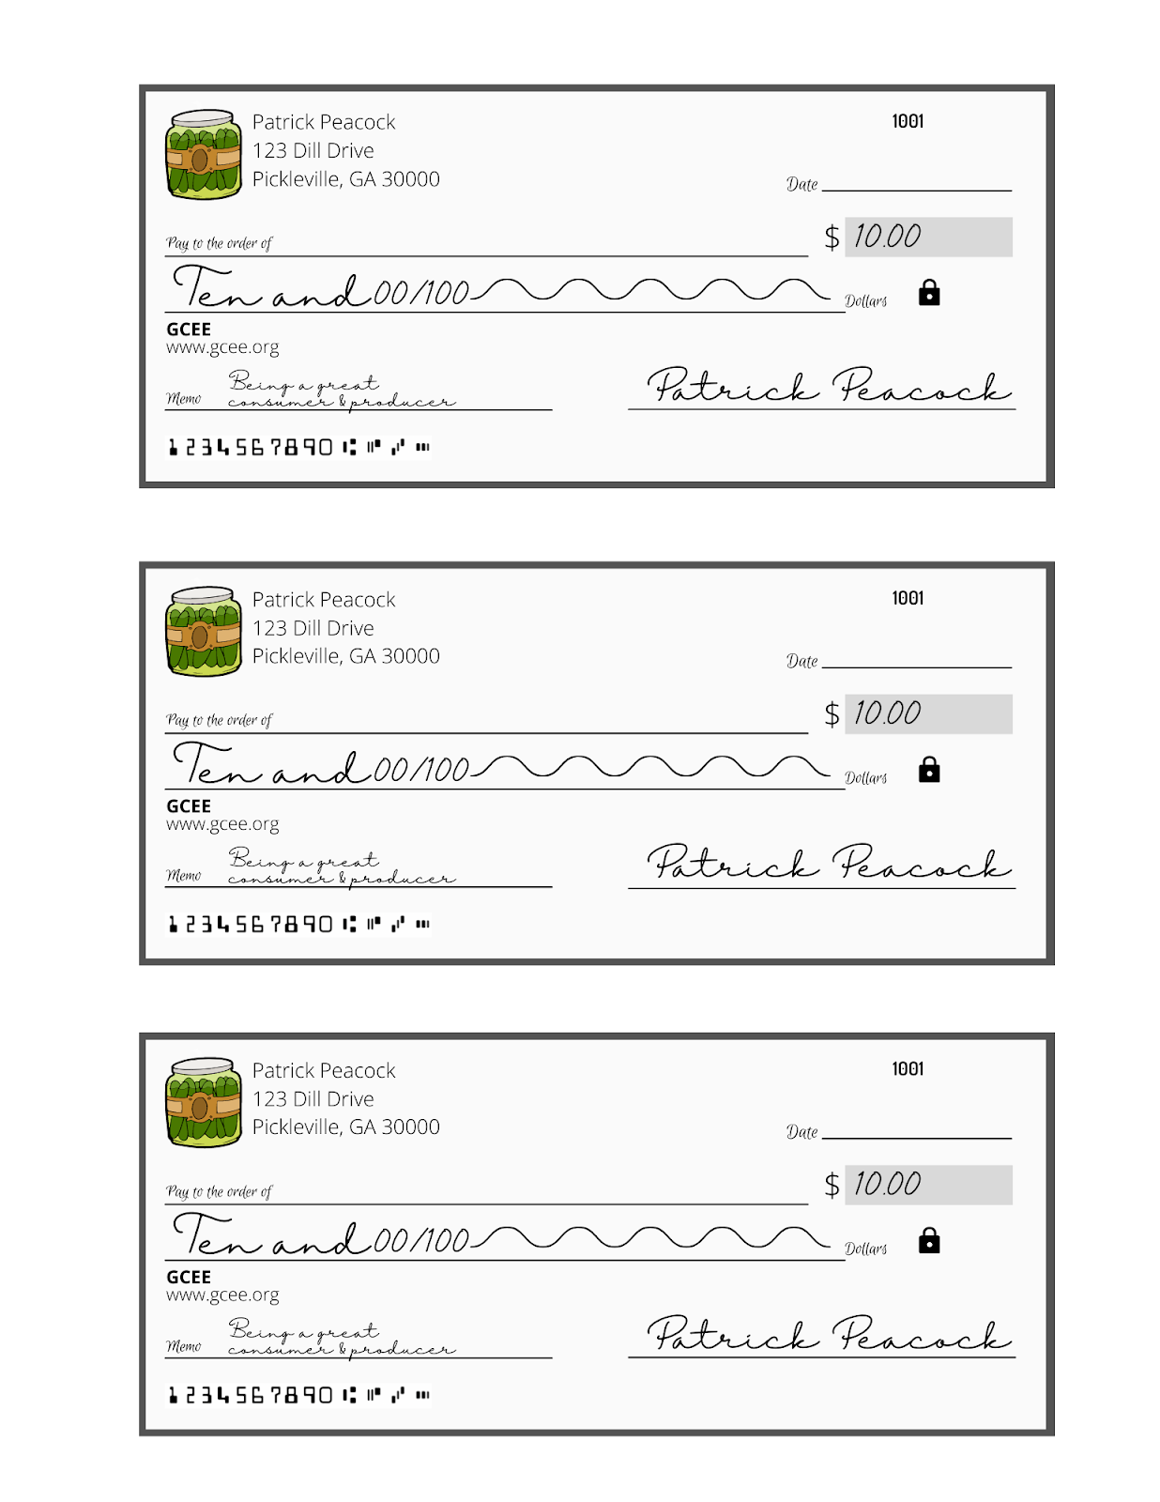
Producers Are Consumers Too Matching Activity
Directions: Draw a line from the producers to the good they need to do their job.

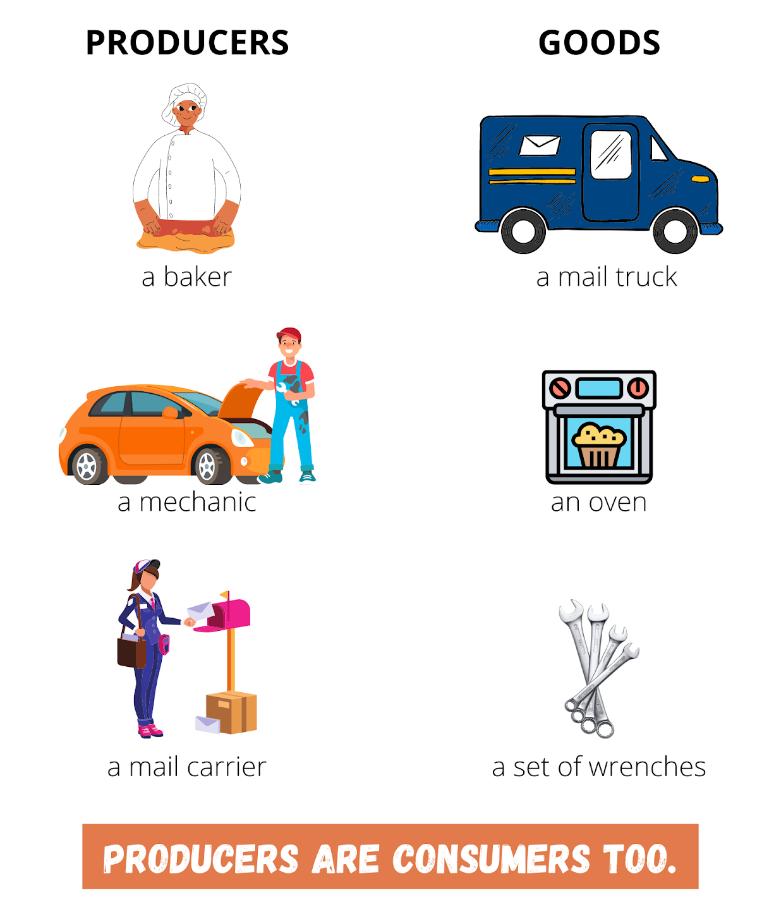

Answer Key for Producers Are Consumers Too Matching Activity
Directions: Draw a line from the producers to the good they need to do their job.

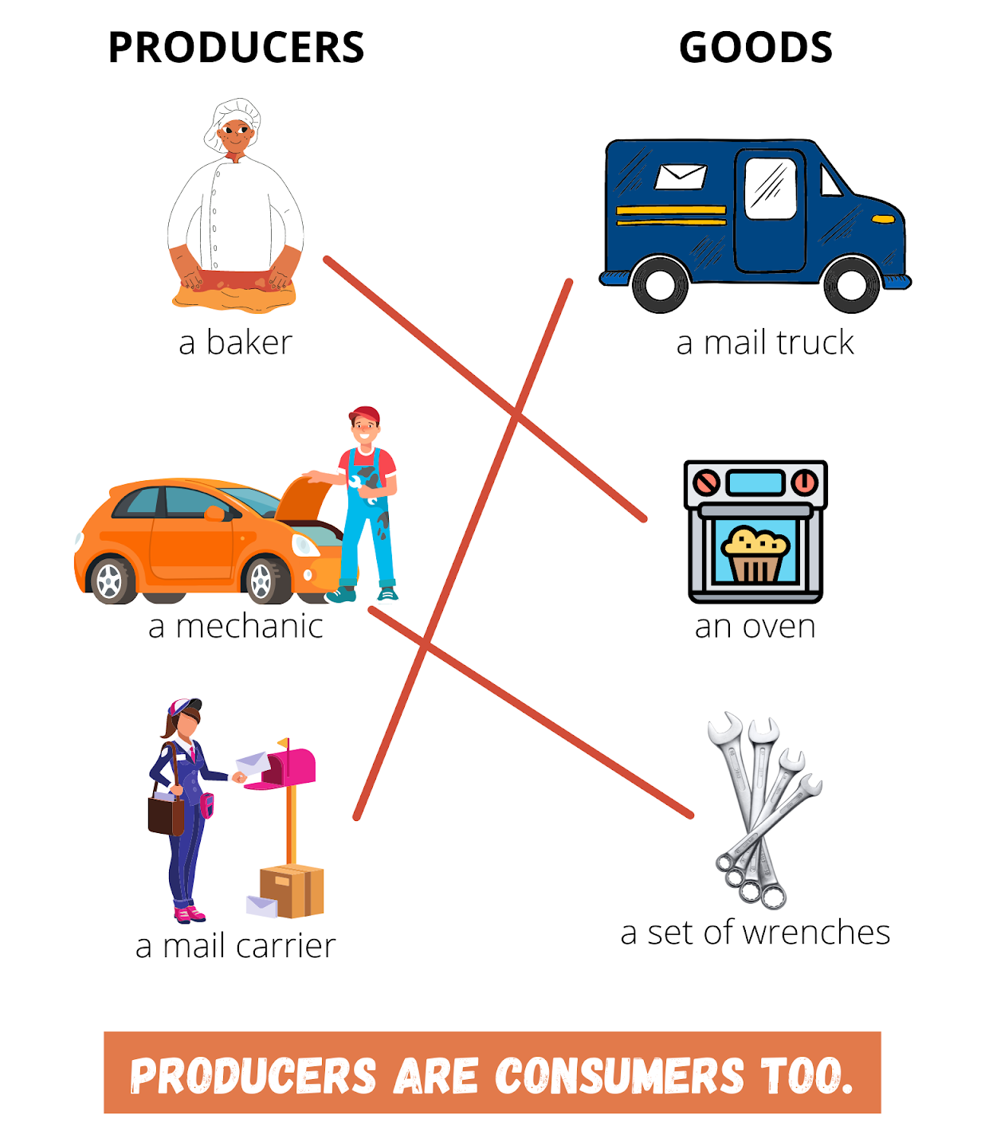

Lesson Plan 2
Time 30 mins | National Standards in Economics  STANDARD 2: DECISION MAKING, STANDARD 7: MARKETS AND PRICES
Objectives  Students will be able to:  - Understand the difference between producers and consumers. | Materials  - Make An Ad Activity Slides  - Mount Olive Pickles Tour Video on YouTube  - Chart paper and marker
Activities

Video Hook
Open the Make An Ad Activity Slides to slide 15. Read Mr. Pickle’s words. Open the video link. When you show the video of the pickle factory tour, fast forward to the time marker 1:30 to skip the historical part and get to the actual factory tour. The students will watch a video of a real pickle factory producing pickles. Display slide 16 that poses the question, “Can you name anyone else who is a producer and a consumer?” Discuss as a class.

Assessment

Think-Pair-Share
Draw a large T-Chart on chart paper with the headings, “Producers” and “Goods They Need”. Give students a couple of minutes to share and record their responses. Then, ask them to share and defend their answers with a classmate next to them. Then share and review their answers as a class. Write their answers on chart paper. See sample answers on Answer Key for Producers and Goods T-Chart.

Answer Key for Producers and Goods T-Chart
Directions: See sample answers for the Producers and Goods T-Chart for the Think-Pair-Share assessment.

PRODUCERS | GOODS NEEDED TO DO JOB
Teacher | Computer, markers
Driver | Car
Doctor | X-ray machine, medicine

