Time 30 mins | National Standards in Economics  STANDARD 1: SCARCITY, STANDARD 2: DECISION MAKING, STANDARD 4: INCENTIVES, STANDARD 6: SPECIALIZATION
Objectives  Students will be able to:  - Listen to a story and determine the advantages of setting goals, being creative, and making money.  - Define and understand the meaning of specialization.  - Participate in a hands-on activity that reinforces the featured concepts of specialists/entrepreneurs, workers, capital resources, and products. | Materials  - Book- Sloth & Squirrel in a Pickle by Cathy Ballou Mealey  - Visual - Putting the Pieces Together Activity  - Sets of Puzzle Strips – run off on cardstock and cut into pieces (for ease of organization use a different color for each set)  - Envelopes or paperclips for puzzle strip set management  - Assessment - Create Your Own Puzzle Activity  - Markers, crayons, or colored pencils  - Scissors
Activities

Puzzle Strip Teacher Preparation
Collect and prepare the materials prior to the class. Cut and make the appropriate amount of puzzle strip sets.

Read Aloud
Tell students that they will be listening to a story that is about two friends setting out to accomplish a goal. Explain that one friend is a “doer” and the other friend is a “thinker” and you will be asking them to identify which one is which at the end of the story. Read the book aloud or watch a YouTube read aloud: https://www.youtube.com/watch?v=lpwVwa8GaxI Ask them who was the “doer” [speedy Squirrel] and who was the “thinker” [slow Sloth]. Discuss why it’s possible for friends to be different than each other.

Putting the Pieces Together Activity
Display the Visual, Putting the Pieces Together Puzzle Strip. Read the information. Review the following economic concepts if necessary. Natural Resources: gifts from nature, such as land, water and trees, Entrepreneur: a person who organizes, operates, and assumes the risk for a business hoping to make a profit. Human Resources: human effort directed toward producing goods and services (labor). Capital Resources: goods produced and used to make other goods and service (tools). Specialization: focusing on the production of selected goods and services. Specialist: an expert who is devoted to one occupation or branch of learning. Product: something manufactured or refined for sale.

Explain to the students they will be assembling their own puzzle strips. Students may work in pairs or small groups. Distribute the prepared puzzle strip sets. Inform students to wait until the sets have been distributed and you say “GO!” Say “GO!” and allow the puzzle strips to be completed, this takes between 3-5 minutes. The correct assembly of the puzzle strips is self-checking. Ask the students who put together their puzzle first if they all did the same thing to put it together or did they each specialize in doing a specific part of the task. Possible answers may include yes, they each were responsible for a specific part of the task. Was anyone a puzzle specialist? Possible answers may include no, they just worked on a part of the overall task instead of trying to do everything. Instruct the students to mix the puzzle pieces up and return them to the envelope or secure them with a paperclip.
Assessment
Create Your Own Puzzle Activity
Checks for student understanding of the featured concepts as it challenges them to create their own puzzle strip. Once completed, these may be redistributed to other classmates who can check to see if they agree with the puzzle strip’s content. This process reinforces the concepts and checks for student understanding.

Visual

Putting the Pieces Together Activity
Below is an example of a puzzle strip that shows the workers and resources needed to create a finished product. The four parts of the puzzle show:
- The specialist or entrepreneur who takes the risk for making the product
- The workers, human resources, who create it
- The tools, capital resources, the workers use
- The finished product

1. 2. 3. 4. 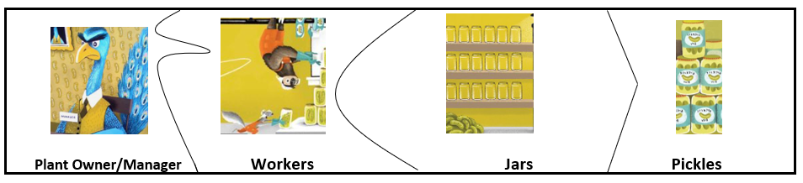

Puzzle Strips

Putting the Pieces Together Activity

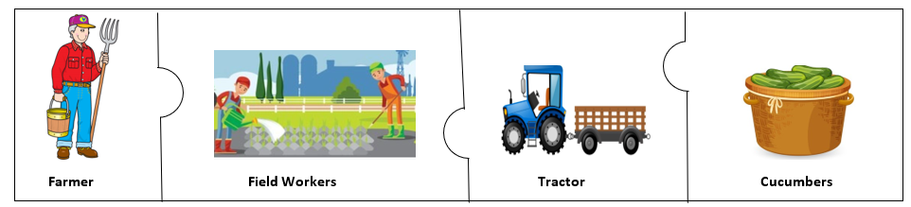

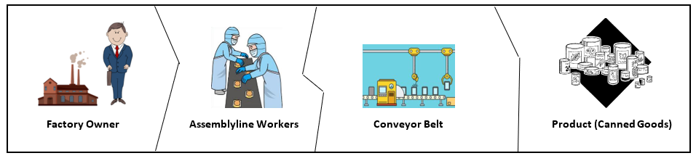

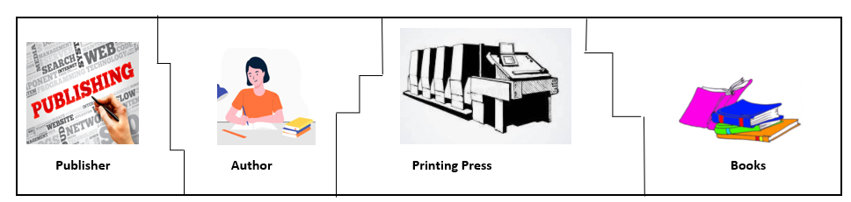

Assessment

Create Your Own Puzzle Activity

Using examples from the book, Sloth and Squirrel in a Pickle, draw and label a puzzle that shows:

- The specialist or entrepreneur who takes the risk for making the product
- The workers, human resources, who create it
- The tools, capital resources, the workers use
- The finished product

Examples include:
- Ice Cream Truck Owner, Ice Cream Truck Operator, Freezers, Popsicles
- Bicycle Repair Shop Owner, Repairman, Screwdrivers & Pliers, Fixed Bicycle
- Pickle Pop Entrepreneurs, Pickle Pop Sellers, Jars, Pickle Pops

