**How Does One Energy Policy - a Ban on Gas-powered Cars - Affect So Many People Differently?**

In this economics lesson, students will analyze the effects of a single energy policy - a ban on the sale of gas-powered vehicles - to learn how costs and benefits affect different groups of people.

**Description of the lesson**

Students will use a jigsaw approach to examine a 2022 policy from California that bans gas-powered vehicles by 2035. Students will first group together by role to brainstorm and begin weighing the costs and benefits of the policy specific to their role. Then students will disperse into new groups with a representative from each role. Students will hear how this policy can affect different groups of people and examine potential opportunity costs. Ultimately groups will vote for or against this policy and provide suggestions as to how the policy could be improved. Assessment for this lesson includes expanding the discussion on policy with a template for teachers to create an assessment for their own local energy policy.

**Economics**

Economics is the study of choices which includes policy decisions. Policymakers must weigh the costs and benefits of decisions but also take into account that the costs and benefits are different for different groups that are affected by the policy. Policies never affect people equally and have unseen consequences for groups of people, therefore, it is important for policy-makers to be willing to adjust policies. This could make more people/groups of people better off or lessen some of the costs that groups of people might experience from the policy. While there are always winners and losers with policies, it is important for decision-makers to examine policies from as many perspectives as possible taking into consideration the costs of a policy including opportunity costs as well as benefits. Policy makers should attempt to implement policies that have the greatest benefits for most people relative to the costs.

|  |  |
| --- | --- |
| **Objectives**:  Students will be able to:   * Recognize that government policies have costs and benefits. * Evaluate the benefits and costs of energy policies from varying perspectives. * Formulate an argument, using the economic way of thinking. * Identify ways a policy might be changed to eliminate or reduce consequences for various groups. | **Materials**:   * Slide presentation * Pen/Pencil, one per student * Copies of Activity 2.1 Thinking about Policies Like an Economist * Copies of Activity 2.2 Policy Stakeholder Roles, enough that every student has a role * Copy of Activity 2.3 Teacher Discussion Ideas, one for the teacher * Copies of Activity 2.4 Policy Discussion and Decisions, one per student * Copies of Activity 2.5 Assessment: Analyzing a Policy, one per student * Computers or other devices for access to the internet for the assessment |
| **Suggested Time Frame**:  90 minutes | **National Standards in Economics or Personal Finance**:   * Standard 2: Decision Making * Standard 16: Role of Government and Market Failure |
| **Teacher Preparation**:   * Prior to the lesson, view the video recommended in procedure step #4, [California’s move to ban sales of new gasoline-fueled cars could spread to other states(7:56)](https://www.youtube.com/watch?v=q1QdkPmWcHM) to see more perspectives on the policy. The Video is on slide 6. If time is an issue, students can watch the video as homework the night before. * Materials for second jigsaw group (step 12): Write a number 1 through 5 in the upper right-hand corner of each copy of Activity 2.2: Policy Stakeholder Roles so that each stakeholder group has a 1, 2, 3, 4, and 5. For example, for Policy Stakeholder 1: Consumers there should be five copies, each copy having a number 1, 2, 3, 4, or 5 in the upper right-hand corner; for Policy Stakeholder 2: City planners in California there should be five copies, each copy having a number 1, 2, 3, 4, or 5 in the upper right-hand corner. If you have additional students (more than 25) it is okay to duplicate roles within a group, make sure that there is at least one of every role in each group. * To prepare for Assessment: Analyzing a Policy (Activity 2.5), find a current issue or policy (energy or otherwise) that is affecting your local community, city, state (can also be a national issue). Provide students with a few readings, videos, podcasts, or other resources that offer different perspectives on the issue. They should use these resources to identify some policy stakeholders and then begin working through the assessment thinking about how the policy might affect the stakeholders. Ultimately, voting for or against the policy and then adjusting the policy so they are in favor of it or adjusting it so more stakeholders will favor the policy. | |

|  |
| --- |
| **Lesson: Part One** |
| 1. Tell students that today they will be considering energy policy and its impact on different groups of people. Explain that California and several other states are banning the sale of new gas-powered vehicles by 2035.[1] This means that consumers will look to electric vehicles, or EVs, as their main vehicle option. Use slide 2 and ask the students    * Is this a good policy or bad policy? Why? (*Answers will vary widely, especially given your geographical location, but many students will say yes, this is a good policy because gas powered vehicles are part of the climate change problem. Others might say that this is not a good policy because there are still other things causing climate change or that oil is not going to go away. Accept all answers and listen to what the students are saying regardless of their supporting evidence, or lack thereof.)*    * What do we mean when we say good policy or bad policy? (*Answers will vary again but students will likely talk about how many people the policy can help or hurt, the cost of the policy being worth it, etc.)* 2. Display slide 3. Remind students that economics is the study of decisions. A policy is an example of a decision made by lawmakers. Economists regularly examine policies such as the one in California by weighing the costs against the benefits. Define **costs** asthings unfavorable to a decision maker and **benefits** as things favorable to a decision maker**.** As an example, tell the class the school board is considering a new policy requiring that all students carry a see-through backpack. Discuss the following on slide 4:    * What are the costs for students, teachers, or parents associated with this policy? *(Answers will vary but may include: students not liking the style or lack of privacy for items in their backpacks. Parents or students will have to spend money to buy the new item. Teachers might have to check that students are following the new policy including potential discipline.)*    * What are the benefits for students, teachers, or parents associated with this policy? *(Answers will vary but may include: increased level of safety as you cannot hide things in your backpack, students will all have similar backpacks so there is less competition for fashionable or desirable items, etc.)*   **Group Discussion – Introducing the Idea**   1. Hand out *Activity 2.1: Thinking about Policies Like an Economist* to each student. Then give students 2-3 minutes to record their responses to the first two prompts. These prompts are also on slide 5. 2. Tell students that the costs and benefits they listed are likely from one perspective–theirs. Have students watch this PBS News Hour Video, [California’s move to ban sales of new gasoline-fueled cars could spread to other states](https://www.pbs.org/newshour/show/californias-move-to-ban-sales-of-new-gasoline-fueled-cars-could-spread-to-other-states)[2] (7:56) to see more perspectives on the policy. The Video is on slide 6. **Note**: You could have the students watch the video as pre-work if time is an issue in your class. 3. Explain that many people are involved in policy decisions, and they all have their own opinions. Also, people in different situations or roles face unique costs and benefits from a policy that may conflict with those in other situations or roles. It is generally expected that good policymakers examine how the policy can or will affect many different people. Have students write down people or groups of people that might be affected by a policy like this one on Activity 2.1 (Question 3). This prompt is on slide 7. After a minute or so, ask students who they think might be affected by a policy like this and record their answers on the board. *(Answers may include: consumers/people who drive cars, oil companies, gas station owners and employees, mechanics and car repair shops, car manufacturers, city planners, electricians to install charging stations, etc.)* 4. Tell students that in addition to looking at the benefits and costs of a policy, economists must also consider opportunity costs. **Opportunity cost** is the value of the next-best alternative when a decision is made; it's what is given up. Definition is on slide 8. 5. Using slide 8, give students the following example: If a state requires a certain amount of its land be dedicated to a solar farm there are costs beyond the dollar amount of this project. Ask the students what must be given up to make the solar farm? *(Answers may vary but students should point out that the land has alternative uses: farming, housing, open field, etc. You can also point out there are other opportunity costs in terms of what the tax dollars could have been used for.)* Point out that the opportunity cost of the solar farm is the highest valued alternative use of the land. Likewise, the opportunity cost includes the highest valued alternative use of the tax dollars. The opportunity cost is NOT all alternative uses of the land or tax money.  |  | | --- | | **Lesson: Part Two** | | **Jigsaw Activity Learning Groups**   1. Explain to students that in a moment they are going to get a piece of paper that identifies the role of someone who might be affected by the California EV policy and provides helpful background information. 2. Distribute one role from *Activity 2.2: Policy Stakeholder Roles* to each student. Give students 2-3 minutes to read the information on their sheet. Use slides 2.9-2.10 for procedures 9-11. 3. Explain that students will join a group composed of students who have the same stakeholder role to discuss their answers to the questions from slide 2.10. Give students 10 minutes to join the group, brainstorm and talk about their roles. During this time, students should answer the following questions on slide 2.10 as a group using the back/blank side of their stakeholder role sheet.  * What benefits would the policy have for someone in this role? * What costs would the policy have for someone in this role? * In general, how would someone with this role feel about banning gas-powered vehicles? Explain. Be sure to identify the most important benefits and/or costs in your decision.  1. After about 5 minutes, walk around to each group and do a brief check on students’ understanding of their role. Use Activity 2.3 Teacher Discussion Ideas to help you guide the discussion for the different roles. **NOTE**: This is meant to be a quick check of their understanding and to make sure the groups are not completely off base and are using the information (or other reasonable information they might have from their own knowledge) to help their cost-benefit analysis. Plan to spend about 30 seconds-1 minute with each group. Stakeholders may change opinions between this step and getting into bigger groups (procedure 13) once they hear others’ points of view. Additionally, stakeholders do NOT all have to agree at this step.   **Jigsaw Activity Teaching Groups**   1. Once students have brainstormed within their role groups, using a jigsaw method, students create new groups of 5 with each group having one representative for each stakeholder role. You can also assign new groups with each group having one of each of the stakeholder roles. Use slide 2.11 for procedures 12-14. **NOTE**: If classes are uneven, it is ok to have duplicates of a role within a group but try to spread out roles as much as possible so that there is at least one of every role in each group. 2. Hand out *Activity 2.4: Policy Discussion and Decisions* to each student. Within their new groups, tell students to take time to explain their role, the costs, and the benefits of the ban on new gas-powered vehicles as it pertains to them. Tell students to take note while others are speaking as ultimately the group will decide to vote for or against the policy and support their decision. 3. Give students 15-20 minutes to discuss and answer the questions on Activity 2.4.   **Jigsaw Activity Debrief**   1. Bring the class back together to debrief and discuss the effects of the energy policy on different policy stakeholders. 2. Display slide 2.12. Rhetorically, ask the students the question from the title–How does one energy policy affect so many people differently? Use slide 2.12 for procedures 16-18. 3. Explain that with every policy there are costs and benefits. As you’ve discussed in your groups, often different groups of people have different costs and benefits. 4. Follow up talking through *Activity 2.4: Policy Discussion and Decisions* by asking the class how their groups answered the following questions:    * How did your group vote overall? (*Answers may vary but some groups will have voted in favor of the policy while other groups will have opposed the policy.)*    * Which role had the most influence or was the most important in your decision? Explain why. (*Answers will vary greatly here and will vary quite a bit given geographical differences in classes. Follow up with groups where appropriate to get more information about their preferences or why some roles were less heavily weighted in the decision.)*    * What opportunity costs does a bill like this have? Please list and explain 2-3 and specify which role(s) is most likely to experience those opportunity costs. (*Answers will vary but may include money being spent for other social, infrastructure, education, etc. programs. Other opportunity costs could include discussions on alternative uses of land. Make sure students identify the highest-valued alternative as the opportunity cost and not all alternatives.)* 5. Next, explain that every policy has unseen consequences or groups of people who might be drastically hurt by a policy. An unseen consequence is an effect that might not have been thought of or anticipated. Give students the example that an unseen consequence of the EV policy is that there are more costs related to charging an EV than initially thought including people in apartments, people who rent or share a house/condo with roommates, and a variety of other circumstances. 6. Reiterate the question rhetorically, how does one energy policy affect so many people differently? Display slide 13 and explain that there are no perfect policies out there. There are policies which are better and worse and even those assessments are highly subjective depending on the groups being affected. So, one way that students can use the ideas of economics and economic decision-making is to examine what is happening, weigh the costs and benefits, think about opportunity costs of a policy, and then possibly revise a policy to improve it. Every policy can be improved because often there are unseen consequences or groups of people who might be drastically hurt by a policy. Therefore, it is important for us to think about ways to improve a policy. 7. Ask the class the final question from Activity 2.4: Policy Discussion and Decisions on slide 14:  * Regardless of how you voted, what improvements could be made to the policy to either make it feasible to pass (if your group was not in favor) or make it so more roles within the group were in favor of the bill (if you were in favor but some roles were against).To help you do this think about the costs of the different roles and whether there are ways to reduce the costs for those groups? (*Answers may vary but may include more money towards infrastructure changes, subsidies for companies to produce electric vehicles to make it cheaper for car companies, pushing the deadline/timeline to accommodate infrastructure changes, etc.)*   **Teacher Follow-Up – What's happened since the 2022 California law?**  March 2024 - The EPA has finalized what are the toughest standards for vehicle emissions that limit the amount of greenhouse gases allowed from tailpipes. The new rules are designed to accelerate the transition to electric vehicles, but it hasn't come without some pushback.  EPA Announcement – Short reading: <https://www.epa.gov/newsreleases/biden-harris-administration-finalizes-strongest-ever-pollution-standards-cars-position>  PBS Newshour analysis - Video: <https://www.pbs.org/video/driving-change-1710967866/>   |  | | --- | | **Lesson: Closure** | | 1. Either have students return to their seats or remain in their groups. Review the important content in the lesson with the following discussion. Alternatively, you could assign these questions for homework or use for a short answer test question.    * What are benefits? *(Answer: things favorable to a decision maker)*    * What are costs? *(Answer: things unfavorable to a decision maker)*    * What are some benefits and costs of a policy that requires teachers to assign homework every weeknight? (*Answers will vary but may include: teachers and students would have a lot more work to do each day completing the assignments (students)and grading (teachers). It would allow for more comprehensive checks on understanding so teachers would know if students understood things more and students would have more practice.*)    * What groups are affected by a policy like this? (*Answer: teachers, students, parents, students’ friends who want to play with the students but they are busy in the evenings*.)    * Is each group affected equally? Why? (*Answer: No, the teacher might be more affected as they have to create more homework and spend time grading. The students might only complete one sheet of work but the teacher has to grade an entire class of homework for example.*)    * What is opportunity cost? *(Answer: is the value of the next-best alternative when a decision is made; it's what is given up)*    * What are some opportunity costs of the homework policy? (*Answers will vary but may include: Teachers could be prepping for other activities or doing something with their friends/family instead of grading the homework. Students could be with their family/friends rather than completing the homework or spending time doing a sport, instrument practice, or other after school activity instead of doing the assignments.*)    * Are there unseen consequences to this homework policy–things that a policymaker may not have considered or wouldn’t be aware of until the policy was implemented? (*Answers will vary but may include: impact on non-school age children in the family; the impact on parents who have more than one child with homework assignments each evening; the impact on principals who must enforce the homework policy*)    * How could you adjust or change the policy to reduce the consequences for various groups? (*Answers will vary but may include: Teachers could assign homework a few times a week rather than every day, parents could be required to grade the assignments or sign off that it was complete so teachers do not have the extra work.*)    * Why is the homework policy complicated? (*Answer: Because there are many groups involved and the costs and benefits are different for each group.*)    * Why is the California energy policy so complicated? (*Answer: so many groups with varying costs and benefits, high opportunity costs*)  **Assessment**  1. Have students return to their chairs. Hand out *Assessment: Analyze a Policy* to each student and have them use their computers to research and answer the questions. This could also be done as homework. Optional: use slides 15 - 17 to walk students through the assessment.   Some sample assessment items:   1. Suppose a state adopts a new policy requiring all farms to have windmills to generate electricity. An opportunity cost of that policy might include:    1. the dollar amount of the windmill for each farm.    2. **the land the windmills are taking up could be used for crops for livestock.**    3. the state could use hydroelectric power if they did not pass this policy.    4. the farmers would be able to use the electricity from the windmill. 2. Why are there such differences in opinions on energy policies when it is a commodity that everyone needs?    1. Groups of people are unable to cooperate with other groups.    2. People do not understand that everyone needs energy.    3. **People’s costs and benefits for any policy vary.**    4. Energy policies are not effective. 3. Pick a school policy that is new this year. Briefly describe the policy. What are some of the expected costs and benefits of the policy? What opportunity costs are there regarding this policy?   *Teacher note: you can have them come up with their own policy or provide a brief reading about a local policy to answer this question.* | | |  | |



1. List 2-3 benefits of implementing a policy such as California’s ban on the sale of new gas-powered vehicles by 2035.

1. List 2-3 costs of implementing a policy such as California’s ban on the sale of new gas-powered vehicles by 2035.

1. List 2-3 people or groups of people that might be affected by a policy such as California’s ban on the sale of new gas-powered vehicles by 2035.

**Policy Stakeholder 1: Consumers**

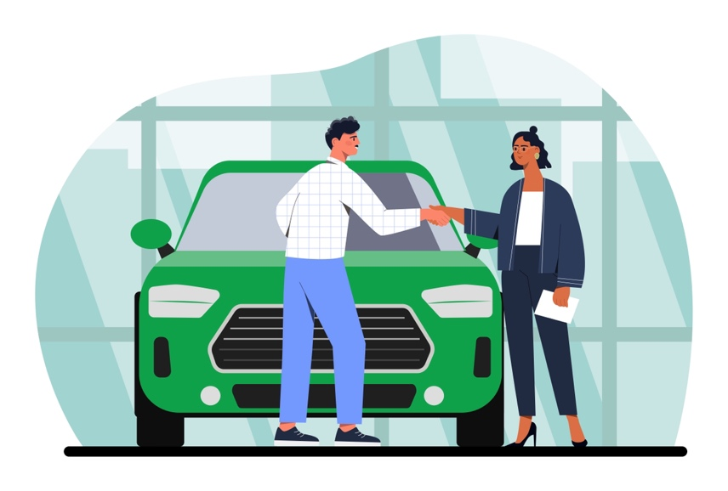

The Intergovernmental Panel on Climate Change (IPCC) is a group founded by the United Nations in 1988 and made up of scientists whose findings are endorsed by world governments. IPCC reports have found that California is a leader in the electric vehicle (EV) sector and that the economy of California benefits from faster EV adoption. Reports also reveal that pollution disproportionately affects disadvantaged communities, and reducing pollution benefits them. Gas-powered vehicles release about 1.5 billion tons of greenhouse gases (GHGs) into the atmosphere each year, mostly in the form of carbon dioxide (CO2). This accounts for about 17% of U.S. greenhouse gas emissions. Additionally, reports highlight that state and national leaders are calling for earlier phaseouts of internal combustion engines.

As part of this policy, consumers must make many vehicle-related decisions. First is what car to buy. According to data from Cox Automotive, the parent company of Kelley Blue Book, the average transaction price for new EVs was $53,469 in July 2023, compared to $48,334 for new gas-powered vehicles. Consumers could also consider buying used cars; however, this would perpetuate the emissions issue that the ban is trying to address.

Consumers must also consider the price of buying gasoline versus recharging EV batteries. Gas prices have risen steeply and are subject to fluctuations in national and international markets. Many consumers feel the strain on their wallets at the gas pump. For many, the cost of charging would be much less. Besides the dollar amount, time is an issue. Electric vehicles can take upwards of an hour to charge, while a gas-powered vehicle can be refueled in minutes.

A regularly occurring cost for vehicles whether it be electric or gas-powered is the cost of maintenance. All-electric vehicles typically require less maintenance than conventional vehicles because the electrical system (battery, motor, and associated electronics) typically requires minimal scheduled maintenance, and brake systems generally last longer than those on conventional vehicles because of regenerative braking. There are also fewer fluids to check, change, and maintain. However, batteries have a limited lifespan and only have a certain number of charges. Many EV car manufacturers offer a battery warranty but replacing batteries can be a significant expense (upwards of $20,000). However, as technology improves and more competition exists, battery life and cost will improve for consumers. Maintenance costs for a gas-powered vehicle are estimated to be around $792 per year although this can vary greatly with vehicles. Also, skipping regular maintenance of auto services can lead to major costs later.

Another major consideration for consumers is where and when to charge EVs. It may be easier for people in single family houses to recharge. But it will be difficult for people living in apartment complexes where there are many vehicles with limited parking and outlets for charging. Additionally, California has limited grid capacity, although as technology improves, this could be enhanced in the future (although the timing is unclear). Currently, consumers are being encouraged to charge their cars in the evening or during off-peak times to avoid grid overload, which has contributed significantly to wildfires in the state for the last several years.

**Policy Stakeholder 2: City planners in California**

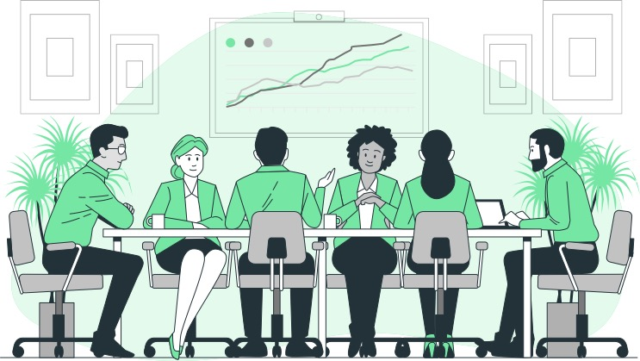

City planners across the state face additional hurdles in achieving the goals of this policy. One of the most significant challenges is the limited availability of charging stations. Currently, there are not enough reliable charging stations in California. Currently there are about 80,000 charging stations in public places, which falls significantly short of the 250,000 it aims to have by 2025. The Alliance for Automotive Innovation, representing many major car makers, agrees that lack of infrastructure including the lack of charging stations is a major barrier. Additional challenges for planning in California include meeting the required driving range. The regulation stipulates that vehicles should be able to travel at least 150 miles without recharging. This poses a significant challenge for long road trips. One potential solution could involve the installation of recharging stations along various highways. However, how would hundreds of thousands of charging stations be constructed and who would bear the costs?

Furthermore, individuals who store their vehicles in private home garages might find evening charging feasible. However, even if apartment property owners were to install charging stations in assigned parking areas, apartments typically provide only one parking space, even when apartments have multiple tenants who own cars. This is why the streets near residential complexes are often congested with parked vehicles.

CA Governor Newsom signed into law several bills to accelerate critical infrastructure projects across California. These bills allocate funding to help build the electric grid, ensure safe drinking water, boost the state’s water supply, and modernize the transportation system. These are all major infrastructure issues that will impact electric vehicle (EV) use. The electrical grid falls short of the ability to power the state with the added use from charging EVs. Water has been a major issue in the state of California and a lack of water (in part due to droughts and climate change) with the strained grid has led to major wildfires in the state. The bill includes $180 billion in state, local, and federal infrastructure funds over the next ten years which is estimated to create up to 400,000 good-paying jobs. While this could be good for urban and densely populated areas it’s unclear how much benefit rural or lower population areas will experience.

**Policy Stakeholder 3: Car companies (i.e., General Motors, Ford, Honda, Fiat Chrysler)**



Because California is the largest auto market in the U.S., many states base their car emission requirements on what is happening in California. Some automakers like GM and Ford have been investing large amounts of money since 2018 to develop electric vehicles (EV). Other companies like Fiat Chrysler (part of Stellantis) have been less enthusiastic about the transition and are unlikely to be able to meet the targets set by California in time.

There seems to be strong consumer demand for EVs, but sales of EVs made up only 3% of total sales in 2022. One hurdle to EV adoption is their price. According to data from Cox Automotive, the parent company of Kelley Blue Book, the average transaction price for new electric cars was $53,469 in July 2023, compared to $48,334 for new gas-powered vehicles. Car companies will need to figure out how to supply affordable EVs. The most significant source for the price difference is expensive batteries for electric cars.

Environmental impact is another cost facing car companies. Gas-powered vehicles release about 1.5 billion tons of greenhouse gases (GHGs) into the atmosphere each year, mostly in the form of carbon dioxide (CO2). This accounts for about 17% of U.S. greenhouse gas emissions. MIT researchers found that the creation of large lithium-ion batteries is one source of EV emissions. Mining and processing the materials for modern EV batteries, including lithium, cobalt, and nickel, requires the use of fossil fuels. As a result, building the 80-kWh lithium-ion battery found in a Tesla Model 3 creates between 2.5 and 16 metric tons of CO2, with the exact amount depending greatly on the energy source used for processing the materials. This intensive battery manufacturing means that building a new EV can produce around 80% more emissions than building a comparable gas-powered car. But just like gasoline cars, most emissions from today’s EVs come after they roll off the production floor. The major source of EV emissions is the energy used to charge their batteries. The U.S. Department of Energy found that EVs create 3,932 lbs. of CO2 equivalent per year, compared to 5,772 lbs. for plug-in hybrids, 6,258 lbs. for typical hybrids, and 11,435 lbs. for gasoline vehicles.

**Policy Stakeholder 4: California Utility Companies**

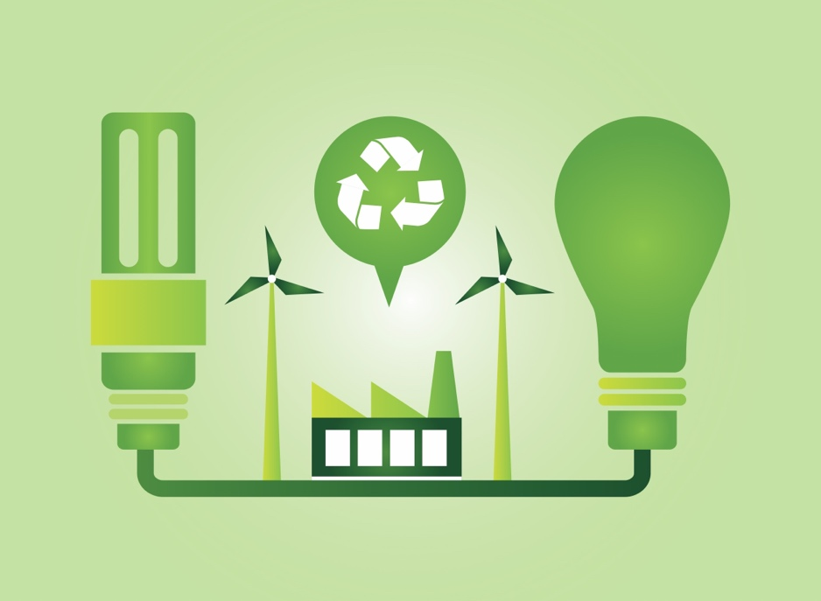

California currently does not have enough energy during heatwaves. The high use of energy during periods of high temperatures can put a lot of strain on power lines. Additionally, during drought and heat waves, dying trees can fall and damage power lines which can still be highly active and start a spark. This has led to many wildfires in the last few years, especially when the climate is so dry.

While California gets most of its energy from renewable sources during the day, it does not yet have the storage capacity to distribute sufficient solar power after the sun goes down. To address this challenge, the state may consider using diesel generators or natural gas plants as a backup when the grid is strained. However, it's important to note that diesel-powered generators cannot be used beyond 2023, raising the question of what alternative backup options exist. California is poised to lead the way in addressing a challenge that other U.S. states are likely to encounter as they transition away from fossil fuels and increase their reliance on grid-based energy.

The California Department of Water Resources has been designated as the "strategic reliability reserve" due to its substantial power production and consumption resulting from its dams and management of the state's water pumping infrastructure. The department could reimburse utility companies if they must buy extra power and add temporary power generators, including those powered by fossil fuels during times when there is high-energy use. Furthermore, the department has the authority to develop new energy storage facilities and environmentally friendly power generation stations.

**Policy Stakeholder 5: Lithium battery producers**



The extraction of minerals like lithium, cobalt, and nickel, which are essential for modern EV batteries, involves the use of fossil fuels for mining and high-temperature processing. There is also an immense demand for these minerals. The Democratic Republic of Congo (DRC) holds a dominant position in the cobalt industry. It is home to half of the world's reserves, and nearly 90 percent of the cobalt produced in DRC goes into automakers' batteries. The extraction of cobalt can come at a significant human cost. For years, reports have surfaced about dire working conditions in Congo's informal mining sector. Amnesty International and the Congolese rights group Afrewatch published a report detailing deaths and injuries among the workers, including countless children working in small-scale, hand-dug mines, often in manually carved tunnels that frequently collapsed, burying miners alive.

The U.S. is going to have to diversify its sources of minerals, but companies must obtain minerals domestically or from countries that have free trade agreements with the U.S. The problem is that some of the largest deposits of nickel and cobalt are in Indonesia and the DRC, respectively—countries with which the U.S. does not have free trade agreements.

China, on the other hand, has substantial stakes in both countries. The country itself is not mineral-rich, but it owns almost half of the cobalt mines and controls a quarter of the lithium supply. In 2022, China refined 95% of manganese, roughly 70% of cobalt and graphite, two-thirds of lithium, and over 60% of nickel which are all key materials for lithium-ion batteries. The U.S. has small amounts of those, and other elements used in EVs, but permitting for mining and processing is cumbersome.

Battery producers have limited natural resources and are constrained by current production. However, with EVs becoming the main vehicle produced, companies are working to expand the life cycle and power of the existing technology–this is to ensure longer battery life and stretch the existing limited resources. As more research is conducted alternative batteries and materials will be explored.

Teacher: Use this document and suggested bullet points below to help you guide the discussion while students are in their Policy Stakeholder groups in procedures 11-12.

**Policy Stakeholder 1: Consumers**

1. What benefits would the policy have for someone in this role?
   * General reduction in pollution and reduction in pollution to help economically disadvantaged individuals.
   * Cheaper to charge than filling up with gas. Might also be more price stable as gas prices have been volatile in the past.
2. What costs would the policy have for someone in this role?
   * EVs are expensive and there are few used options given the newness of them in general.
   * Issues with charging EVs.
     + What happens to the people who live in multi-person housing (i.e., apartments, roommates, etc.).
     + Grid capacity to charge is an issue in California.
     + Extensive time to charge a vehicle vs. filling up with gas
3. In general, how would someone with this role feel about banning gas-powered vehicles? Explain. Be sure to identify the most important benefits and/or costs in your decision.
   * Accept any opinion as long as they back their opinion with examples of the costs or benefits above (or have other reasonable costs and benefits). Note that stakeholders may change their opinions between this step and getting into bigger groups once they hear other points of view. Additionally, stakeholders do NOT all have to agree at this step.

**Policy Stakeholder 2: City Planners in California**

1. What benefits would the policy have for someone in this role?
   * The infrastructure bill and other changes will create about 400,000 jobs in California and have subsequent economic benefits. ‘
   * With the already strained electrical grid the regulation will enact substantial infrastructure issues that are needed for future projects and growth.
2. What costs would the policy have for someone in this role?
   * Limited charging stations in urban areas and more challenges for charging in rural stations. Challenges for charging and infrastructure issues because the regulation requires that vehicles should be able to travel 150 miles at a time–how can this be accommodated?
   * City accommodation issues with charging stations for people living in apartment complexes.
   * Charging stations straining the electrical grid.
3. In general, how would someone with this role feel about banning gas-powered vehicles? Explain. Be sure to identify the most important benefits and/or costs in your decision.
   * Accept any opinion as long as they back their opinion with examples of the costs or benefits above (or have other reasonable costs and benefits). Note that stakeholders may change their opinions between this step and getting into bigger groups once they hear other points of view. Additionally, stakeholders do NOT all have to agree at this step.

**Policy Stakeholder 3: Car company (i.e., General Motors, Ford, Honda)**

1. What benefits would the policy have for someone in this role?
   * Some car companies have been working on EVs for a while and will sell more cars than competitors who do not have adequate supply.
   * Consumers seem to have high demand for these vehicles which will increase profits for car companies.
   * Post-production EVs emit fewer greenhouse gases and CO2 than Hybrids and gas-powered vehicles.
2. What costs would the policy have for someone in this role?
   * Some car companies have not invested money into producing EVs and will lose out on potential profits and take on a high-cost investment to continue to produce these vehicles which can be risky.
   * Large amounts of greenhouse gases and CO2 during the production. Including emissions from charging batteries.
   * EVs are more expensive for consumers than gas-powered vehicles currently.
3. In general, how would someone with this role feel about banning gas-powered vehicles? Explain. Be sure to identify the most important benefits and/or costs in your decision.
   * Accept any opinion as long as they back their opinion with examples of the costs or benefits above (or have other reasonable costs and benefits). Note that stakeholders may change their opinions between this step and getting into bigger groups once they hear other points of view. Additionally, stakeholders do NOT all have to agree at this step.

**Policy Stakeholder 4: Electric company/ California Load-Serving Entity (LSE)**

1. What benefits would the policy have for someone in this role?
   * Because of limited power constraints the California Department of Water Resources has the ability to develop new energy storage facilities and environmentally friendly power generation stations for future use.
   * California is leading the way in the US for addressing the transition away from fossil fuels making it easier for other states to follow suit.

1. What costs would the policy have for someone in this role?
   * Strained power grid especially during heat waves and other periods of high-energy use.
   * There are limited alternative energies to non-renewable sources or storage of renewable energy (i.e., storing solar energy collected during the day).
2. In general, how would someone with this role feel about banning gas-powered vehicles? Explain. Be sure to identify the most important benefits and/or costs in your decision.
   * Accept any opinion as long as they back their opinion with examples of the costs or benefits above (or have other reasonable costs and benefits). Note that stakeholders may change their opinions between this step and getting into bigger groups once they hear other points of view. Additionally, stakeholders do NOT all have to agree at this step.

**Policy Stakeholder 5: Lithium battery producer**

1. What benefits would the policy have for someone in this role?
   * The US has small amounts of resources needed to produce EV batteries.
   * EV battery production will improve as the market moves away from gas-powered vehicles which will make batteries more productive and possible using different resources.
2. What costs would the policy have for someone in this role?
   * Extraction of battery minerals uses fossil fuels and relies on controversial labor practices (unsafe conditions, child labor, etc.).
   * The majority of resources needed for batteries is in Indonesia and the Democratic Republic of Congo (DRC) which the US does not have free trade agreements with. However, China does have substantial stakes in both countries and owns a substantial amount of the resources for EV battery production.
3. In general, how would someone with this role feel about banning gas-powered vehicles? Explain. Be sure to identify the most important benefits and/or costs in your decision.

* Accept any opinion as long as they back their opinion with examples of the costs or benefits above (or have other reasonable costs and benefits). Note that stakeholders may change their opinions between this step and getting into bigger groups once they hear other points of view. Additionally, stakeholders do NOT all have to agree at this step.

|  |  |  |  |
| --- | --- | --- | --- |
|  | What benefits would the policy have for this group? | What costs would the policy have for this group? | Would this group be in favor of the policy? |
| Role 1: Consumers |  |  | Y / N |
| Role 2: City Planners in California |  |  | Y / N |
| Role 3: Car companies (i.e., General Motors, Ford, Honda) |  |  | Y / N |
| Role 4: California Utility Companies |  |  | Y / N |
| Role 5: Lithium battery producers |  |  | Y / N |

1. Ultimately, after hearing from the different roles of people affected by the policy, is your group in favor of the policy to ban gas-powered vehicles in California by 2035?
2. Which role had the most influence or was the most important in your decision? Explain why.
3. What opportunity costs does a bill like this have? Please list and explain 2-3 and specify which role(s) is(are) most likely to experience those opportunity costs.
4. Regardless of how the group voted, what improvements could be made to the policy to either make it feasible to pass (if your group was not in favor) or make it so more policy stakeholders within the group were in favor of the bill (if you were in favor but some stakeholders were against).To help you do this, think about the costs from the different roles and if there are ways to reduce the costs to those stakeholders?

*Use this document as an alternative assessment using a policy of your choosing - either locally or nationally. Provide students news articles, podcasts, and other information and then have them answer the following questions.*

1. Based on the policy provided, think of 5 groups of people that might be affected. List them in the first column.

|  |  |  |  |
| --- | --- | --- | --- |
| Groups of people | Costs of adopting the policy for this group. | Benefits of adopting the policy for this group. | Is this group likely to vote for or against the policy? Explain |
|  |  |  |  |
|  |  |  |  |
|  |  |  |  |
|  |  |  |  |
|  |  |  |  |

1. Based on your table in question 1, should this policy be passed? Why or why not?
2. Regardless of how you voted, what improvements could be made to the policy to either make it feasible to pass (if your group was not in favor) or make it so more roles within the group were in favor of the bill (if you were in favor but some roles were against).To help you do this think about the costs from the different roles and if there are ways to reduce the costs to those groups.

## References

Advanced Clean Cars II | California Air Resources Board. (n.d.).<https://ww2.arb.ca.gov/our-work/programs/advanced-clean-cars-program/advanced-clean-cars-ii>

Avery, D. (2023, September 8). These 9 states are banning the sale of Gas-Powered cars. CNET. <https://www.cnet.com/roadshow/news/states-banning-new-gas-powered-cars/>

Goodwin, A. (2022, June 9). What Biden’s proposed EV charging standards mean for you. CNET. <https://www.cnet.com/roadshow/news/biden-administration-proposed-ev-charging-standards/>

Orf, D. (2023, January 6). Does the world have enough lithium for batteries? Popular Mechanics. <https://www.popularmechanics.com/science/energy/a42417327/lithium-supply-batteries-electric-vehicles/>

Role Card Sources

**Role 1: Consumers**

AAA. (2015, October 7). What does it cost to own and operate a car? AAA Automotive. <https://www.aaa.com/autorepair/articles/what-does-it-cost-to-own-and-operate-a-car>

Intergovernmental Panel on Climate Change. (2023). IPCC Sixth Assessment Report (AR6) - Synthesis Report: Summary for Policymakers.<https://www.ipcc.ch/report/ar6/syr/downloads/report/IPCC_AR6_SYR_SPM.pdf>

Maintenance and safety of electric vehicles. Alternative Fuels Data Center: Maintenance and Safety of Electric Vehicles. (n.d.). <https://afdc.energy.gov/vehicles/electric_maintenance.html>

Smith, B. K. (2022, October 1). *Locals react to* *gas vehicle ban plan for 2035*. WKTV NewsChannel2.<https://www.wktv.com/news/locals-react-to-gas-vehicle-ban-plan-for-2035/article_5c709418-418d-11ed-9715-177bc72412c4.html>

Valdes, R. (2023, July 10). How much are electric cars? *Kelley Blue Book*.<https://www.kbb.com/car-advice/how-much-electric-car-cost/>

**Role 2: City Planners in California**

The Associated Press. (2022, August 25). California is poised to phase out sales of new gas-powered cars. NPR. <https://www.npr.org/2022/08/25/1119381508/california-ban-gas-cars-2035>

Walters, D. (2022, August 29). California’s ban on gas-powered cars won’t be easy. CalMatters.<https://calmatters.org/commentary/2022/08/californias-ban-on-gas-powered-cars-wont-be-easy/#:~:text=California%20will%20ban%20sales%20of,powered%20new%20cars%20after%202035>.

California, S. O. (2023, July 10). Governor Newsom signs infrastructure & budget legislation to build More, faster. California Governor.<https://www.gov.ca.gov/2023/07/10/governor-newsom-signs-infrastructure-budget-legislation-to-build-more-faster/>

**Role 3: Car company (i.e., General Motors, Ford, Honda)**

De La Garza, A. (2022, August 26). Some Automakers Didn’t Take Climate Change Seriously. California’s New Gasoline Car Ban is Making Them Face Reality. Time.<https://time.com/6209011/california-gasoline-car-ban-electric-vehicles/>

Reduce climate change. (n.d.).<https://www.fueleconomy.gov/feg/climate.shtml>

Are electric vehicles definitely better for the climate than gas-powered cars? (n.d.-c). MIT Climate Portal.<https://climate.mit.edu/ask-mit/are-electric-vehicles-definitely-better-climate-gas-powered-cars>

Rezvani, A. (2022, August 27). California wants to end sales of new gas cars by 2035. Here are 4 key roadblocks. NPR.<https://www.npr.org/2022/08/27/1119360031/california-gas-cars-electric-cars-zero-emission-climate-change>

**Role 4: California Utility Companies**

Ronayne, K. (2022, July 1). To avoid blackouts, California may tap fossil fuel plants. AP News.<https://apnews.com/article/california-gavin-newsom-solar-power-climate-and-environment-036f59845ab510729378e52a39b81ae1>

**Role 5: Lithium battery producer**

Lienert, P. (2021b, July 7). Analysis: When do electric vehicles become cleaner than gasoline cars? Reuters.<https://www.reuters.com/business/autos-transportation/when-do-electric-vehicles-become-cleaner-than-gasoline-cars-2021-06-29/>

Bashizi, K. H. A. (2023, August 4). Mines for electric car metals in Congo strain workers’ health, families. Washington Post.<https://www.washingtonpost.com/world/interactive/2023/ev-cobalt-mines-congo/>

Beaule, V. (2023, February 8). Artisanal cobalt mining swallowing city in Democratic Republic of the Congo, satellite imagery shows. ABC News.<https://abcnews.go.com/International/cobalt-mining-transforms-city-democratic-republic-congo-satellite/story?id=96795773>

Are electric vehicles definitely better for the climate than gas-powered cars? .(n.d). MIT Climate Portal.<https://climate.mit.edu/ask-mit/are-electric-vehicles-definitely-better-climate-gas-powered-cars>

Northam, J. (2023, July 22). China dominates the EV battery industry. Can the rest of the world catch up? NPR.<https://www.npr.org/2023/07/22/1189580644/china-dominates-the-ev-battery-industry-can-the-rest-of-the-world-catch-up>

1. <https://ww2.arb.ca.gov/our-work/programs/advanced-clean-cars-program/advanced-clean-cars-ii> & <https://www.cnet.com/roadshow/news/states-banning-new-gas-powered-cars/>
2. PBS News Hour Video, California’s move to ban sales of new gasoline-fueled cars could spread to other states: <https://www.pbs.org/newshour/show/californias-move-to-ban-sales-of-new-gasoline-fueled-cars-could-spread-to-other-states>