From Power Plant to PlayStation™: Electricity’s Journey from Producer to Consumer
Author: Angie Battle
Objectives:  Students will be able to:  - Identify the natural, human, and capital resources used to produce and distribute electricity to consumers.  - Explain that consumers (in their homes and businesses) voluntarily exchange money for the electricity produced by power plants.  - Explain that electric companies pay for productive resources to produce electricity using money from consumers who purchased their product.  - Identify the process of generating and distributing electricity for consumer use. | Materials:  - PPT presentation: “Electricity Explorers: Unraveling Resources”  - Energy 101: Electricity Generation YouTube video (embedded in presentation but linked here in case of technical issues) https://www.youtube.com/watch?v=20Vb6hlLQSg  - Activity 1.1 Note Taking Sheet: Examples of Productive Resources, one copy per student  - One piece of string, twine, or yarn, at least 6 feet long  - Paper clips or tape  - Activity 1.2a Cards: Capital Goods, one set, printed and cut out on dotted lines  - Activity 1.2b Cards: Natural Resources, one set, printed and cut out on dotted lines  - Activity 1.2c Cards: Human Resources, one set, printed and cut out on dotted lines  - Activity 1.3 Assessment: Electricity’s Journey from Producer to Consumer worksheet, one copy per student
Suggested Time Frame:  45 minutes | National Standards in Economics:  Standard 1: Scarcity  Next Generation Science Standards:  4-PS3-2 Energy
Teacher Preparation:
- It is recommended to take 15 minutes of preparation for the lessons.
- Cut a piece of string, twine, or yarn that is at least 6 feet long.
- Print Activity Cards 1.2a: Capital Goods, 1.2b: Natural Resources, and 1.2c: Human Resources in color on sturdy cardstock (preferably) and cut apart.
- Print copies of Activity 1.1 Note Taking Sheet: “Examples of Productive Resources,” and Activity 1.3: Assessment “Electricity’s Journey from Producer to Consumer,” one each per student.
Warm-Up/Bellringer
- Display Slide 1 of the PowerPoint to begin the lesson. Tell students they will embark on a journey in which electricity makes its way from where it is generated to their living room.
- Advance to Slide 2 and ask students to raise their hand if they enjoy playing video games at home. Several students will raise their hands. Ask students, “Do you play video games on a video console like PlayStation™, on a computer or laptop or even your phone?” Allow them a few moments to take turns responding. Answers may vary between those three options.
- Show Slide 3 which reminds them that the video game console, computer, and other items in their homes are powered by electricity. Then ask, “How does this work? Is it magic?” Answers will vary but may include it’s not magic, it’s electricity. Next, ask, “How do electric companies generate and distribute electricity to our homes and people’s businesses?”
- Go to Slide 4 and declare, “It’s the power of productive resources!”
- Display Slide 5 and tell students that productive resources are the natural resources, human resources, and capital goods available to make goods and services. The next few slides will elaborate on what productive resources are and give examples in the production and distribution of electricity. It is not necessary to spend more than a couple of minutes with each part.

Group Discussion – Introducing the Concepts
- Display Slide 6: Define natural resources as “gifts of nature” - like air, soil, and water - present without human intervention. Ask students if they can think of any more examples than those named. Answers may vary but may include wood from trees, fish, gold, sunlight, oil, wheat, cattle, etc.
- Display Slide 7: Tell students that these are examples of natural resources used when producing electricity. Ask students if there are any examples that are surprising. Answers may vary but may include any named on the slide. Note that students may be unfamiliar with biomass. If necessary, define it as renewable, organic materials that come from plants and animals such as wood, crops, manure, compost, and some garbage.
- Display Slide 8: Define human resources as the people who do the mental and physical work to produce goods and services and is sometimes referred to as labor. That labor includes the mental and physical work necessary to do their job. Explain to students that people like teachers trade their labor for income. People use their income – money or salary exchanged for the use of their labor - to trade for the things they do not produce themselves.
- Ask if they can think of any other examples of human resources. Answers may vary but may include firefighters, bankers, chefs, delivery drivers, construction workers, etc.
- Display Slide 9: Tell students these are examples of human resources that perform work in generating and distributing electricity from the power plant to homes and businesses. Review each human resource as follows:
- power plant operator - someone who controls, operates, and maintains machinery to generate electricity
- lineworker - someone who installs, services, and emergency repairs electrical lines in the case of lightning, wind, ice storm, or ground disruptions
- meter reader - someone who works in the field to read the electrical meters on homes to make sure homeowners are paying the correct amount each month for their energy consumption
- electrician - someone who specializes in electrical wiring of buildings, transmission lines, stationary machines, and related equipment
- electrical engineer - someone who designs, develops, tests, and manages the manufacturing of electrical equipment

- Display Slide 10: Define capital goods as goods produced and used to make other goods and services. Tell students that producers use goods that are produced to make other goods and services. Tell them you use a computer to do your work. That computer is a capital good. Ask students for additional examples such as what capital good a carpenter might use Answer: Hammer or saw. What might a baker use? Answer: Oven, mixer.

- Display Slide 11: Tell students these pictures are examples of capital goods used to generate and distribute electricity. Explain we are about to see the sequence or order in which these are used in the production and distribution of electricity. We will learn more about how each one is used in this process.

Check for Understanding – Individual Activity

- Advance to Slide 12 and ask students, “How does electricity produced in power plants get to your home?” Pass out a copy of Activity 1.1 Note Taking Sheet: “Examples of Productive Resources” to each student. Tell them they will watch a video on electricity generation to help them answer this question. Instruct them to use the note taking sheet to jot down examples of natural resources, human resources, and capital goods they observe in the video, “Energy 101: Electricity Generation.” https://www.youtube.com/watch?v=20Vb6hlLQSg
Click on image in slide to show video.

- At the conclusion of the video, have students take 2 minutes to turn to their closest neighbor and share examples of productive resources they recorded on their note taking sheet. They may add to their notes if their partner shares something they missed and vice versa. Circulate around the room to listen to the conversations about what they noticed. Answers you may hear are natural resources such as ocean tides, natural gas, coal, wind power, and capital goods such as wind turbine, transformer, transmission lines, towers, substations, breaker box, light sockets, outlets, etc. Note: You may want to have the students watch the video a second time and stop at different points to give them an opportunity to write down the productive resources mentioned.

Check for Understanding – Read Aloud and Note Taking

- After 2 minutes, ask students if there was any category of productive resource they did not see or hear specifically mentioned. Answer: human resources. Explain to students the video focused on the natural resources and a few capital goods, but it did not name jobs associated with electricity generation and distribution. Say to them, “Spoiler alert, we are going to see this sequence again in the next several slides. We will not see examples of human resources here either. However, in our next activity, you will be given an opportunity to learn about these jobs and how they fit in the whole process of generating and distributing electricity.”

- Display Slides 13-20. For each slide read aloud or have students read aloud the steps electricity takes from production to consumption. As you do, instruct them that they should continue adding examples to their Activity 1.1 Note Taking Sheet: “Examples of Productive Resources.”

- Each of these slides are numbered 1-8 to indicate what step of the process is being explained.
  - Display Slide 13: Step 1- Electricity is made at a generating station by huge generators. Generating stations can use wind, coal, natural gas, nuclear power, or water.
  - Display Slide 14: Step 2 – The electrical current is sent through station transformers to increase the voltage to push the power long distances.
  - Display Slide 15: Step 3 - The electrical charge goes through high-voltage
transmission lines that stretch across the country.
  - Display Slide 16: Step 4 - It reaches a substation, where the voltage is lowered
so it can be sent on smaller power lines.
  - Display Slide 17: Step 5 - It travels through distribution lines to your neighborhood.
Smaller transformers reduce the voltage again to make the power safe to use in our homes. These smaller transformers may be mounted on poles or sitting on the ground.
  - Display Slide 18: Step 6 - The electricity connects to your house and passes through a meter that measures how much your family uses.
  - Display Slide 19: Step 7 - The electricity goes to the service panel, usually in your basement or garage, where breakers or fuses protect the wires inside your house from being overloaded (Never touch a service panel!).
  - Display Slide 20: Step 8 - The electricity travels through wires inside the walls to the outlets and switches all over your house allowing you to play video games.

- Give students another 2 minutes to share with their partner what they have added to their notes. As you walk around you may hear answers such as generating station, nuclear energy, service panel, outlets, switches, etc.

Group Activity – Create a Power Line

- Advance to Slide 21 and read it aloud: “You will now create a POWER LINE showing how electricity makes its journey from producer to consumer using what we know about productive resources.” Choose two students to hold the two ends of the long piece of string, twine, or yarn. Pass out the Activity 1.2a Cards: Capital Goods, Activity 1.2b Cards: Natural Resources, and Activity 1.2c Cards: Human Resources (19 cards in all). If you have more students than cards remaining, you can partner students with those with a card. If you have more cards than students, you can put up the first couple capital goods cards in their correct places as an example.

- Advance to Slide 22. Read aloud or have a student read aloud the text on the slide, “The first cards to put on our POWER LINE will be capital resources used by electric companies to generate and distribute electricity. There are 8 of them. You must put them in the correct sequence of production, distribution, and consumption.” Tell students they will use details they remember from the video and previous slides to determine where to put the capital good cards in order of when they are used in the process. Ask if anyone believes they have the first card. Answer: Generating Station. Affirm aloud that a generating station is a capital good. Hand that student a piece of tape or a paper clip with which to attach the card to the left side of the piece of string. You will continue this process with each correct response. The order of the cards to be added in this first round (from left to right) is:
- GENERATING STATION
- STATION TRANSFORMER
- TRANSMISSION LINES
- SUBSTATION
- DISTRIBUTION AND TRANSFORMERS
- METER
- SERVICE PANEL
- WIRES, OUTLETS, AND SWITCHES THROUGHOUT YOUR HOME
Reiterate that each of these images represents capital goods.

- Go to Slide 23. Read aloud or have a student read aloud the text on the slide: “The next set of cards to put on our POWER LINE will be natural resources used by electric companies to produce electricity. There are 4 of them. You must attach them to the capital resource card they would be used with.” Tell the students there is a hint in the image. Ask if they can figure it out.
(Hint: The four natural resource cards will be attached to the first capital good card, generating station.) Those cards are labeled water, coal, natural gas, and wind. As you did in the last round, emphasize that each of these images represents natural resources used in the production of electricity.

- Advance to Slide 24. Read aloud or have a student read aloud the text on the slide: “The final set of cards to put on our POWER LINE will be human resources who work to produce and distribute the electricity to consumers. There are 6 of them. You must attach them to the capital resource card they can work with.” Tell students there’s more than one correct spot on a capital good card for each of these remaining cards. Have students who have the remaining cards read each one or read it for them. After each one, ask the class where each should go. Answers:
  - METER READER - can only be attached to the METER card.
  - POWER PLANT OPERATOR - can only be attached to the GENERATING STATION card.
  - ELECTRICAL ENGINEER - can be attached to any capital good card.
  - LINEWORKER - can be attached to either the TRANSMISSION LINES card or the DISTRIBUTION LINES AND TRANSFORMERS card.
  - ELECTRICIAN - can be attached to any capital good card.
  - POWER PLANT TECHNICIAN - can only be attached to the GENERATING STATION card.

- Go to Slide 25 and pose the question: "How do electric companies get the PRODUCTIVE RESOURCES they use to produce electricity for consumers?”

- Advance to Slide 26 and use the following points to guide students through the diagram.

- Consumers from homes and businesses voluntarily exchange their money for electricity when they pay their electric bill.
- Electric companies voluntarily exchange the money received from consumers with owners of productive resources.
- Electric companies use the productive resources to generate electricity which they sell to homes and businesses.

- Display Slide 27. Read the slide to students: "Because of this voluntary exchange, both the producer of electricity (an electric company) and the consumers (homes and businesses) expect to be better off after the trade.” Ask students:
  - How are consumers better off as a result of this voluntary exchange? Answer: They have electricity for their homes and/or businesses.
  - How is the electric company better off? Answer: The electric company gets money to buy the productive resources needed to generate and distribute electricity.

Closure: Group Discussion – Create a Power Line Debrief

- Display slide 28-29: To wrap up the lesson, ask students the following questions:
  - What are natural resources? Answer: Natural resources are "gifts of nature," like air, soil, water, present without human intervention.
  - What are human resources? Answer: Human resources are the people who do the mental and physical work to produce goods and services.
  - What are capital resources? Answer: Capital resources are goods produced and used to make other goods and services.
  - What do consumers voluntarily trade with electric companies to get electricity in their homes? Answer: Money
  - What do electric companies do with the money they receive from consumers? Answer: They pay for the productive resources needed to generate and distribute electricity.
  - How are producers and consumers of electricity better off because of this voluntary exchange? Answer: The producers can pay for the productive resources they must have to generate and distribute electricity and consumers get the electricity they want.

- Display Slide 30: Remind students that neither a video game console nor an electric fan they use in their home is powered by magic. As with all goods we consume that require electricity, the electricity must be produced and distributed to consumers who pay a price for it. This requires a lot of natural resources, human resources (labor), and capital goods to provide consumers the electricity they want.

Check for Understanding: Assessment
28. Provide each student a copy of Activity 1.3 called Assesssment Electricity’s Journey from Producer to Consumer worksheet. Allow them about 10-15 minutes to complete it either independently or with a learning partner. Go over the correct answers with students using the answer key provided.

Extension

Create a station with copies of the cards. Students can sort them into the three categories – natural resources, capital goods, and human resources.

Students may be interested in furthering their understanding of how producers generate electricity and how consumers in the U.S. use electricity. Below are some websites that can help in researching these topics.
- How Does Your State Make Electricity: https://www.nytimes.com/interactive/2020/10/28/climate/how-electricity-generation-changed-in-your-state-election.html
- Your Region’s Source of Energy:
https://www.epa.gov/egrid/power-profiler#/
- Energy Consumption Per Capita (By State):
https://www.eia.gov/state/
- How Does Electricity Get to Your Home?
https://mrelectric.com/blog/how-does-electricity-get-to-your-home

Natural Resources | Human Resources | Capital Resources

Someone who works in the field to  read the electrical meters on homes make sure they are paying the  correct amount each month for  their energy consumption  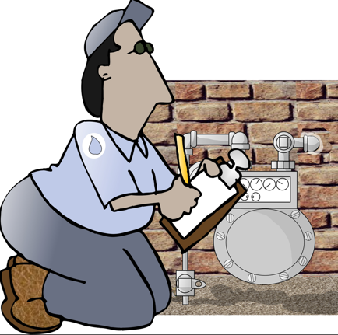  METER READER | Someone who controls, operates,  and maintains machinery to  generate electricity  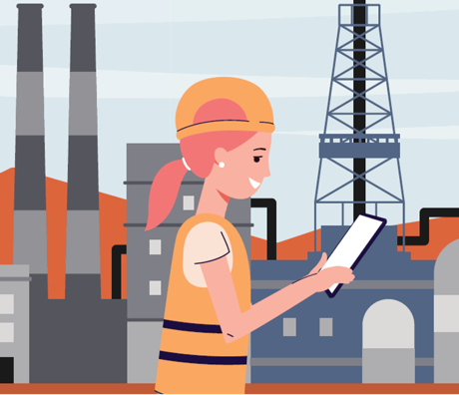  POWER PLANT OPERTATOR | Someone who designs, develops, tests and manages the manufacturing of electrical equipment  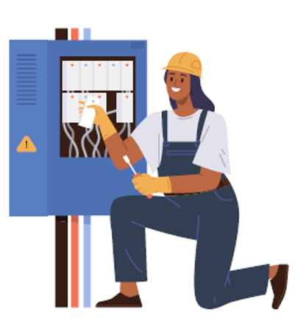  ELECTRICAL ENGINEER
Someone who installs, services, and emergency repairs electrical lines in  the case of lightning, wind, ice  storm, or ground disruptions  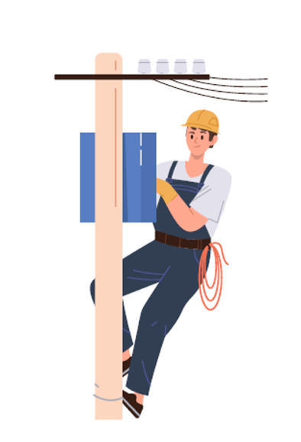  LINEWORKER | Someone who specializes in  electrical wiring of buildings, transmission lines, stationary  machines, and related equipment  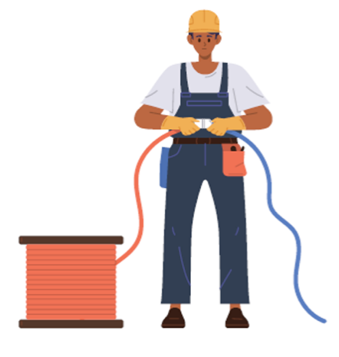  ELECTRICIAN | Someone who is responsible for controlling and monitoring all of the equipment found in power plants, such as boilers, turbines and generators  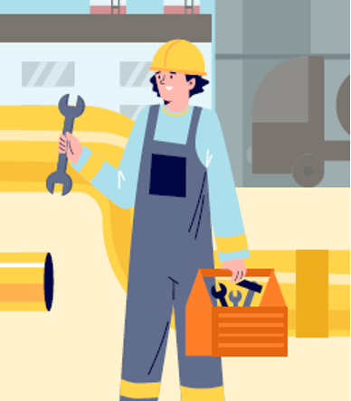  POWER PLANT TECHNICIAN

Name _____________________________________________
Electricity’s Journey from Producer to Consumer

Part 1 Directions: Write an N in the box above any image below that shows a NATURAL RESOURCE, and H above an image of a HUMAN resource, and a CG above a CAPITAL GOOD.

Part 2 Directions: Electrician Eddie wants to share the process of getting electricity from a producer (electric company) to the consumers (household and businesses).
He’s got a few of steps mixed up. Write the correct sequence number in front of each step.
A few are done for you.

Step ____ - The electricity goes to the service panel where breakers or fuses protect the wires inside your house (Never touch a service panel!)
1
Step ____ - Electricity is produced at generation stations.
Step ____ - The electricity gets to a substation where the voltage is lowered so it can be sent on smaller power lines.
8
Step ____ - The electricity travels through wires inside the walls to the outlets and switches all over your house… allowing you to play video games
Step ____ - It goes through transmission lines that stretch across the country.
Step ____ - The electricity travels through the smaller distribution lines and goes into smaller transformers to reduce the voltage again before it goes to our homes.
Step ____ - The electricity connects to your house and passes through a meter that measures how much your family uses.
2
Step ____ - The electricity goes through station transformers to increase voltage.

Part 3 Directions: Write the correct term from the word bank below into the place on the diagram where it goes.

Part 4 Directions: Explain how electric companies and households and businesses benefit from this voluntary exchange illustrated in Part 3.

________________________________________________________________________________________________________________________________________________________________________________________________________________________________________________________________________________________________________________________________________________________________________________________________________________________________________________________________________
Name _____________________________________________
Answer Key
Electricity’s Journey from Producer to Consumer

Part 1 Directions: Write an N in the box above any image below that shows a NATURAL RESOURCE, and H above an image of a HUMAN resource, and a CG above a CAPITAL GOOD.
N
CG
H
H
N
CG

Part 2 Directions: Electrician Eddie wants to share the process of getting electricity from a producer (electric company) to the consumers (household and businesses).
He’s got a few of steps mixed up. Write the correct sequence number in front of each step.
A few are done for you.
7

Step ____ - The electricity goes to the service panel where breakers or fuses protect the wires inside your house (Never touch a service panel!)
1
Step ____ - Electricity is produced at generation stations.
4
Step ____ - The electricity gets to a substation where the voltage is lowered so it can be sent on smaller power lines.
8
Step ____ - The electricity travels through wires inside the walls to the outlets and switches all over your house… allowing you to play video games
3
Step ____ - It goes through transmission lines that stretch across the country.
5
Step ____ - The electricity travels through the smaller distribution lines and goes into smaller transformers to reduce the voltage again before it goes to our homes.
6
Step ____ - The electricity connects to your house and passes through a meter that measures how much your family uses.
2
Step ____ - The electricity goes through station transformers to increase voltage.

Part 3 Directions: Write the correct term from the word bank below into the place on the diagram where it goes.
ELECTRICITY
PAYMENT
(electric bill)
ELECTRIC COMPANY
(producer)
HOMES & BUSINESSES
(consumers)
PRODUCTIVE
RESOURCES

Part 4 Directions: Explain how electric companies and households and businesses benefit from this voluntary exchange illustrated in Part 3.
Households and businesses benefit from this voluntary exchange because they get electricity they want to use. Electric companies benefit by getting the money they use to pay for the productive resources they use.
________________________________________________________________________________________________________________________________________________________________________________________________________________________________________________________________________________________________________________________________________________________________________________________________________________________________________________________________________

