Lesson 3: The Future of Batteries
Author: Chris Cannon

In this economics lesson, students will simulate how batteries operate and analyze future improvements to batteries to explain how they can improve productivity.

Description of the lesson
Students participate in an interactive simulation that demonstrates how batteries operate. After discussing how the productivity of batteries has improved, students participate in three mini-skits, with corresponding discussions, to see how various parties are trying to improve batteries or use them in more creative ways in the future.

Economics
The global market for batteries is valued around $105 billion USD and growing as batteries become an increasingly important part of modern technologies in fields like automotive, healthcare, and renewable storage. This lesson will focus on how batteries improve productivity–the amount of output related to one unit of input during a specific amount of time and economic efficiency–the degree to which waste is minimized in production of a good or service and how enhancements to batteries could increase productivity and efficiency over time.

Objectives:  Students will be able to:  - describe how batteries work (at a basic level).  - explain efforts to improve batteries.  - analyze how technological improvement can impact productivity and efficiency.  Concepts:  Productivity  Economic Efficiency | Materials:  - Future of Batteries Slides  - Pencil or pen, one per student  - Scratch sheet of paper for brainstorming, one per student  - Painter’s tape (Three different colors if possible, but the lesson can be done with one) Do not use masking tape.  - Activity 3.1: Human Battery Signs, one set for the class  - Ball of yarn or string or a piece of yarn probably 8-10 ft in length  - TedEd: How do Batteries Work Video (YouTube) https://www.youtube.com/watch?v=9OVtk6G2TnQ  - Activity 3.2: Future of Batteries Questions, one per student, printed front/back  - Activity 3.3: Future of Batteries mini skits (four copies of skit A, two copies of skit B, and four copies of skit D)  - Activity 3.3: Character Name Badges for the students to wear during the skits, printed and cut apart.  - Activity 3.4: Future of Batteries Discussion Guide, one copy for teacher
Suggested Time Frame:  50 minutes | National Standards in Economics or Personal Finance:  Voluntary National Content Standards in Economics  - Standard 15: Economic Growth  - Investment in factories, machinery, new technology, and in the health, education, and training of people stimulates economic growth and can raise future standards of living.
Preparation

Prior to the lesson, use the painter’s tape to create three squares on the floor that mimic what is found on Slide 8 of the slide deck.
Procedure

- Display Slide 1 and tell students that in this lesson they will learn about some of the economics surrounding the battery industry and its future. Ask students what a battery is. (Answer will vary, but most students should be able to point out that it is a device that stores energy that could be used at a later time.)
- Display Slide 2. Explain that a battery is a container in which chemical energy is converted into electricity and used as a source of power.
- Distribute a sheet of scratch paper to each student. Give students 60 seconds to brainstorm as many ways as they can think of that they use batteries on any given day. After the 60 seconds, tell students to turn to their neighbor next to or behind them and compare their lists for 30-45 seconds. Call on five or six students to share a few things on their list. Answers will vary but will likely include phones, cars, remote controls, Bluetooth speakers, computers, etc. You may wish to write their answers on a whiteboard or chart paper.
- Display slide 3 and discuss the following:
  - What do you see/observe? Answers will vary, but eventually lead them to the fact that many of these batteries look similar and perform similar functions but operate using a variety of chemicals.
  - Why might these batteries that, in many cases, are similar sizes and perform many of the same functions, use so many different materials? Students will be guessing for the most part so answers will vary, but will likely include suggestions that the materials have different lifespans, they can or cannot be recharged, etc. At this stage of the lesson, it is not important to explain these in any further detail.
- Display slide 4 and explain that there are a wide variety of other kinds of batteries, like the ones in their phones, industrial batteries, and car batteries.
- Display slide 5 and ask if anyone knows what this type of battery is. Answers will vary. Click for animation to reveal that this is an image of a battery for an electric Tesla Model S.
- Display slides 6 and 7 and explain that batteries have many uses that we often don’t consider and point out some of the additional information about the economic impact of batteries.
- Display slide 8 and explain that despite the difference in looks and uses, almost all batteries operate on the same basic physics and chemistry. There are two metals separated by some kind of electrolyte. An electrolyte in a battery is the substance that allows electrical current to flow between the anode and the cathode. Electrolytes may be fluids or solids. Soluble salts, acids, and bases can generally act as electrolytes.
- Tell students that to understand some of the economic concepts related to batteries, it is helpful to first understand the science of how most batteries work. So, they will participate in a simulation to help them understand how most batteries work.
- Ask for three volunteers or select three students. Give each student a sign from Activity 1: Human Battery Signs. Tell the student with the Metal 1 sign to stand in one of the outside boxes taped on the floor. Tell the student with the electrolyte sign to stand in the middle box and the student with the Metal 2 sign to stand in the remaining box. Note: You are essentially trying to recreate the visual from slide 8.
- Select 8-10 students (or ask for volunteers) to stand inside the Metal 1 box behind the person with the sign. Tell the class these students represent electrons.
- Explain that these are the basic components of a battery. When the battery is built, the electrolyte material causes some chemical reactions in the metals. Ask the student who is the electrolyte to say something exciting or do a move that represents a chemical reaction (their actual answer or movement doesn’t matter). If they can’t come up with anything, have them tell the following joke: “What is the liquid inside the iPhone’s battery called? Apple juice!”
- Explain that the joke excited the electrons or made them groan and want to go somewhere else. Tell the electrons to show their excitement by spinning around, groaning, or laughing - as long as they are moving.
- Tell the student holding the Metal 1 sign that s/he is not happy about all this movement and to tell the electrons to leave. Ask the student with the Metal 2 sign to say that he/she would welcome the electrons over there.
- If any student starts to step out of the box, yell “STOP!” Tell the electrons they can’t just go anywhere; they need a path to take. Ask for suggestions from the non-participating students about what path the electrons could take. Answers will vary, but you are listening for someone to say “they could go through the electrolyte” or something similar. If a student says they need a wire or cable, respond that that is a good idea, but we don’t have one (yet).
- When someone suggests they go through the electrolyte, have the student holding the electrolyte sign politely inform the electrons they may not cut through.
- Explain that there’s another idea (or, if a student had already suggested using wire/cable bring that back up). Reveal your ball of yarn and say that it represents a metal wire - or a conductor - that can be used to connect Metal 1 to Metal 2 without going through the electrolyte.
- Lay down enough yarn to connect the two outside boxes so that the electrons can go around the electrolyte. Explain that the electrons will now be able to leave Metal 1 and go to Metal 2 as long as they stay on the yarn.
- Have the student holding the Electrolyte sign repeat their exciting phrase or movement. Tell the electrons to get excited (spin around). Tell the person holding the Metal 1 sign to say get out and the person holding the Metal 2 sign to say, “You’re welcome over here.”
- Explain that this time, the electrons should walk along the rope/string and go to Metal 2. Tell them to make a buzzing sound as they move. Explain that this buzzing sound is what creates the power for the battery. Once all the electrons have moved to Metal 2, explain that they just created a current or power along that piece of string. If we were to plug something into that piece of string, we could power it.
- Explain that because all of the electrons are now inside of Metal 2, the battery is dead. In sequence, the flow looks like the images below – also on Slides 8-10:
  - 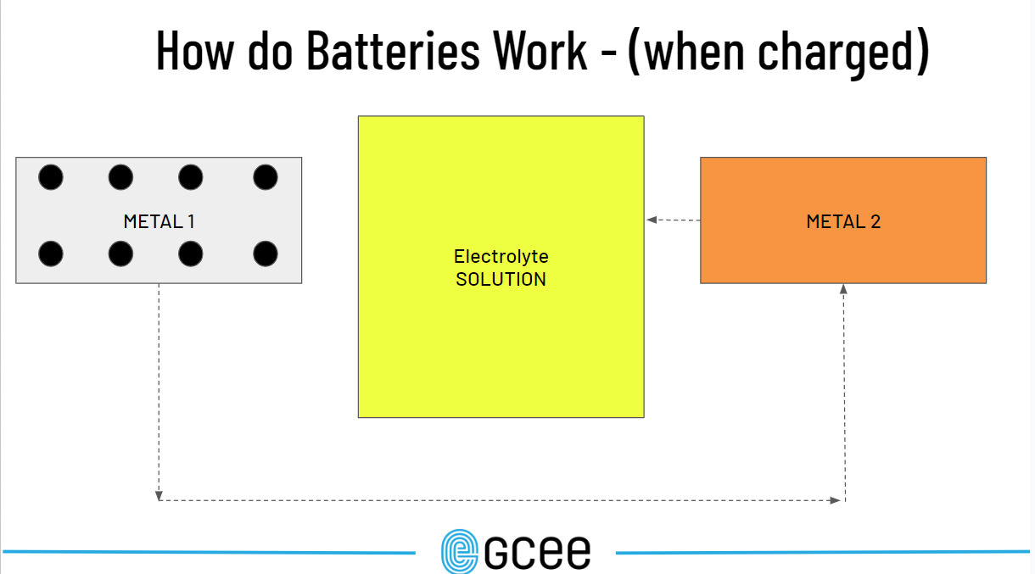
  - 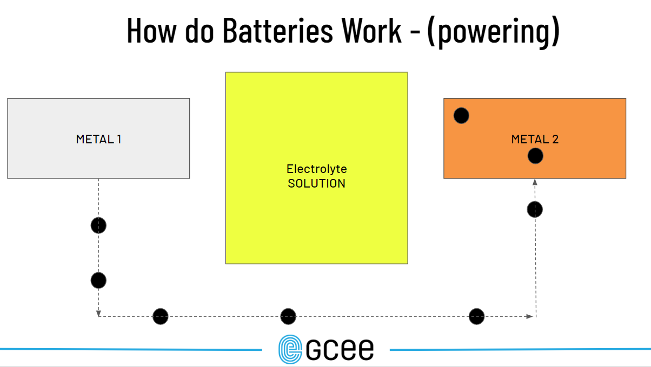
  - 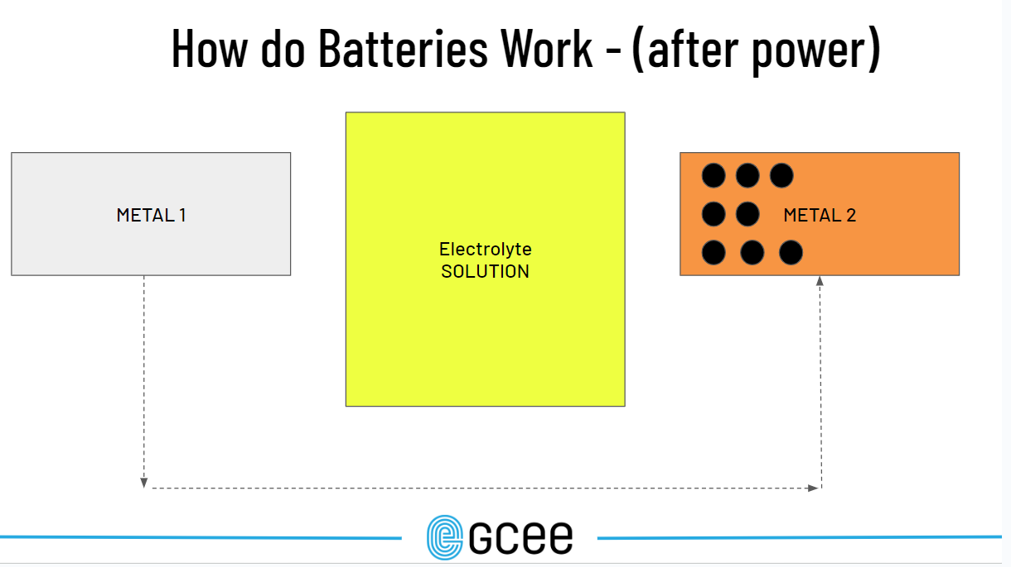
- Explain that in order to get the electrons back over to Metal 1, the battery must be re-charged. This involves plugging the battery into a charger that will make it hot and uncomfortable in Metal 2, so the electrons want to return to Metal 1. Explain that you have done that, and the electrons should go in reverse along the yarn back to Metal 1.
- Before the last electron reaches Metal 1, stop that student, and remove them from the line. Explain that over time Metal 1 will deteriorate and become unstable, so it can no longer accommodate all the electrons. Note: You can even move the tape on the floor to shrink the Metal 1 box if you want to.
- Thank all the volunteers and have them return to their seats.
- Display slide 11 and debrief the activity with the following discussion.
  - Where did the “power” come from? Answer: The transfer of electrons between the metals.
  - What would happen if we put more “actions” (like running programs in the background, checking the weather, etc.) along the line/yarn? Answer: The more things the battery is powering, the quicker it will run out.
  - What are some ways you can think of that might improve the design and use of batteries? Answers: Answers will vary, but some innovations that have improved the design of batteries are: changing the types of metals and electrolytes used, stacking batteries, using different conductors, and improving recharging speeds.
- Display slide 12 and play the video “How Batteries Work” from the link in materials/on slide.
- Display slide 13. Point out that you haven’t discussed why batteries are so important.
- Ask the class why, based on their experiences, batteries are useful to our society. Note: If they watched the video, they could also use information from the video. Answers will vary, but may include portability, rechargeability, a large variety of applications, etc.
- Explain that in economic terms, batteries do two things: increase productivity - the rate of output per unit of input per unit of time and economic efficiency - minimizing or eliminating the waste of resources in the production process. In this case, the improvements in productivity are a specific type known as capital productivity - how well physical capital (like a battery) increases the production of goods and services. This means that the battery itself is more productive. In other words, advances in the technology of batteries over the years (different metals, different designs, different chemicals, etc.) increased productivity because fewer or smaller batteries are needed to perform similar tasks. In the case of a battery the output is either energy or time and newer batteries can produce more time (output) with the same size (input). As for efficiency, batteries are playing a large role in storing energy produced by solar panels, hydro plants, and other “green” energy sources thus reducing energy waste. Explain that students will see this more in the next activity.
- Display slide 14 and discuss the following:
  - What do you see on the slide? Answers will vary, but students might point out a red line that is upward sloping and a blue line that is downward sloping, there are years on the x axis, etc. Point out that all the information on this slide is related to lithium batteries - like the ones in their smartphone in most cases.
  - What are the blue bars showing? Answer: The changing cost of providing one kilowatt hour of energy with a lithium battery. Point out that in 2008 it cost nearly $1,000 (the input) to provide just one kilowatt hour of energy - which is the output. But improvements in battery technology resulted in increased productivity (more energy output with fewer inputs) for energy producing firms. They can now provide more energy using fewer batteries in the same amount of time. Using fewer batteries also reduces the cost of producing a kilowatt of energy. It now costs less than $100. This has another benefit. As the cost of energy decreases, a buyer could allocate the same amount of money toward energy but get much more output for that money - a benefit to household and commercial energy consumers.
  - What is the red line showing? Answer: Battery energy density, or how many hours of charge per liter of lithium used. In this case, the line is upward sloping indicating that the same size lithium battery is capable of lasting much longer than those of 10 years ago - another increase in capital productivity.
  - What are some ways society might benefit from the data seen on this slide? Answers will vary, but include Longer lasting products like phones, cars, medical devices. This means less down time charging and cheaper energy means either consumers could spend less on energy or consume more energy with the same money, etc.
- Display slide 15 and ask students what they see. Answers will vary. Explain that this device is a household storage unit for solar energy. As solar panels collect heat and convert it to energy, some of the energy collected gets wasted as it is transferred back to the electrical grid. These batteries and ones like them store energy for future use to reduce waste - thus improving efficiency.
- Ask students; “What are some ways batteries could be improved in the future?” Answers will vary, but students may suggest things like making them last longer, making them more powerful, etc.
- Explain that students are now going to participate in or observe three mini-skits/demonstrations that will help them understand the future of batteries. Tell them that as they watch and/or participate, they should think about how batteries can improve productivity and/or efficiency.
- Distribute one copy of Activity 3.2: Future of Batteries Questions to each student. Explain that they will now watch three mini-skits and after each skit you will discuss what that skit taught the class about the future of batteries.
- Ask for four volunteers (or select four students) for skit A. Distribute one copy of Activity 3.3: Future of Batteries Mini Skit (A) and the appropriate “badge” to each of the four volunteers. Assign each student one of the roles in the skit. Give them a moment to read over their parts. Encourage them to really get into their parts when appropriate. Instruct the rest of the class to read over their skit A questions and listen closely for the answers.
- Have the four skit A volunteers perform their skit for the class.
- Using Activity 3.4: Future of Batteries Discussion Guide as a model, review the answers to questions 1-3 with the class referencing the skit where necessary.
- Repeat steps 35 and 36 for skits B and C.
- Tell students to answer questions 10-12 on their own. This can be done in class, assigned for homework, or used as an online discussion if needed. Suggested responses are provided on Activity 3.4 but use teacher discretion regarding whether this will be a class discussion or individual review.
- Display Slide 17. Remind students that there are many types of batteries that have a variety of uses. Ultimately, most batteries help increase productivity and efficiency. There are several efforts by large corporations to improve batteries so they can further increase productivity and efficiency.
Closure

- Conclude the lesson with the following discussion:
  - What is a battery? Answer: A device that stores energy (usually chemical) for future use (usually electrical).
  - How do batteries work? Answer: By charging electrons on one side of the battery and having them move to the other side of the battery. While the electrons are moving, they can charge other electronic devices.
  - What improvements have been made to batteries? Answers will vary, but make sure they include better storage capacity, faster charging, and integration into power grids.
  - What is productivity and capital productivity? Answer: the rate of output per unit of input per unit of time and capital productivity is the improvement to a machine or capital resource that allows it to make more output per unit of input. In the case of a battery, the battery’s output is time so increasing output with the same or fewer inputs is an improvement in productivity.
  - What is efficiency? Answer: minimizing or eliminating the waste of resources in the production process.
  - How does an increase in productivity or efficiency benefit society? Answer: Consumers and producers can essentially do more with less. In terms of batteries, fewer batteries are needed to get the same amount of output. Regarding efficiency, the example used in this lesson is that certain types of energy creation (solar/wind) create wasted excess energy. Batteries can store that excess energy for future use and, therefore, it is no longer wasted.
  - Can you give another example of technological change that resulted in increased productivity and efficiency for society? Answers will vary but look for things like faster internet speeds allow for faster searching/downloading/processing so whereas it might have taken minutes to download a file years ago, that same file can be downloaded in mere seconds today. Therefore, someone who is downloading files for a job (legal secretary for example) can do more in the same amount of time. For efficiency, something like a public transportation system might be an example (it moves more people than one car at a time), new recycling techniques that reduce wasted plastic by converting them to new uses, or even something like Zoom that has allowed for more remote work, thus reducing wasted time in traffic.
Assessment

- The assessment for this lesson includes the multiple-choice questions below as well as student responses to questions 10 - 12 from Activity 3.2: Future of Batteries Questions on their own. These can be completed for homework and submitted to the teacher (using Activity 3.4: Future of Batteries Questions Discussion Guide for scoring) or completed in class for block and longer class periods.

Multiple choice questions

1. 20 years ago, AA batteries in a basic TV remote control could last several months to a year at most. Modern AA batteries of the same size can typically power modern TV remote controls (with more functionality) for more than a year - even with daily use. This is an example of an increase in
- charging capacity.
- capital efficiency.
- capital productivity.
- charging sustainability.
(Answer C)

2. Economic efficiency is MOST closely related to which other concept?
- equity
- waste
- scarcity
- competition
(Answer B)

3. Consumers benefit from improvements to battery productivity because they
- get more energy output with fewer inputs.
- no longer have to spend money on energy.
- require fewer electronic goods that need batteries.
- can convert all battery powered items to rechargeable batteries.
(Answer A)

Extension

This lesson barely scratches the surface of sustainability as it relates to the power grid. There is also the reality that even though batteries are lasting longer, they still don’t last forever and must be disposed of at some point.

An extension opportunity for this lesson would be to investigate further sustainability initiatives with batteries including recycling, “clean batteries” and even edible batteries. The following sites might be useful for this research:

Battery Council International: https://batterycouncil.org/sustainability-stewardship/
Federal Department of Energy Battery Resources: https://www.energy.gov/search/site?keywords=batteries&sort_by=search_api_relevance

METAL 1
ANODE

LOSES ELECTRONS
(aluminum, zinc, granite, magnesium)

METAL 2
CATHODE

GAINS ELECTRONS
(lithium oxides, cobalt, nickel, manganese)

ELECTROLYTE

Separates Anode and Cathode, facilitates electron exchange

Name:________________________________________________ Date:_________________ PD:_______

Skit A - Increased energy density
- What is energy density as it relates to batteries?

- What are some actions being taken to attempt to increase energy density?

- How would this change to batteries improve productivity and/or efficiency?

Skit B - Charging Enhancements
- What is charging capacity as it relates to batteries?

- What actions are being taken to attempt to improve charging capacity?

- How would this change to batteries improve productivity and/or efficiency?

Skit C - Integrating with Power Grids
- What are some ways batteries play a role in supporting power grids?

- What actions are being taken to increase the use and availability of battery energy storage systems?

- How would this change to batteries improve productivity and/or efficiency?

Reflection Questions (Answer individually)

- Of the three topics you learned about, which one do you feel has the potential to make the greatest impact on the average consumer? Explain your answer.

- Describe at least two ways batteries make you more productive and/or efficient. Be sure to use the terms in their economic sense.

- Other than the ones already mentioned, explain at least one additional innovation to batteries you’d like to see in your lifetime that could improve productivity and/or efficiency in the local, national, or global economy and explain why you think it would be beneficial.

Skit A - Increased energy density
4 Characters: Narrator, Company X, E-Trucking Service, and Future Trucking

[Company X should go to one side of the room. E-Trucking Service and Future Trucking should be on the opposite side of the room. Narrator can stand in the middle].

Narrator: In this scene, Company X, an eco-friendly manufacturing company is expecting a delivery from E-Trucking Service, a battery powered trucking service on the opposite coast. Company X has decided not to use gas-powered machinery or other fossil fuel burning components in its supply chain.

Company X: Great, our new factory is up and running and now we are just waiting for the first delivery of our raw materials from the other coast.

E-Trucking Service: E-trucking here! We’ve got you covered. Everything’s loaded up on our battery-powered trucks, and we’re headed your way! [Begin walking towards Company X but stop halfway.]

Company X: Hey! Why did you stop? We need that material immediately!

E-Trucking Service: It’s our batteries’ energy density. Energy density is like the “fuel tank” of a battery. They only last for so long, and we have to stop and charge for a couple of hours before we can get back on the road. Sorry.

Company X: A couple of hours? That’s a lot of unproductive downtime for us!

Future Trucking: Hi, we’re Future Trucking and, thankfully, companies like Tesla, Solid Power, QuantumScape, and Zeta Energy are working on all kinds of solutions to this problem. Some solutions include solid-state batteries, which replace the liquid in traditional batteries with a solid material to increase the physical space where electrons can be stored. They are also working on new materials that could double the density of current batteries and on the connective parts of batteries that could improve where the energy in batteries comes from. [Start walking towards Company X and walk all the way - wave at E-Trucking as you pass].

Narrator: With these and other improvements to energy density, Future Trucking will be able to deliver materials to Company X more quickly, meaning less downtime and more productive time making their goods and services.
.
Skit B - Charging Enhancements
2 Characters: Employee 1, Employee 2

Employee 1: [Pretend to plug in your phone/device like you are charging it.]

Employee 2: [Walk next to Employee 1 and plug in your device.]

Employee 1: Ran out of battery too, huh?

Employee 2: Yep, gotta recharge before I can go back into the field and collect more data, thankfully, it’s only gonna take a few minutes.

Employee 1: A few minutes? Hahaha. More like an hour! The charging capacity - the speed at which a battery fills with energy - is pretty bad.

Employee 2: Not with these batteries of the future. Companies like Xiaomi (Zie-omee), OPPO and Energous are changing the game. The most recent Xiaomi phones can fully charge a completely dead battery to 100% in 17 minutes! This is due to advanced materials like silicon anodes, which can store more energy and charge faster than traditional graphite anodes used in lithium-ion batteries. It is also the result of making use of radio frequencies for improved wireless charging. By improving charging, these innovations aim to reduce waiting time and make our devices more convenient and efficient–there’s less wasted time. [Unplug your phone.]

Employee 1: What? Done already? But I’m only at 15%!

Employee 2: Sorry, hope your company gets these improved batteries soon. It definitely improves my efficiency–I waste a lot less time waiting to recharge before I can work. See ya later! [Walk away].

Employee 1: [Sigh and look bored]. Wish my device had better charging capacity!

Skit C - Integrating with Renewable Energy
Characters: Solar Panel Company (SPC), Mayor, Secretary, BESS installer. [Solar Panel Company (SPC) and Mayor should be close together as if in a meeting. BESS installer should be standing away from them with the secretary.]

SPC: Mayor, first of all, thank you for buying all those solar panels from my company for your town. We would love to install more solar panels and wind turbines in your town.

Mayor: Yes, we have enjoyed the panels, and they have helped our energy grid to some degree, but only when it’s sunny. Also, on some days we’ve noticed we get so much sun that the panels actually produce too much energy. Last fall, for example, we shut some of them down because we wasted almost 25% of their energy. I know it’s windy here, but not all the time. I bet we’d have the same problem with wind turbines. Sorry, we’re not interested in using our tax dollars this way.

SPC: But studies show more people want green energy.

Mayor: Yes, but my voters also despise inefficiency and waste.

Secretary: [Walk over with BESS installer]. Mayor, your next appointment is here, and they overheard your conversation and insisted on coming in. Their name is BESS.

BESS Installer: Hi! Actually, my name is not BESS, BESS is what I can offer you: B - E - S - S - a battery energy storage system. Companies like Tesla, LG, and Prologium are hard at work creating these massive batteries that can store tremendous amounts of energy. This really reduces waste. In fact, there are parts of Texas that have stored so much solar energy, they currently have enough power in their batteries to power 1.3 million homes for up to 8 hours and it can be used day or night!

Mayor: Whoa! So, no more wasted energy? That sounds much more efficient! We should just run the town off these batteries.

BESS Installer: Not so fast. These batteries don’t create energy, they just store it so it’s not wasted. You still need your power grid infrastructure and things like solar panels and wind turbines. BESS batteries just store the excess and let you use it when you want.

Mayor: Excellent! I’ll bring this to the town council next week. Secretary, will you prepare the agenda for next week to include discussing BESS and getting more solar panels.

Secretary: I will - and I think I’ll look into getting some solar panels for my house as well!

SPC: Woohoo! The future looks bright with these battery energy storage systems!
Narrator | Company X
E-Trucking Service | Future Trucking

Employee One | Employee Two
Secretary | Mayor
Solar Panel Company | BESS Installer

Name:____________________________________________ Date:_________________ PD:_______

Skit A - Increased energy density
- What is energy density as it relates to batteries?
Energy density is like the “fuel tank” of a battery. It’s how long the battery can provide energy. [If students seem confused, explain that in the battery simulation, it’s how long the string would be].
- What are some actions being taken to attempt to increase energy density?
Replacing materials inside of batteries where electrons can be stored, increasing the physical space of electron storage, changing the connective parts of batteries so they can store more power are some of the advancements.
- How would these changes to batteries improve productivity and/or efficiency?
They could improve productivity by getting the same output (time, in this case) with fewer inputs (size and/or number of batteries needed).

Skit B - Charging Enhancements
- What is charging capacity as it relates to batteries?
The speed at which a battery fills with energy. In the student simulation, it would have been how fast the electrons could get back over to their original starting position.
- What actions are being taken to attempt to improve charging capacity?
Changing the materials inside of batteries (like silicone anodes) and making use of radio frequencies that can move faster than physical connections.
- How would this change to batteries improve productivity and/or efficiency?
As seen in the skit, one worker’s downtime was reduced because their battery-powered device could be recharged quickly. People who rely on battery powered devices could get back to work faster and, therefore, get more done in the same amount of time as someone waiting for a device to recharge. This increases efficiency (reduces waste) and productivity.
Skit C - Integrating With Power Grids
- What are some ways batteries play a role in supporting power grids?
Storing excess power from solar, wind, and other sources for use later when it is dark, no wind is blowing, etc.
- What actions are being taken to increase availability of battery energy storage systems?
Big companies like Tesla are increasing manufacturing of huge storage batteries and integrating them into existing power grids (like in Texas).
- How would this change to batteries improve productivity and/or efficiency?
Specific to renewable energy (like solar or wind) these batteries will store excess energy that can’t be currently consumed by the grid. This reduces waste–increases efficiency. This article has some insight into why these batteries are needed: https://www.theatlantic.com/science/archive/2023/10/solar-power-duck-curve-waste/675842/
Reflection Questions (Answer individually)

- Of the three advancements you learned about, which one do you feel has the potential to make the greatest impact on the average consumer? Explain your answer. Answers will vary but look for students to make connections between something with the battery improvement and a consumer. For example, having a phone battery that can last longer and charge faster would be beneficial to most people because most people have phones. Charging faster would also be a tremendous help to people with electric cars. On the other hand, solar panel integration is perhaps only helpful to people who have installed solar panels or in cities that have installed them at scale.

- Describe at least two ways batteries make you more productive and/or efficient. Be sure to use the terms in their economic sense. Answers will vary but some common answers might include their laptops/phones/tablets being portable means they can be more productive. They can work on the move so they may be able to complete electronic assignments on the bus or communicate with work or something at hours that would not be possible without batteries. In other words, they can literally do two things at once in some cases. Some students may have back-up batteries for their houses that would allow them to keep doing their daily routines in power-outages where many people may not be able to do those. Power outages can create severe inefficiencies so having energy backups can solve that problem. Students may also use the route of having a battery on their phone that allows them to multi-task. This may also be an example of productivity if the student makes the point that without the battery-powered device, multiple devices (and therefore more batteries or access to outlets) would be needed. The ability to complete schoolwork on the bus while traveling to a game or home improves their efficiency of time.

- Other than the ones already discussed, explain at least one additional innovation to batteries you’d like to see in your lifetime that could improve productivity and/or efficiency in the local, national, or global economy and explain why you think it would be beneficial. Answers will vary greatly here and are to some extent unpredictable. If they conduct some basic research, they might find things like miniature batteries, edible batteries, batteries that charge while in use, batteries made completely of natural materials, etc.

