Lesson 3: Incentivizing Energy Conservation at our School
Author: Amanda Jennings

Students learn about different incentives used to influence people's energy consumption and then create incentive plans to conserve energy at their school.

Description of the lesson
In this lesson students will work towards answering the question: What is the best way to influence people’s behavior so they conserve energy at our school? Students begin by watching a short video about why energy conservation is important. Then, they read three primary sources to identify different types of incentives used to influence people’s energy consumption and categorize them as positive/negative and monetary/nonmonetary. Students work together to identify the benefits and costs of each incentive they read about. Next, working in groups, students develop two different incentive plans that could be used to influence people to conserve energy at their school and use cost/benefit analysis to determine which plan they will choose.

Economic Concepts
This lesson focuses on how monetary and nonmonetary incentives can influence people’s behavior, specifically their energy consumption. Students will see how institutions (like power companies) use prices and other incentives to affect energy consumption. Students will also evaluate the benefits and costs of the incentives and use economic decision-making to identify which incentive(s) would be “best” to use at their school.

Objectives:  Students will be able to:  - identify examples of positive and negative incentives.  - identify examples of monetary and nonmonetary incentives.  - describe how incentives can be used to affect people’s choices and behaviors.  - analyze the costs and benefits of using different incentives to influence people’s choices and behaviors.  Concepts:  Incentives, costs, benefits | Materials:  - PowerPoint slides  - Video: Conserving Non-Renewable Resources (PBS Learning Media - this video can be downloaded and has a license that allows for its use in lessons)  - Poster Paper/Chart Paper, 1 piece for each group of 4-5 students  - Activity 3.1: Source 1: Home Energy Report, one copy for each student  - Activity 3.2: Source 2: Time of Day Pricing, one copy for each student  - Activity 3.3: Source 3: SmartCurrents Program, one copy for each student  - Activity 3.4: Cost Benefit Analysis: Energy Conservation Incentives (in your home), 1 for each group of 4-5 students  - Activity 3.5: Cost Benefit Analysis: Energy Conservation Incentives (in our school), 1 for each student
Suggested Time Frame:  60 minutes | National Standards in Economics or Personal Finance:  Voluntary National Content Standards in Economics  - Standard 4: Incentives  - People usually respond predictably to positive and negative incentives.
Preparation

As this lesson is inquiry-based, there are very few “right/wrong” answers. Being familiar with the materials and possible arguments students might make ahead of time can lead to more thoughtful and impactful whole-group discussions. It might also be helpful for teachers to write their own argument (see assessment) in response to the central question before the students begin the lesson, remembering that the teacher’s argument is one of many possible arguments students could construct.
Procedure

- Show Slide 3.2. Place students in pairs. Connect to prior content knowledge by asking students to engage in a think-pair-share to answer the following question: What are some rewards and penalties you have received in your lives either at home, at school, or in your communities? Have students think independently for one minute, then share with a partner for 2 minutes, then lead a whole class discussion asking students to share a reward or penalty they said or heard about when they shared with their partner. Make a list of the rewards and penalties on the board.

- Show Slide 3.3.Encourage students to see that rewards and penalties are both ways of influencing our behavior. Introduce the term incentive: A reward that makes people better off or a penalty that makes people worse off. Tell students that incentives are used to influence people’s behavior and their choices.

- Show Slide 3.4. Ask students to think about the reward or penalty they shared with their partner, ask them to recall why they received the reward or penalty, and if/how the reward/penalty changed their behavior. Students should think independently for one minute, share with their partner for two minutes, and then be prepared to share with the whole class either what they said, or what they hear their partner say. For example, “once when I was working with my dad cleaning offices, I found a check in the trash. I told my dad, and he gave the check to the office workers. The office workers gave me a teddy bear and a card. I felt very proud of myself (one reward) and I also got a new stuffy (second reward). After that, I looked very carefully when I emptied the trash cans hoping to find more checks.”

- Show Slide 3.5.Tell students that incentives can be used to change many different kinds of behaviors and that today, they are going to think about incentives while they answer the following question: What is the best way to influence people’s behavior so they conserve energy at our school? Tell students that they are going to start by learning a little bit about energy conservation and why it is important, then they will learn about some incentives that have been used to encourage people to conserve energy, and finally they will work in groups to develop a plan to incentivize people to conserve energy at their school.

- Show Slide 3.6. Ask students, “What do you know about energy conservation?” (Accept all student answers.)

- Show Slide 3.7. Tell students they are going to watch a short video to help them have a shared understanding about what energy conservation is and why energy conservation is important. Show the video, Conserving Non-Renewable Resources.

- Show Slide 3.8. After the video, discuss the following:
- What are non-renewable resources? (Answer: resources that once they are used up are gone.)
- What are some reasons you learned about in the video that we should conserve energy? (Answers could include: most energy is from nonrenewable resources (and we can run out of them); nonrenewable resources have more than one use (they are scarce); using lots of energy has a price, and we can reduce our monthly bills by conserving energy).
- What are some ways you learned about in the video that we can conserve energy in our homes? (Answers could include: turning off the air conditioner when you aren’t using it, closing the refrigerator door, turning off lights, and replacing light bulbs with more energy-efficient bulbs.)
- What incentives (a reward and penalties) did the people in this video have to conserve energy? (Answers could include a reward of paying lower energy bills when conserving energy or a penalty of paying high electricity bills for leaving the refrigerator door open, a penalty of a stinky apartment and rotten food in the refrigerator.)
  - What are some other ways you know of to conserve energy? (Answers will vary and may include unplugging appliances, using battery-saving modes on electronics, and closing the door when the heat/air conditioning is on.)

- Tell students that they will work in groups of 2-3 to read three sources. Hand out a copy of Activities 3.1, 3.2, and 3.3 to each student. Tell students each source is an example of how a power company has used rewards and/or penalties to try to influence the behavior of its customers (the households that get electricity and natural gas from the power company).

- Show Slide 3.9.Tell students to look at Activity 3.1 Source 1: Home Energy Report. Ask a student to read the Source Description out loud. Make sure students understand the description. Place students in groups of 2-3. Tell students that working in groups they should read the source again and then answer these two questions:
- What customer behavior is the energy company trying to influence? Answer the prompt and put a box around the part or the source that helps you answer the question.
- How is the energy company trying to influence customer behavior? Answer the prompt and put a circle around the part or the source that helps you answer the question.

- Instruct students to read, discuss, and annotate their sources.

- Lead a whole class discussion asking students to share the behavior they think the power company is trying to influence and the incentive (reward/penalty). (Answers could include: the company wants you to use less energy (behavior) and they are trying to influence customers’ behavior with a reward of feeling proud/better than their neighbors or sad/worse than their neighbors. The power company is using peer pressure to change their behavior.)

- Repeat this process (steps 8-11) for Sources 2 and 3.

- Show Slide 3.10. (Answers for Source 2 could include: the company wants customers to use less electricity during the afternoons (behavior) and they are trying to influence customer behavior with a penalty, higher prices, for using electricity in the afternoon and a reward, lower prices, at other times of the day.)

- Show Slide 3.11. (Answers for Source 3 could include: the company wants customers to use less electricity when there are a lot of people trying to use electricity (behavior) and they are trying to influence customer behavior with a reward (free thermostat and $25 credit per year for customers who participate in the program) for letting the power company adjust the temperature of your home to use less electricity).

- Show Slide 3.12.Tell students that in addition to incentives being positive (rewards) or negative (penalties) incentives can sometimes involve money called monetary incentives and sometimes not involve money called non-monetary incentives. Ask students to review the three sources and identify an example of a monetary incentive and a non-monetary incentive. (Student answers will likely include: the thermostat is monetary because it has a value of approximately $250 and the $25 credit. The Home Energy Report is non-monetary because it uses peer pressure to change behavior. )

- Once students have read and shared in a whole group discussion about each of the three sources, tell students they are going to think about different ways to categorize the incentives (rewards/penalties) they read about. They are going to think about the benefits and costs of each incentive. Handout a copy of Activity 3.4: Cost Benefit Analysis: Energy Conservation Incentives (in your home) to each group of students.

- Slide 3.13. Tell students that benefits are things favorable to a decision maker or the rewards gained from an action/activity.

- Show Slide 3.14. Tell students that costs are what decision maker must give up when making a choice.

- Show Slide 3.15. Have students work in their groups of 3-4 to complete the cost-benefit analysis including (1) describing the incentive, (2) categorizing the incentive as positive, negative, monetary, or non-monetary, (3) identifying benefits and costs of each incentive. Each group should identify the incentive they think is the “best” (most likely to influence customers energy use) and be prepared to describe why they think it is the best (using the cost/benefit analysis).

- Show Slide 3.16. In whole group discuss the following:
- What incentive did your group select as most likely to influence customer behavior and why? (Answers will vary. As long as students are using the concepts of incentives and costs/benefits to support their answers, accept all answers.)
- Each of these incentives is offered by the same power company to the same customers. Why do you think they offer multiple incentives at the same time? (Answers will vary but might include that different people think different things are important. Some people think saving money is most important so they might be most influenced by the Time of Day Rate incentive. Other people might think that getting new gadgets is cool so they are most influenced by the SmartCurrents Program.)

Conserving Energy at School

- Show Slide 3.17. Remind students that while they have been thinking about how power companies try to influence energy conservation at home, our focus today is to influence energy conservation at school. Share the central question with the students again: What is the best way to influence people’s behavior so they conserve energy at our school?

- Show Side 3.18. Place students into groups of 4-5. Make sure each group has a piece of chart paper or poster paper, and markers/colored pencils for writing. Tell students that using what they have learned about incentives and influencing energy conservation behaviors, they are going to develop one to two (depending on time and students) different types of incentives designed to influence people’s behavior so they conserve energy at our school. Students can use words and pictures to describe their incentive plans. They should (1) identify what the incentive is, (2) describe the specific behavior they are trying to influence and (3) identify the incentive as positive or negative and monetary or nonmonetary. Students should be prepared to present their plans to the class.

- Students present their plans (or one of their plans) to the class. Students should hang their plans (on poster paper) around the room to create anchor charts of student thinking in preparation for the assessment. These anchor charts will support students in recalling the important ideas they shared and heard their classmates share. Note: if time allows, it can be helpful for students to have the opportunity to do a “gallery walk” to examine the posters more closely.

- After the presentations, tell students that they now have identified some possible plans and are ready to answer the central question for the class: What is the best way to influence people’s behavior so they conserve energy at our school?

Closure

- Show Slide 3.19. Ask the following questions.
- What are incentives? (Answer: Incentives are rewards that make people better off or penalties that make people worse off)
- What is an example of a positive incentive? (Answers will vary but may include paying a lower price, praise from a teacher.)
- What is an example of a negative incentive? (Answers will vary but may include paying a fine, losing a privilege like technology time.)

- What is an example of how an incentive has changed people’s choices or behaviors? (Answers will vary but may include examples from sources 1, 2, & 3.)

Assessment

- Working in pairs or independently, depending on student readiness, students develop an argument that describes which incentive(s) they would use to affect people’s energy use behavior at their school.

- Show Slide 3.20. To help construct their arguments, students select two incentive plans from the plans presented by the whole class and conduct a cost benefit analysis using Activity 3.5 Cost Benefit Analysis: Energy Conservation Incentives (in our school). Distribute a copy of Activity 3.5 to each student.

- Show Slide 3.21. After completing the analysis, students will create an argument. A complete argument should include: (1) describe the incentive plan they selected including what behavior they are trying to influence and how their incentive(s) will influence that behavior, (2) identify whether the incentives were positive, negative, monetary, non-monetary, (3) use evidence from the cost/benefit analysis to describe why they think the plan they selected would be the best way to influence people’s behavior so they conserve energy at our school.

Extension

- Students can enact their plan and/or present their plan to leaders at the school or district level to advocate for change and encourage energy conservation at their school/district.

Primary Source Description: This is a Home Energy Report created by DTE Energy Company. DTE provides electricity and natural gas to homes in Michigan. Home Energy Reports are sent to DTE customers every month.

1. WHAT customer behavior is the energy company trying to influence? _____________________________________

_________________________________________________________________________________________________

Draw a box around the part of the source below that helps you understand WHAT behavior DTE Energy Company is trying to influence.

2. HOW is the energy company trying to influence customer behavior? ______________________________________

_________________________________________________________________________________________________

Draw a circle around the part of the source below that helps you understand HOW they are trying to influence behavior.
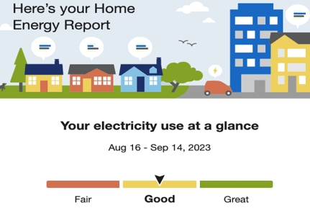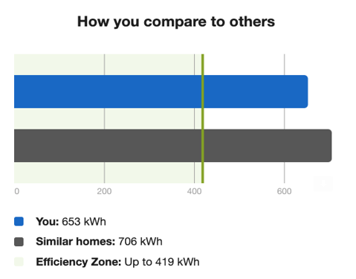

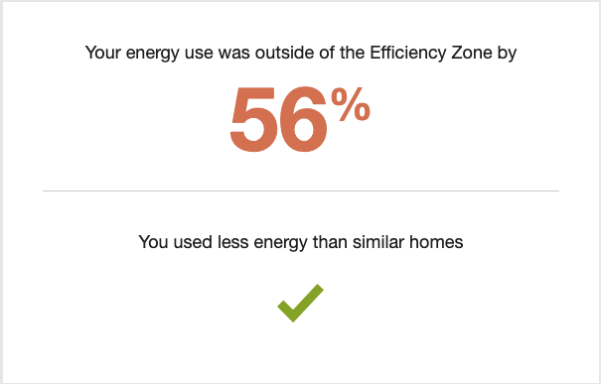
Nice Work! You were more efficient in this report than your last one.

The Efficiency Zone represents the 20% of similar homes in your comparison group that used the least energy this period. To create this group, we use your home profile to look for 100 single-family homes in your areas with a similar heating source and square footage.

Primary Source Description: This is a description of the “Time of Day Pricing” plan offered by DTE Energy Company. DTE provides electricity and natural gas to homes in Michigan. DTE offers more than one pricing plan.

1. WHAT customer behavior is the energy company trying to influence ? ________________________________

____________________________________________________________________________________________

Draw a box around the part of the source below that helps you understand WHAT behavior DTE Energy Company is trying to change.

2. HOW is the energy company trying to influence customer behavior? _________________________________

____________________________________________________________________________________________

Draw a circle around the part of the source below that helps you understand HOW they are trying to change behavior.

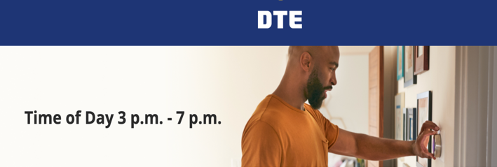
More Choice, More Control
Choose when you use your energy and gain more control over your bill with our Time of Day 3 p.m. to 7 p.m. rate. When you adjust your habits and do laundry and dishes or cool your home in off-peak hours, you can take advantage of a lower rate. It’s good to know you don’t need to make any changes: Our low off-peak rate extends 20 hours on weekdays and all weekend long.
Designed with the State of Michigan to manage the demand of an increasingly electrified world, the Time of Day 3 p.m. to 7 p.m. rate lets you take advantage of lower rates, so we can manage energy supply. When you have more choice and more control, everyone wins.

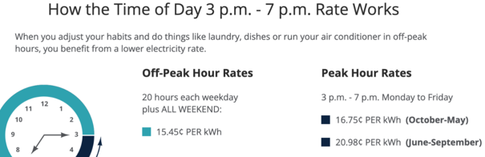
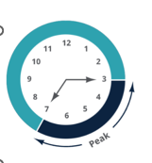

Primary Source Description: This is a description of the SmartCurrents Program created by DTE Energy Company. DTE provides electricity and natural gas to homes in Michigan. Enrolling in this program is optional for DTE customers.

1. WHAT customer behavior is the energy company trying to influence? ________________________________

____________________________________________________________________________________________

Draw a box around the part of the source below that helps you understand WHAT behavior DTE Energy Company is trying to change.

2. HOW is the energy company trying to influence customer behavior? _________________________________

____________________________________________________________________________________________

Draw a circle around the part of the source below that helps you understand HOW they are trying to change behavior.

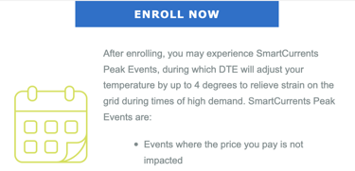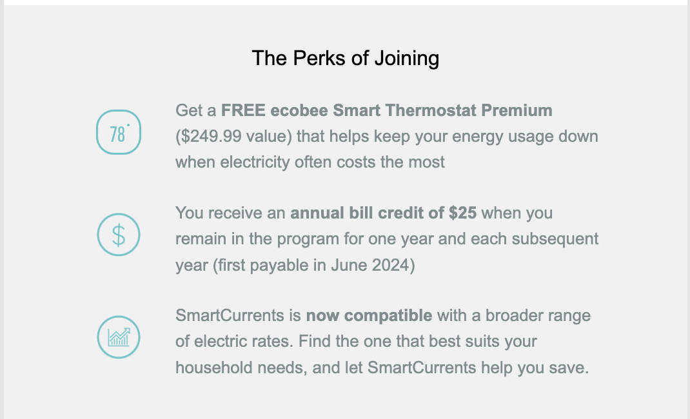
After enrolling, you may experience SmartCurrents Peak Events, during which DTE will adjust your temperature by up to 4 degrees to relieve strain on the grid during times of high demand.

