# **How Big is the Military Pie?**

What is the appropriate amount of money to allot for the United States military?

|  |
| --- |
| **IMPORTANT:** You can have several activities in 1 lesson. If you identify a resource (URL, File, Ed Tech Tool) in the procedure section, be sure to name the file or URL name within the Materials and Preparation section the same name as seen in the Activities section. Otherwise, we will not understand where the file or URL needs to be linked/uploaded. If we do not understand what you would like us to do, we will send the lesson plan back for clarification. |

### **Objectives**

Students will be able to:

* Evaluate the level of military spending in the United States
* Describe the arguments for both increasing and/or decreasing the size of the U.S. military
* Explain the trade-offs and opportunity costs that the U.S. faces when determining the size of the military’s budget

### **Time**

120 minutes

### **National Standards in Economics or Personal Finance**

Scarcity 12-1*:* 1. Choices made by individuals, firms, or government officials are constrained by the resources to which they have access.

Decision Making 12-2: To determine the optimal level of a public policy program, voters and government officials must compare the marginal benefits and marginal costs of providing a little more or a little less of the program’s services.

### **Materials and Preparation**

* Introduction
* Visual 7.1 – World Military Spending Graph
* Visual 7.2 – Spending by Category Graph
* Visual 7.3 – Discretionary Spending Graph
* Visual 7.4 – Military Spending as percent of GDP
* Handout 7.1 – U.S. Military Spending Debate Questions
* Handout 7.2 – Debate Directions
* Handout 7.3 – “Yes, We are the World’s Policeman” Article
* Handout 7.4 – “A Moral Obligation to Intervene” Article
* Handout 7.5 – “Can Iran be Stopped” Article
* Handout 7.6 – “War: A Gambling Man’s Game”
* Handout 7.7 – “Why the Founding Father’s Would Object to Today’s Military” Article
* Handout 7.8 – “The Problem of Excessive Military Spending in the United States” Article
* Handout 7.9 – “The Pentagon Just Announced Something No Millennial Has Ever Experienced” Article

### **Activities**

**Day 1:**

1. Give each student a copy of the introduction. They can use it as a reference during the discussion and it will focus them on the topic of the lesson.
2. Give each student the question sheet (handout 7.1).
   * Question 1 will be answered after showing the students graphs depicting current U.S. defense spending. They will be providing their opinions on the size of the U.S. military based solely on the data provided in the graphs.
   * Questions 2-4 will be answered following the class debate. These questions will force the students to reflect of the arguments provided during the debate and possibly make adjustments to their initial opinion.
3. Show the students the charts and graphs that depict the various measurements of the United States’ military spending. You could give each student a copy of the graphs or just show them on the projector (Visuals 7.1-7.4).
4. Discuss with the students how to read and interpret the data on each graph. Be sure that the students understand what discretionary spending is and why measuring an expense as a percent of GDP is an important way to measure the spending.
   * Visual 7.1 shows the top 15 counties in terms of military spending in 2023 (in millions of dollars)
   * Visual 7.2 shows U.S. spending per category as a percentage of the 2024 federal budget (defense spending accounted for 13% of total spending)
   * Visual 7.3 shows U.S. spending per category as a percentage of the 2024 discretionary budget (note: The discretionary budget are expenditures that go through the annual appropriations budgeting procedure, as opposed to the mandatory spending which mandated by law.)
   * Visual 7.4 shows U.S. military spending as a percentage of GDP from 1952 to 2022.
   * Introduce and discuss potential military threats that could challenge the United States.
     1. China’s growing military
     2. Russia’s encroachment on Ukraine
     3. Nuclear weapon in North Korea or Iran
5. Read the directions and rules for the debate with the class (Handout 7.2).
6. Divide the class into two teams and put them in opposite sides of the classroom. One team will be in support of a larger U.S. military, while the other team will be in support of a smaller military.
7. Split the “larger military” team into four evenly-sized groups and the “smaller military” team into three evenly-sized groups.
8. Give each group copies of one of the 3-4 supporting documents for their argument (Handouts 7.3-7.6 **(Optional: only use 7.3 & 7.4 to condense the information)** to the “larger military” team and Handouts 7.7-7.9 to the “smaller military” team.
9. Give the students 20-25 minutes to read and discuss the material within their small groups and then an additional 10-20 minutes to discuss their arguments as a team (this may carry over into day 2).
10. Have the students write down their answers to these questions when formulating their arguments:
    * What are our goals in terms of military power, international relations and national security?
    * What size does the military need to be to accomplish these goals? (bigger, small, or the same as our current military)
    * What trade-offs do we face if the military is increased or decreased in size?

**Day 2:**

1. Give the students 5-10 minutes to review their arguments and strategy.
2. Begin the debate by reviewing the rules.
3. At the conclusion of the debate, the students should answer the remaining questions on their worksheet.

### **Assessment**

INTRODUCTION

**How Big is the Military Pie?**

In 2024, the American government spent $850 billion on national defense, more than the next 10 countries combined! What are the costs and benefits of spending so much money on national defense? Is this too much money or not enough? How much should the U.S. spend?

These are very difficult questions to answer and admittedly, questions that don’t have singular concrete answers. Therefore, it is important to understand the reasoning behind the arguments for increasing or decreasing the size of our military.

Defense spending consumes about one-eighth of our national spending and approximately 50% of the discretionary spending. As with any other spending decision, there are trade-offs. Money that is allocated to national defense cannot be spent on highways, schools, Social Security, NASA, debt reduction, or the myriad of other programs funds by the U.S. government. Do the benefits of these programs outweigh the costs of having a smaller military?

To answer this question one must examine the potential costs and benefits of downsizing the military. One could argue for a military that falls along wide spectrum of spending, from nothing but a force large enough to protect the country in case of attack to doubling our current spending. Let us examine arguments put forth by two competing schools of thought that outline the relationship between our national goals and how our country deals with foreign relations.

The first school of thought is the Wilsonian Idealism, founded on Woodrow Wilson’s belief that peace could be established and maintained through the collective actions of many nations. There would be no need for unilateral action by nations. The world would be safe and prosperous through collective international actions. In this kind of framework America would not need to be an outlier in military spending as it is today, but rather have the capability to join with other nations in the defense of peace and democracy should the need arise.

On the other end of the spectrum would be *realpolitik,* brought to the forefront of American politics by Henry Kissinger in the 1960s. Realpolitik which is German for “realistic politics,” meaning a diplomacy based on power and practicality in relation to the situation rather than based on ideology or moral values. Within this theoretical framework, a nation should (and generally will) make policy decisions based on gaining and wielding power. One could therefore argue that in the post-Cold War era, where the U.S. is arguably the sole superpower, that it is in our best interests to maintain a military hegemony.

Further clouding the debate are disagreements about the role that the United States should play around the world. Some argue that as the foremost superpower, it is our responsibility to maintain order and police the world. Others would say that our country was founded on the belief that large militaries are inherently dangerous and unnecessarily expensive, and that the sole purpose of a military is to defend one’s territory rather than to wage foreign wars.

VISUAL 7.1

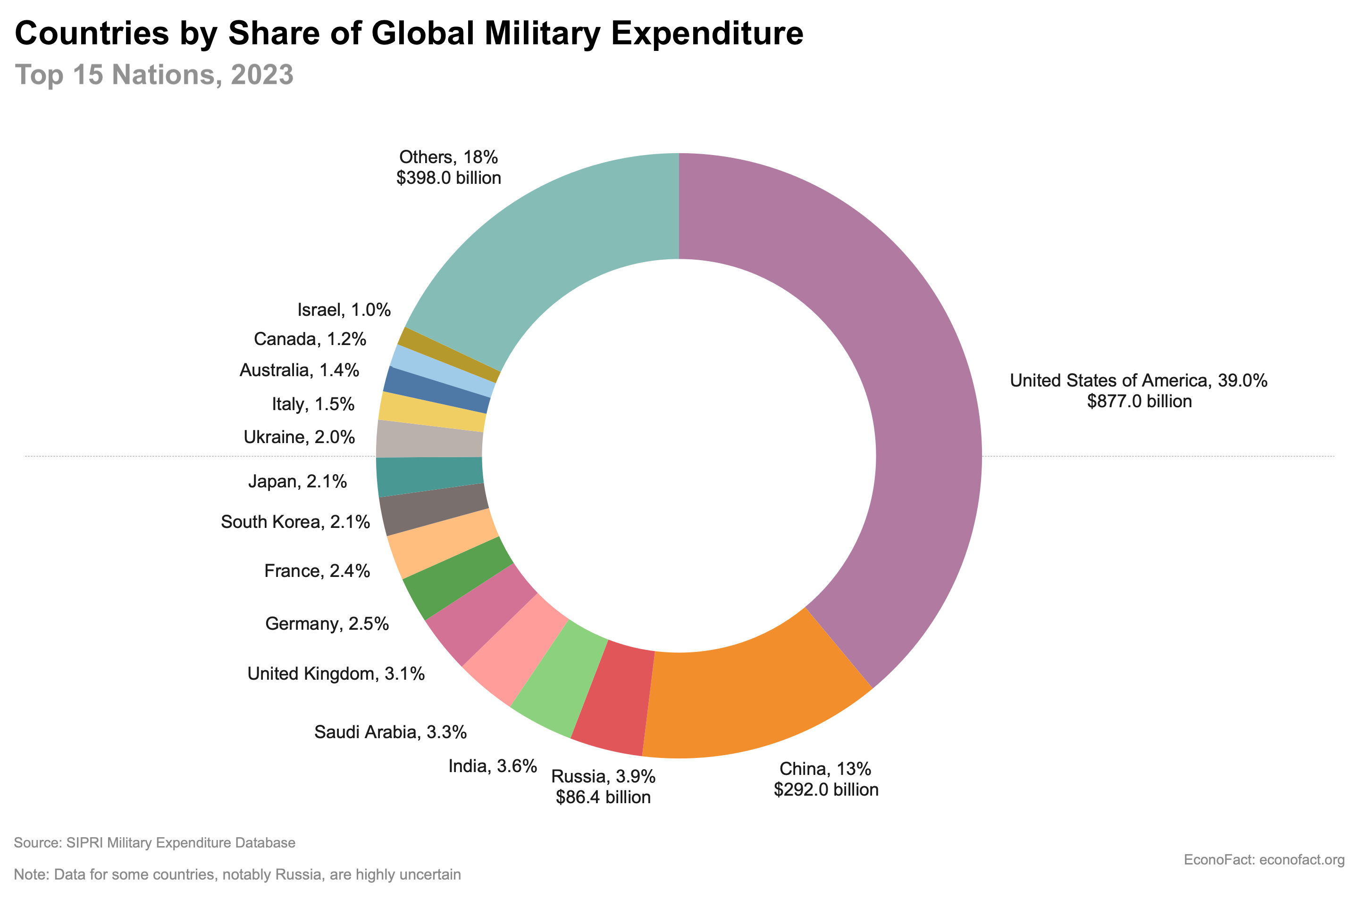

<https://econofact.org/u-s-defense-spending-in-historical-and-international-context>

VISUAL 7.2

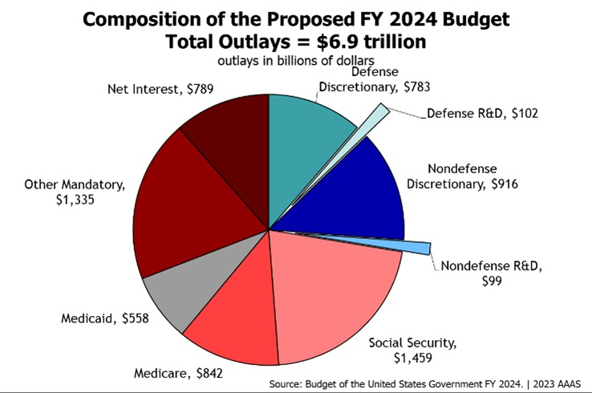

<https://cossa.org/house-passed-gop-budget-would-decimate-science-funding/>

VISUAL 7.3

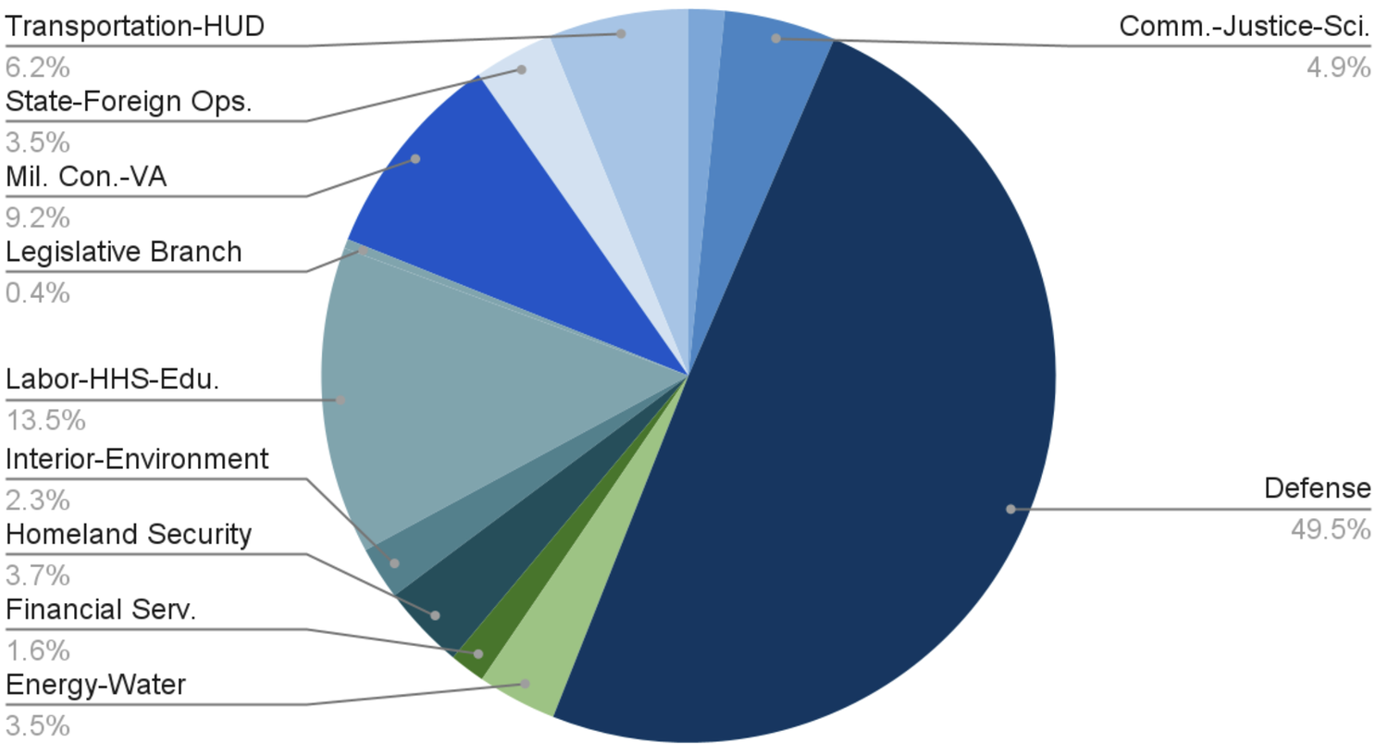<https://www.progressivecaucuscenter.org/where-does-the-pie-go-analyzing-discretionary-spending>

VISUAL 7.4

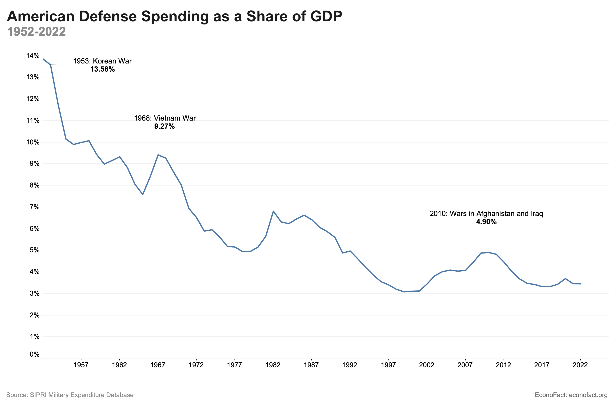<https://econofact.org/u-s-defense-spending-in-historical-and-international-context>

HANDOUT 7.1

Name_______________________________________

**U.S. Military Spending Debate Questions**

1. After examining the graphs showing U.S. military spending and considering the recent military and diplomatic conflicts, explain why you feel that the United States government should decrease, increase, or maintain its current levels of military spending.
2. After listening to both sides of the debate, have your views changed? How so? Why or why not?
3. What do you think is the proper role for the United States military?
4. Should the U.S. military budget but reduced, increase, or stay the same? Why?

HANDOUT 7.2

**Military Spending Debate Directions and Rules**

Today we will be discussing and debating the size of the United States military. The class will be randomly divided into two teams; one team will argue for a larger military, while the other side will argue for a smaller military.

Each team will be broken up into three-four groups. Each group will be given a resource to help you develop your argument. Discuss the article within your group and create and outline of arguments that you can share with the team.

The teams will come back together and each team will share their findings. Your team will then create a unified strategy and initial defense of your position.

**Debate Option 1:** Each team will select one student to present the initial argument. Once both sides have presented, anyone can comment. You must raise your hand and wait to be called on by the teacher.

**Debate Option 2:** Lincoln –Douglas Style team Debate

1. Moderator announces proposition to be debated.   
   For example: "The United States’ role in the world requires it to have a larger military"
2. The Moderator must introduce each speaker after the Timekeeper calls time.
3. The Timekeeper must now keep track of the time, letting participants know when they have one minute left to speak and when their time is up.
4. 5 Minutes: Lead Debater for the Affirmative position presents position.
5. 3 Minutes: Question Asker from the Negative position team asks questions of Question Answerer from the Affirmative position team.
6. 5 Minutes: Lead Debater for the Negative position presents argument.
7. 3 minutes: Question Asker from the Affirmative position team asks questions of Question Answerer from the Negative position team.
8. 3 Minutes: Affirmative Rebutter responds to the arguments raised by the questions.
9. 3 Minutes: Negative Rebutter responds to the arguments raised by the questions.
10. 5 Minutes: Affirmative Closer sums up position, referring to new issues raised in the debate.
11. 5 Minutes: Negative Closer sums up position, referring to new issues raised in the debate.

**Rules for Respectful Discussion**

-You do not need to believe in the argument that you are making.

-Try to persuade the other side by using evidence and logic.

-Do not attack the person with whom you are debating, attack the argument.

-Always be respectful.

-Keep an open mind.

-Raise your hand and wait to be called on.

-Have fun and stay engaged.

HANDOUT 7.3

[NATIONAL REVIEW ONLINE](http://www.nationalreview.com/)

September 17, 2013 12:00 AM

**Yes, We Are the World’s Policeman**

U.S. troops around the world are the greatest preservers of liberty and peace in the world.

By Dennis Prager

In his speech to the nation on Syria last week, the president twice emphasized that America is not the “world’s policeman.” According to polls, most Americans agree.

Unfortunately, however, relinquishing this role assures catastrophe both for the world and for America.

This is easy to demonstrate. Imagine that, because of the great financial and human price, the mayors and city councils of some major American cities decide that they no longer want to police their cities. Individuals simply have to protect themselves.

We all know what would happen: The worst human beings would terrorize these cities, and the loss of life would be far greater than before. But chaos would not long reign. The strongest thugs and their organizations would take over the cities.

That is what will happen to the world if the United States decides — because of the financial expense and the loss of American troops — not to be the “world’s policeman.” (I put the term in quotes because America never policed the whole world, nor is it feasible to do so. But America’s strength and willingness to use it has been the greatest force in history for liberty and world stability.)

This will be followed by the violent death of more and more innocent people around the world, and economic disruption and social chaos. Eventually the strongest — meaning the most vile individuals and groups — will dominate within countries and over entire regions.

There are two reasons why this would happen.

First, the world needs a policeman. The world in no way differs from cities needing police. Those who oppose America’s being the world’s policeman need at least to acknowledge that the world needs one.

Which leads to the second reason: If the United States is not that policeman, who or what will be?

At the present moment, these are the only possible alternatives to the United States:

a) No one

b) Russia

c) China

d) Iran

e) The United Nations

The first alternative would lead, as noted, to what having no police in an American city would lead to. Since at this time no country can do what America has done in policing the world, the world would likely divide into regions controlled in each case by tyrannical regimes or groups. China would dominate Asia; Russia would re-dominate the countries that were part of the former Soviet Union and the East European countries; Russia and a nuclear Iran would dominate the Middle East; and anti-American dictators would take over many Latin American countries.

In other words, (a) would lead to (b), (c), and (d).

Would that disturb those Americans — from the Left to the libertarian Right — who want America to stop being the “world’s policeman”?

Note well that Europe is not on the list. Europeans are preoccupied with one thing: being taken care of by the state.

As for (e), the United Nations, it is difficult to imagine anyone arguing that the United Nations would or could substitute for the United States in maintaining peace or liberty anywhere. The U.N. is only what the General Assembly, which is dominated by the Islamic nations, and the Security Council, which is morally paralyzed by Chinese and Russian vetoes, want it to be.

Americans are retreating into isolationism largely because of what they perceive as wasted American lives and treasure in Iraq and Afghanistan. But this conclusion is unwarranted.

It is *leaving* — not fighting in — Iraq and Afghanistan that will lead to failures in those countries.

Had we left Japan, what would have happened in that country and in Asia generally? Had we left South Korea, would it be the vibrant democracy, and economic power, that it is today — or would it have become like the northern half of the Korean peninsula, the world’s largest concentration camp? Had we left Germany by 1950, what would have happened to Europe during the Cold War? We did leave Vietnam, and communists imposed a reign of terror there and committed genocide in Cambodia.

American troops around the globe are the greatest preservers of liberty and peace in the world.

To return to our original analogy of cities without police: Thinking that we can retreat from the world and avoid its subsequent violence and tyranny is like thinking that if the police go on strike in Chicago, the suburbs will remain peaceful and unaffected.

We have no choice but to be the world’s policeman. And we will eventually realize this — but only after we and the world pay a terrible price.

In the meantime, the American defeat by Russia, Syria, and Iran last week means that the country that has been, for one hundred years, the greatest force for good is perilously close to abandoning that role.

HANDOUT 7.4

|  |  |
| --- | --- |
| **Opposing view: A Moral Obligation to Intervene**  By Jamie M. Fly  Mar 03, 2011 | USAToday.com |
| http://images.clickability.com/pti/spacer.gif, Picture |

As Libyan leader [Moammar Gadhafi](http://content.usatoday.com/topics/topic/People/Politicians,%20Government%20Officials,%20Strategists/World%20Leaders/Muammar%20al-Gaddafi) clings to power, vowing to fight "to the last man and the last woman," opposition forces in the eastern part of [Libya](http://content.usatoday.com/topics/topic/Places,%20Geography/Countries/Libya) no longer under government control are pleading for international assistance as the death toll mounts.

Unfortunately, as chaos in Libya has grown, the response of the Obama administration has been to equivocate and waver. It was not until Monday, two weeks after the uprising began, that the Pentagon announced it was sending two naval vessels to the region.

President Obama said on Thursday that his administration was reviewing the option of a no-fly zone, but key officials have sent mixed messages, citing resource limitations and even questioning whether such action was necessary. That is despite numerous reports by those fleeing the violence and journalists on the ground that the regime continues to bomb rebel-held positions from the air.

A no-fly zone enforced by the U.S. and key allies does not require the approval of the [United Nations Security Council](http://content.usatoday.com/topics/topic/Organizations/International%20Agencies,%20Alliances,%20Cartels/United%20Nations%20Security%20Council). The no-fly zones over [Saddam Hussein](http://content.usatoday.com/topics/topic/People/Politicians,%20Government%20Officials,%20Strategists/World%20Leaders/Saddam%20Hussein)'s [Iraq](http://content.usatoday.com/topics/topic/Places,%20Geography/Countries/Iraq) and NATO's 1999 war with [Serbia](http://content.usatoday.com/topics/topic/Places,%20Geography/Countries/Serbia) over [Kosovo](http://content.usatoday.com/topics/topic/Kosovo) did not have the council's explicit blessing.

It is in our interest to see the Libyan people free themselves from Gadhafi's brutal reign. We should thus explore all possible options to do so, including arming the opposition so they are not slaughtered by regime forces.

Gadhafi's days are over. It is just a matter of time until he is forced from power. The question is whether we will stand on the sidelines and continue to watch thousands be killed in protracted fighting or whether we will ensure that his departure is hastened and casualties minimized.

Intervening is a moral obligation for the United States — a moral obligation we've all too often ignored in similar cases in the past, with disastrous consequences. This time we need to get it right. It's time for President Obama to lead.

*Jamie M. Fly is executive director of the Foreign Policy Initiative. He served during the* [*George W. Bush*](http://content.usatoday.com/topics/topic/People/Politicians,%20Government%20Officials,%20Strategists/Executive/George%20W.%20Bush) *administration at the National Security Council and in the Office of the Secretary of Defense.*

HANDOUT 7.5

## **Persian power**

### **Can Iran be stopped?**

# **The West should intervene in Syria for many reasons. One is to stem the rise of Persian power**

Jun 22nd 2013

IN 2009 Iran was on the verge of electing a reformer as president. Ayatollah Ali Khamenei, the supreme leader, subverted the vote and crushed the ensuing protests. Last week the same desire for change handed a landslide victory to Hassan Rohani—and Mr Khamenei hailed it as a triumph.

When a country has seen as much repression as Iran, outsiders hoping for a better future for the place instinctively want to celebrate along with all those ordinary Iranians who took to the streets. The smiling Mr Rohani’s public pronouncements encourage optimism, for he sounds like a different sort of president from the comedy-villain, Mahmoud Ahmadinejad, who precedes him. Yet even if his election bodes well for Iranians, it does not necessarily hold equal promise for the rest of the world. Iran’s regional assertiveness and its nuclear capacity mean that it is a more dangerous place than it ever was before.

The case for Qompromise

Given the country’s obvious weaknesses, that sounds implausible. Inflation is running at over 30%, and the economy shrinking. Inequality is growing, with 40% of Iranians thought to be living below the poverty line. Sanctions restricted May’s oil exports to just 700,000 barrels a day, a third of what they used to be; as a result there are shortages of basic goods and growing unemployment caused by factory closures.

Yet the Persian lion has not lost its claws, nor has the theocracy suddenly become a democracy. Mr Rohani was indeed the most reformist of the candidates on offer at the election, but in much the way that Churchill was more of a teetotaller than George Brown. The 64-year-old cleric has been a loyal servant of the Islamic Republic from its inception. For years he headed the national security council (see [article](http://www.economist.com/news/middle-east-and-africa/21579826-irans-new-president-hassan-rohani-has-been-hailed-abroad-reformist-breath)). He is constrained by a system that deemed just eight people fit to stand in the recent election and rejected 678 others (including a former president). The president’s power is limited by Iran’s other institutions, many of which are in conservative hands.

While Iran’s politics have probably changed less than Mr Rohani’s election suggests, the balance of power between Iran and the rest of the world has been shifting in Iran’s favour for two reasons. First, thanks to heavy investment in nuclear capacity by the mullahs, and despite attempts by the West and Israel to delay or sabotage the nuclear programme, Iran will soon be able to produce a bomb’s worth of weapons-grade uranium in a matter of weeks (see [briefing](http://www.economist.com/news/briefing/21579815-neither-irans-election-nor-sanctions-nor-military-threats-are-likely-divert-it-path)). Iran has installed more than 9,000 new centrifuges in less than two years, more than doubling its enrichment capability. It is a short step from the 20% enriched uranium that the country’s facilities are already producing at an increasing rate to conversion into the fissile material needed for an implosion device. Although Western intelligence agencies think Iran is still at least a year away from being able to construct such a weapon, some experts believe that it could do so within a few months if it chose to—and that the time it would take is shrinking.

This makes a nonsense of Western policy on Iran. Round after round of negotiations to try to persuade Iran not to get a bomb have been backed up by the implicit threat that armed force would be used if talks failed. But now it looks as though Iran will soon be in a position to build a weapon swiftly and surreptitiously. Should the West decide to use force, Iran could amass a small arsenal by the time support for a military strike was rallied.

Against that background, a friendlier president becomes a trap as well as an opportunity. He may offer the chance of building better relations through engagement and the gradual lifting of sanctions. But Iran could take advantage of this inevitably slow process to build a weapon.

The other development that threatens the West’s interests is happening around Iran. Despite its economic troubles, the Iranian state is a powerful beast compared with its neighbours, and is keen to assert itself abroad. The Iraqi government is now its ally. It has sway over chunks of Lebanon through Hizbullah, the Shia party-cum-militia it finances. And it has sent Hizbullah into Syria, where its fighters have joined Iranian advisers, money and special forces to help turn the tide of the war in Bashar Assad’s favour. Ostensibly the reason why Barack Obama agreed last week to arm the rebels in Syria (see [article](http://www.economist.com/news/middle-east-and-africa/21579851-americas-decision-send-more-arms-rebels-no-means-guaranteed)) was Mr Assad’s use of chemical weapons; but many believe that the greater reason was his reluctance to see Mr Assad hold on to power as a client of Iran’s.

Hope for the best, prepare for the worst

This analysis may be too gloomy. It is possible that Mr Rohani’s arrival heralds a more pragmatic and less aggressive position. The new president used to serve as Iran’s main nuclear negotiator, and during his campaign made clear the link between Iran’s economic weakness and the nuclear sanctions, and called for better relations with the West. The West should reciprocate, making it clear that it has no intention of impeding Iran’s peaceful development. At the same time, it should continue to push for progress on the nuclear negotiations.

But it must do so warily. Any deal offered to Iran should include restraints draconian enough, and inspection intrusive enough, to prevent it from building a weapon surreptitiously, otherwise it would be worse than not doing a deal at all. And such a deal would very likely be unacceptable to Iran.

The growing risk of a nuclear Iran is one reason why the West should intervene decisively in Syria not just by arming the rebels, but also by establishing a no-fly zone. That would deprive Mr Assad of his most effective weapon—bombs dropped from planes—and allow the rebels to establish military bases inside Syria. This newspaper has argued many times for doing so on humanitarian grounds; but Iran’s growing clout is another reason to intervene, for it is not in the West’s interest that a state that sponsors terrorism and rejects Israel’s right to exist should become the regional hegemon.

The West still has the economic and military clout to influence events in the region, and an interest in doing so. When Persian power is on the rise, it is not the time to back away from the Middle East.

HANDOUT 7.6

**January 23, 2014**

War: The Gambling Man’s Game

*by* [***Kori Schake***](http://www.hoover.org/fellows/10404) *(Research Fellow and member, military history working group)*

What really causes international conflicts? It’s not what you think.

Shape

Geoffrey Blainey’s *The Causes of War* is a genuinely wonderful book. I had it pressed on me by one of the Pentagon’s most thoughtful people, and while it’s not a new book, it should be at the top of the reading lists of people interested in international relations. Like much else in the book, Blainey is straightforward in his title: he is examining why wars occur. He quotes Clausewitz to the effect that of all the branches of human activity, war is the most like a gambling game, and Blainey’s approach is very much marked by game theory.

Blainey argues that assessments of relative power drive decisions on war and peace, and that war occurs when nations misjudge their relative power. He writes, “War is usually the outcome of a diplomatic crisis which cannot be solved because both sides have conflicting estimates of their bargaining power.” Disputes about issues central to states’ interests can be negotiated when there is a clear hierarchy of power—the weaker compromises to prevent war. When there is doubt about the weaker party, compromise is elusive and wars occur, because “war itself provides the most reliable and most objective test of which nation or alliance is the most powerful...war was therefore usually followed by an orderly market in political power, or in other words, peace.”

Blainey draws heavily on the work of Kenneth Boulding, especially the insight that “threat systems are the basis of politics as exchange systems are the basis of economics.” Threats keep peace as well as provoke wars. The pattern most striking to him assessing the data from three centuries of warfare is that leaders are typically optimistic commencing a war. From there, he draws the conclusion that “if two nations are deep in disagreement on a vital issue, and if both expect that they will easily win a war, then war is highly likely. If neither nation is confident of victory, or if they expect victory to come only after long fighting, then war is unlikely.” He proceeds to offer a very persuasive set of historical proofs to support it.

The economic correlation Blainey finds is particularly interesting: war is more likely to occur as optimism about an economic recovery increases. Blainey is no determinist; he sees the historical specifics as important in each war. But looking across 300 years of war and peace, he sees the greatest incidence of wars when states are confident about their future, even when others in the international order rate their futures less optimistically. World War I is, as he so wonderfully phrases it, “the haven of the theory.” Blainey quotes Bethmann Hollweg, chancellor of Germany at the outbreak of the war: “Our people had developed so amazingly in the last twenty years that wide circles succumbed to the temptation of overestimating our enormous forces in relation to those of the rest of the world.”

What makes Blainey’s book so enjoyable is that he’s a stickler for evidence. He examines the historical record and finds that many academic theories about why wars start are, simply, inaccurate. Among those theories are explanations of war as conflicts to generate national unity in times of civil strife; as opportunistic grabs for power; as excuses for economic deprivation; as means to increase economic and cultural connectedness; as caused by peace terms in a previous war; as “accidental”; and as arms races—he finds none of these theories stands up against the facts..

Realists would categorize Blainey as a member of their camp since he is obsessed with power. But I doubt he would consent to be so labeled. A central tenet of realist theory is that states seek to maximize their power; Blainey makes no claims to state motivation; he considers it unimportant. Perceptions of relative strength, rather, are the motivation for warfare.

He identifies seven main factors of a state’s relative strength, the combination of which determines the chances of war: military strength and the ability to apply that strength efficiently in the chosen zone of war; predictions of how outside nations would behave; perceptions of the state’s and its enemies’ internal unity or discord; memories of the sufferings caused by the previous wars; perceptions of prosperity and of ability to economically sustain the kind of war envisaged; nationalism and ideology; and the personality and mental qualities of the opposing sides’ leaders. Those are too many variables for the Realist school to catalogue.

But Blainey does have characteristics of the Realist approach, especially when he argues that “the capacity of an ‘advanced nation’ to conquer quickly was often retarded by its liberalism and its respect for human life.” He is derisive about miscalculation as a cause of warfare, believing it to be “a description masquerading as an explanation,” since “on the eve of each war at least one of the nations miscalculated its bargaining power. In that sense every war comes from a misunderstanding.”

Blainey is especially good rebutting what he calls the Manchester theory, which is that commercial and intellectual progress reduce grievance and misunderstandings that cause wars. This approach, which was common among progressives in 19th century Britain, envisioned the expansion of travel, commercial linkages, and the decline of religion to remove the causes of war. Blainey assesses that “its optimism about human nature and distrust of excessive force reflect the security of its home environment.” That is, it says more about its advocates than warfare. It should give pause to supporters of Wilsonianism that he finds such little support for our generosity to former enemies and making the world in our image preventing future wars.

He also has a very fine chapter on the myths of the nuclear era, reminiscent of the arguments in George Quester’s *Deterrence Before Hiroshima*. Blainey points out that deterrence existed before nuclear weapons, that the technological innovation of the weapons themselves may be overrated as a cause of peace, and that they are as likely to usher in long wars as cataclysmically short ones. Blainey concludes “a heavily-armed world is hardly a reassuring spectacle, but if no alliance or superpower believes it can gain victory by using its massive arms, then the peace is likely to continue.”

The only part of the book that is unpersuasive is Blainey’s attempt to argue that blame is pointless in warfare since “war can only begin and can only continue with the consent of at least two nations.” That is, the parties bear equivalent blame, irrespective of who attacks first. He is, of course, right that much blame is propagandistically apportioned by the winners against the losers, and that the run up to actual fighting typically involves many iterations of interaction. But that does not mean a strong power is justified in demanding anything it desires from a weak power.

Expansionist aims are inherently less sympathetic than preservationist aims, despotism less virtuous than the desire for freedom. And Blainey hurts his case by asserting that Germany “be exonerated for invading Poland in 1939 because on the eve of war she sought humbler concessions than her military might justified; Poland would thereby become the culprit for refusing those concessions.” This is the kind of argumentative cuteness he rightly assails in much of the book, the taking of a reasonable point to ridiculous extreme.

Still, this is an overwhelmingly interesting and important book, full of wonderful insights that challenge traditional political science issues. It also includes some really fine writing, such as this passage: “One vanity of the twentieth century is the belief that it experienced the first world wars, but at least five wars in the eighteenth century involved so many nations and spanned so much of the globe that they could also be called world wars.”

Blainey further does the reader a great service by unearthing historical artifacts whose effects on warfare are largely forgotten: in the days of mercenary armies, for instance, war tactics were more cautious because the rates of desertion were so high. But someone like Napoleon had greater loyalty and therefore could take more risks, like dispersing his troops.

Blainey’s insights are relevant today, as when he concludes that societies have historically been “persuaded to fight because most of their leaders were excessively optimistic and impatient men, and persuaded to cease fighting because those leaders, having failed, had been replaced by more cautious men.” That reads like an epithet of the Iraq and Afghanistan wars, which is yet another reason *The Causes of War* should be required reading for national security experts.

Shape

Kori Schake is a research fellow at the Hoover Institution. She has held the Distinguished Chair in International Security Studies at the United States Military Academy and worked in the Pentagon, State Department, and National Security Council and as senior policy adviser to the 2008 McCain presidential campaign. Her most recent book is [*State of Disrepair: Fixing the Culture and Practice of the State Department*](http://www.hooverpress.org/productdetails.cfm?PC=1568).

HANDOUT 7.7

# **Why the Founding Fathers Would Object to Today’s Military**

By Gregory D. Foster

July 15, 2013

Seven out of ten Americans think the signers of the Declaration of Independence would be disappointed today by the way the United States has turned out, according to a recent Gallup poll. That figure has increased steadily and markedly over the past ten years. If the respondents are correct, why does it matter?

Because, first, America’s founders fathered “a new nation,” President Abraham Lincoln reminded us at Gettysburg. They were the grand architects and engineers of the values, ideals, institutions and character that define the idealized United States we claim to be – a “city upon a hill” to aspire to, to emulate, to actualize.

The founders were bona fide statesmen, accomplished at and dedicated to the high politics of statesmanship, not the self-absorbed, self-indulgent, self-aggrandizing low politics of today. Their métier was, in Aristotelian terms, the practice and propagation of civic virtue. If we could choose, whose counsel concerning the affairs of state would be of greater value: that of Washington, Adams, Jefferson, Madison, Franklin, Hamilton, Jay and their colleagues; or that of Obama, Bush (*pere* and *fils*), Clinton (*homme* and *femme*), Cheney, Rumsfeld, Gore, McCain and their like?

The founders were America’s *philosophes*, men of deep intellect who, by design, sought to marry the world of ideas they appropriated and themselves generated with the world of politics and governance they practiced. What a stark contrast this is to the intellectual aridity of today’s ideologically driven ruling class.

Jefferson referred to his cohorts at the Constitutional Convention as “an assembly of demigods.” In absolute terms, the founders weren’t demigods. Remember slavery, women’s rights, and the treatment of Native Americans? In relative terms, though, compared to what we have today, they stood and continue to stand as giants to pygmies.

Finally, well before the notion of strategy had yet gained intellectual traction (thanks to Clausewitz and others), the founders were inherently strategic in their vision of and approach to statecraft, fully attuned to the legacy they were establishing and leaving. Today, there are only strategically challenged political tacticians running the affairs of state.

So if America’s founders would be disappointed in the United States today, how much of that disappointment, if any, might be directed at the military and what has come to be known as national security affairs? It is a question especially worthy of our attention, since the American people have repeatedly said in polls that, of society’s major institutions, the military is the one they most trust.

Let us start with the Preamble to the Constitution. Whatever the framers’ intent, however aspirational the wording, and notwithstanding the fact that national security wasn’t part of the vernacular of the day, the Preamble stands as America’s enduring security credo.

Its importance is essentially threefold. It lists providing for the common defense (in lower-case letters) as merely one — not the first, not the most important — of the national aims the governing apparatus called for by the Constitution seeks to achieve. Semantically, it captures the normative essence of military affairs as self-defense (not aggression, not power projection). And it thereby implicitly cautions against purchasing defense at the expense of these other strategic priorities — national unity, justice, domestic tranquility, the general welfare, liberty.

The founders had a clear conception of war. It was what occurred whenever military force was employed against another party. It was called what it was — not something euphemistic like “police action,” “stability operation,” “counterinsurgency,” or “humanitarian intervention” — and it was clearly distinguishable from peace, the normal and preferable state of affairs. It had a beginning (to be formally declared by both houses of Congress, the people’s representatives), a middle (to be executed by the president as commander in chief of the armed forces and funded by Congress with the people’s money) and an end (the determination of which was left unclear). It was undertaken only as a matter of necessity — a last resort, not a matter of choice. Madison famously provided one of the most powerful statements ever on war:

Of all the enemies to public liberty war is, perhaps, the most to be dreaded, because it comprises and develops the germ of every other. War is the parent of armies; from these proceed debts and taxes; and armies, and debts, and taxes are the known instruments for bringing the many under the domination of the few. In war, too, the discretionary power of the Executive is extended; its influence in dealing out offices, honors, and emoluments is multiplied; and all the means of seducing the minds, are added to those of subduing the force, of the people. The same malignant aspect in republicanism may be traced in the inequality of fortunes, and the opportunities of fraud, growing out of a state of war, and in the degeneracy of manners and of morals engendered by both. No nation could preserve its freedom in the midst of continual warfare.

Today, we live in a state of constant, potentially endless war — always, without exception, undeclared; invariably by choice (rhetorically disguised as necessity); frequently in secret (to increase the license to act, while minimizing oversight and accountability); often labeled war (to engender fear and urgency), but just as often labeled something other than war (for reasons of expediency, convenience and legal circumvention); initiated and prosecuted by a now permanently imperial presidency, largely devoid of congressional consultation and consent before the fact, sometimes even with minimal congressional notification after the fact.

Such concentration of executive power, such abrogation of legislative authority and responsibility, such marginalization of popular consent would seem to be the ingredients of tyrannical government the founders said the people had the right and the duty to overthrow.

The founders also, we well know, had a pronounced fear of and antipathy toward standing armies — large, permanent, professional military establishments — because of the dual temptations for domestic oppression and international adventurism by those in power, the drain on public resources, and, not least, the not-infrequent aberrant behavior of those in uniform.

This fear led them to invest Congress with specific power to determine the size and composition of the armed services, make rules to govern those forces, mobilize and oversee the federal use of the militia, control the size and distribution of the military’s budget, and, most importantly, declare war.

These enumerated congressional powers and the designation of the president as commander in chief of the armed forces were designed to ensure civilian control of the military — ultimate direction, oversight, and decision-making authority over the military in the hands of properly elected and appointed civilian officials — a concept that has become a cardinal precept and precondition for democracies everywhere. And it was this fear of standing armies that led the founders to prefer the citizen-soldier to the professional. “[When we assumed the Soldier,” said Washington, “we did not lay aside the Citizen.](http://www.brainyquote.com/quotes/quotes/g/georgewash146818.html)” And from Jefferson: “[Every citizen should be a soldier. This was the case with the Greeks and Romans, and must be that of every free state.](http://www.brainyquote.com/quotes/quotes/t/thomasjeff122657.html)” They were not anti-military; far from it. Rather, they were anti-militaristic and anti-interventionist, preferring active, regular commercial and diplomatic engagement, not military involvement, with the rest of the world.

Today, we have much of what the founders would have feared most: a totally professional force, largely unrepresentative of American society, increasingly alienated from the public it is supposed to serve, huge in size, gluttonously expensive, more heavily and lethally armed than any other force in the world, deployed all across the globe all of the time, a source of recurring provocation and adventurism, principally prepared for a preferred American way of war that is no longer relevant, continuously guilty over time of socially and politically irresponsible behaviors (from combat atrocities to internal sexual assault), and singularly at the forefront of both global and domestic militarization (not least by virtue of America’s place as the world’s leading arms dealer).

Notwithstanding the expanded use (and abuse) of the Reserves to further enlarge its capabilities and expand its involvements, it is a force not of citizen-soldiers but of self-described “warfighters” and “warriors” whose job it is to prepare for and wage war. Civilian control of the military has given way to civilian subjugation to the military, a condition born in important measure of the growing lack of military experience of public officials, their enduring strategic illiteracy and their fear of being labeled weak on defense. Add to this the dramatically expanded use of special operations forces and covert operations, which threaten civilian control, undermine accountability and blur proper lines of demarcation between military, security, law enforcement and intelligence activities.

There is, no doubt, much about the military and national security today the founders would have been hard-pressed to anticipate: weapons of mass destruction, cyberwarfare, drones and other autonomous technologies, targeted killing (presumably overseen directly by the commander in chief) and massive electronic surveillance.

But there is much they did anticipate, which explains why the founders might be demonstrably disappointed in the United States today. Many tools of governance they gave us bear a very direct relationship to military and security matters and reflect expectations that have increasingly gone unmet: a well-defined process for lawmaking that reflects the signal importance of the rule of law; the use of and adherence to treaties as binding international compacts that require agreement by both the legislative and executive branches without being undermined or circumvented by such evasive devices as presidential signing statements.; judicial review, which gives the final say to, and demands the involvement of, the judiciary on matters of constitutional import (from war powers to surveillance to due process for enemy combatants); and, of course, *habeas corpus*, due process and freedom from unlawful search and seizure.

Some of today’s national security issues would be familiar to some degree to the founders that no doubt would give them pause now. They were all too familiar with and practiced in the use of secrecy; but would they countenance the suffocating, overweening centrality of secrecy in national security affairs today? They well understood and lived with both the necessary strengths and irritating ills of an independent free press; but would they countenance the divulgence of state secrets by media and whistleblowers (or, conversely, government persecution of such sources)? They were used to and took advantage of mercenaries and privateers; but would they countenance the immense size and inordinate political influence of defense contractors (or their performance of inherently governmental functions)?

America’s founders were sons of the Enlightenment. Their entire approach to government and politics was based on a foundation of reason. Reason today is in lamentably short supply among public officials presuming to be, if we are to bow to the logic that implicitly underlies representative democracy, the best of us who govern the rest of us. Accordingly, especially for those among us who are sworn “to support and defend the Constitution,” there is more than passing value in reminding ourselves of the enduring importance of these founding ideas.

Shape

By Gregory D. Foster // Gregory D. Foster is a professor of national security studies at the National Defense University's Eisenhower School for National Security and Resource Strategy.

HANDOUT 7.8

**The Problem of Excessive Military Spending in the United States**

William Nordhaus

Yale University

Prepared for American Economic Association

Session on “The Costs of War”

January 8, 2005

* * * * *

Most of the papers in this session relate to the costs of war and particularly the war in Iraq. This comment takes a slightly different topic, which is the cost of a large military establishment, although the Iraq war colors my thinking on the subject. Before making these comments, I would like to emphasize that I am in no way an expert on military strategy or history. These are the comments of an economist who is an outsider to this area. My excuse for a foray into this subject is that I have as much experience in the uniformed military forces as does the Vice President of the United States.

The remarks that follow touch on five points. First, I describe the numbers involved. Second, I ask whether the large military spending is justified by external threats. Third, I raise the issue of strategic and budgetary inertia. The next question I address is whether all these resources are burning a hole in our pocket. The final comment examines the role of loose budget constraints on policy outcomes.

1. It is well known that the United States spends large sums on national defense. Total outlays for “defense” as defined by the Congressional Budget Office were $493 billion for FY2005, while the national accounts concept of national defense for 2005 totaled around $590 billion for 2005. 1 The U.S. has approximately half of total national security spending for the entire world. The runners-up appear to be China, with about $50-200 billion of spending for 2004, and Russia, with about $15-50 billion in recent years.2

In one sense, the $590 billion for national security is not a “large” number, because it constitutes only 4.8 percent of GDP, which is smaller than the U.S. spent in earlier hot or cold war periods. On the other hand, national security spending is “huge” by absolute standards. It constitutes about $5000 per family. By comparison, the Federal government current expenditures in 2004 were $14 billion for energy, $4.7 billion for recreation and culture, and $1.8 billion for transit and railroads. Indeed all non-defense consumption and investment expenditures in 2004 were $275 billion as compared to the $553 billion of national defense.

The question I would like to contemplate is whether the country is earning a good return on its national-security “investment,” for it is clearly an investment in peace and safety, as well perhaps in oil supply and exports. The bottom line is, probably not.

2. One way to consider the size of our military expenditures is by comparison with other countries. Other countries face security threats, and they respond by allocating funds to security. Is it plausible that the United States faces a variety and severity of objective security threats that are equal to the rest of the world put together? I would think not. Unlike Israel, no serious country wishes to wipe the U.S. off the face of the earth. Unlike Russia, India, China, and much of Europe, no one has invaded the U.S. since the nineteenth century. We have common borders with two friendly democratic countries with which we have fought no wars for more than a century. Only one country has nuclear weapons that can seriously threaten our existence. One conclusion from this thought is that either the U.S. has a vastly exaggerated sense of threats to it; or that other countries, even the richest ones, are universally neglectful of the threats to their security.3

This simple thought experiment is of course too simple. The future might be different from the past, and we may be facing a “different kind of enemy.” If that is indeed the case, then we would presumably be restructuring our spending to better meet the enemy rather than retaining the same basic structure, a point I return to below.

Additionally, it might be that national security is a global public good that the U.S. is supplying for the rest of the world. This is a complicated issue. During the cold war, some countries probably felt that the U.S. was indeed protecting them. The U.S. did go to war to defend or liberate dozens of countries over the last century. However, more recently, many countries, even our traditional allies in Western Europe, and especially their populations, appear to believe that our supply of the public good of security is in fact harming their security rather than enhancing it. Additionally, under the Bush doctrine, whatever the rhetoric, it is clear that our military strategy and actions are driven primarily by U.S. security issues, and alliances are primarily ones of convenience and opportunity.4

3. One reason that military spending is so large is because of the strategic and economic inertia in this enormous enterprise. It is not possible to reduce spending in obsolete areas quickly. Many costly programs are still in place a decade and a half after the end of the cold war. The U.S. has around 6000 deployed nuclear weapons, and Russia has around 4000 weapons (with a total of around 25,000 nuclear weapons in these two countries).5 There can be little doubt that the world and the U.S. are more vulnerable rather than less vulnerable with such a large stock of weapons, yet they survive in the military budget. There is a kind of security Laffer curve in nuclear material, where more is less in the sense that the more nuclear material floating around the more difficult it is to control it and the more like it is that it can be stolen. Similar vestiges of earlier conflicts are the many military bases in the United States and the large military presence in Western Europe.

Ballistic missile submarines (BMS) are an interesting example of strategic and budget inertia. The U.S. Navy currently deploys 14 BSMs. There is no plan to replace them or to retire them.6 They have an effective strategic depreciation rate of zero even as their current strategic importance has declined to close to zero.

History shows that countries can reduce spending quickly if they so desire. Military spending declined by 74 percent in the first year after World War II and 23 percent in the first two years after the Korean War ended. By contrast, in the five years after the cold war ended, real spending declined only 7 percent. Today’s slow decline in spending on obsolete systems arises largely because there are such weak budgetary and virtually non-existent political pressures on military spending – the “loose budget constraints” I discuss shortly.

4. At best, an excessive military budget is simply economic waste. At worst, it causes problems rather than solving them by tempting leaders to use an existing military capability. During the Clinton administration, Madeleine Albright is reported to have asked Colin Powell, then Chairman of the Joint Chiefs of Staff, what's the point of having this superb military you're always talking about if we can't use it? Colin Powell is said to have replied, correctly if not presciently, American GIs are not toy soldiers to be moved around on some global game board.

Countries without military capability cannot easily undertake “wars of choice” or wars whose purposes evolve, as in Iraq, from dismantling wars of mass destruction to promoting democracy. The last five major wars that the United States undertook (Korea, Vietnam, Kuwait, Afghanistan, and Iraq) were ones in which the U.S. attacked countries that had not directly attacked the United States. Four of the five are still unresolved. Whether the U.S. and the community of nations will benefit from the U.S.’s ability to undertake wars of choice will be debated for many years. But this clearly is one of the side effects of having a military establishment that has a capability far beyond its ability to defend the homeland. To the extent that Vietnam and Iraq prove to be miscalculations and strategic blunders, the ability to conduct them is clearly a cost of having a large military budget.

5. A final concern is that the large national-security budget leads to loose budget constraints and poor control over spending and programs. The Constitution of the United States is clear on the role of public accountability in budgetary affairs: “No Money shall be drawn from the Treasury, but in Consequence of Appropriations made by Law; and a regular Statement and Account of the Receipts and Expenditures of all public Money shall be published from time to time.”

The fact is that Congress exercises no visible oversight on defense spending and a substantial part is secret. For example, the 2004 supplemental appropriations for the Iraq war enacted the following provision: “For an additional amount for ‘Operation and Maintenance, Army’, $23,997,064,000.” This legislation calls to mind the story told by the distinguished analyst Aaron Wildavsky. He was discussing a civilian program with a defense analyst who laughed and said that the program would get lost in the rounding error of the Department of Defense.

Some of the abuses in recent military activities arise because Congress cannot possibly effectively oversee such a large operation where programs involving $24 billion are enacted as a single line item. Indeed, it is clear that the top civilian leadership is unaware of many activities on the ground. How would Congressional oversight be able to keep track of a grant of a few hundred thousand dollars to plant bogus news stories in Iraqi newspapers, which is just a pittance in the $70 billion annual spending on Iraq?

Even worse, how can citizens or ordinary members of Congress understand the activities of an agency like the National Security Agency, whose spending level and justification are actually classified? Even Congressional overseers are surprised when they read in the newspaper about illegal domestic spying or payoffs to foreign reporters. If power, secrecy, and money corrupt, then large sums, appropriated and spent in secrecy, for purposes that are unspecified, can, and in current circumstances do, corrupt absolutely.

HANDOUT 7.9

# **The Pentagon Just Announced Something No Millennial Has Ever Experienced**

By [Matthew Rozsa](http://www.policymic.com/profiles/6397/matthew-rozsa) February 24, 2014

****The news:**** Secretary of Defense Chuck Hagel plans to [announce](http://www.nbcnews.com/storyline/military-spending-cuts/pentagon-wants-cut-troops-1940-levels-ditch-10-u-2-n37086) billions of dollars in military spending cuts, reducing our armed forces to troop levels unseen since 1940— before America entered World War II. In addition to reducing the size of our standing army, he will also [propose](http://www.cbsnews.com/news/defense-secretary-chuck-hagel-to-recommend-deep-budget-cuts-targeting-pay-benefits/) limiting pay raises, increasing health care premiums, reducing benefits like housing allowances, and eliminating the use of A-10 "tank killer" aircraft and the U-2 spy plane. That said, current pay scales and previously earned and/or promised soldiers' benefits will not be impacted.

****What this means historically:**** Before World War II, America would develop large military forces during significant wars (the War of 1812, the Civil War, World War I, etc.) and then return to a small standing army after the major armed conflicts had ended. This was entirely consistent with the intent of our founding fathers who believed, as George Washington [summarized](http://press-pubs.uchicago.edu/founders/documents/a1_8_12s6.html), that "altho' a *large* standing Army in time of Peace hath ever been considered dangerous to the liberties of a Country, yet a few Troops, under certain circumstances, are not only safe, but indispensably necessary."

Unfortunately, World War II was immediately followed by the Cold War, during which both sides united to create a permanently sizeable military establishment in our country. Although the national threat had changed from Nazi Germany to Soviet Russia, and the ideological one from fascism to communism, the result was a half-century of America devoting more of its budget to military spending than any other single program. Idealists on the left and right may have opposed this, but mainstream Democrats and Republicans overwhelmed them.

Then, 23 years ago, the Cold War ended. The first president to inherit a post-Cold War America, Bill Clinton, implemented some military spending [cuts](http://www.americanprogress.org/issues/budget/news/2011/07/06/10041/a-historical-perspective-on-defense-budgets/), but nowhere near pre-Cold War levels.

****What this means for millennials:**** There are three noteworthy features of the world millennials have known:

1. Unlike with the Greatest Generation or Baby Boomers, no single nation or group of nations have posed an existential threat to our security. The closest equivalent has been the threat of terrorism, which as we have seen...

2. ... knows no country. What's more, as [liberal](http://www.brookings.edu/research/papers/2003/09/intelligence-steinberg) and [libertarian](http://www.rand.org/commentary/2003/12/26/CSM.html) think tanks both agree, terrorism can only effectively be fought with strong intelligence gathering, not old-fashioned military might. Indeed, the attempts to treat terrorism as comparable to the major armed conflicts of World War II and the Cold War — i.e., to act as if it involved the kind of traditional on-the-ground military campaigns that justify a massive standing army — have been humiliating failures, from Afghanistan to Iraq.

3. Consequently, Millennials have grown up seeing our government construct [increasingly flimsy excuses](http://theweek.com/article/index/228584/washingtons-daft-punk-justification-for-wasteful-military-spending) to justify its long-standing military establishment. While New Leftists and libertarians have been vocal in pointing out the unconstitutionality and danger of this development, it has been kept out of conventional political discourse. Just as a right-winger like Robert Taft was labeled a "Nazi sympathizer" and a left-winger like George McGovern was branded "soft on communism," so too were early 21st century critics of the military-industrial complex accused of "wanting the terrorists to win." This is the atmosphere of ideological fear tactics to which Millennials have grown accustomed.

****The bottom line:**** When history buffs try explaining the problem with the military arm of our government today, they frequently quote President Dwight D. Eisenhower's [Farewell Address](http://coursesa.matrix.msu.edu/~hst306/documents/indust.html), during which he warned against "the acquisition of unwarranted influence, whether sought or unsought, by the military-industrial complex." While those words are as true now as they were 53 years ago, they don't strike at the heart of what is so wrong with a government that is trillions of dollars in debt, and yet would rather snatch food stamps from single mothers than stop funding foreign interventions. To best encapsulate that, I close with a lesser-known Eisenhower quote, culled from his ["Cross of Iron"](http://www.informationclearinghouse.info/article9743.htm) speech:

*Every gun that is made, every warship launched, every rocket fired signifies, in the final sense, a theft from those who hunger and are not fed, those who are cold and are not clothed.*  
  
*This world in arms in not spending money alone. It is spending the sweat of its laborers, the genius of its scientists, the hopes of its children. The cost of one modern heavy bomber is this: a modern brick school in more than 30 cities. It is two electric power plants, each serving a town of 60,000 population. It is two fine, fully equipped hospitals. It is some 50 miles of concrete highway. We pay for a single fighter with a half million bushels of wheat. We pay for a single destroyer with new homes that could have housed more than 8,000 people.*  
  
*This, I repeat, is not the best way of life to be found on the road the world has been taking.*  
  
*This is not a way of life at all, in any true sense. Under the cloud of threatening war, it is humanity hanging from a cross of iron.*